Scheme of Work
Cambridge Primary
Music 0068
Stage 2

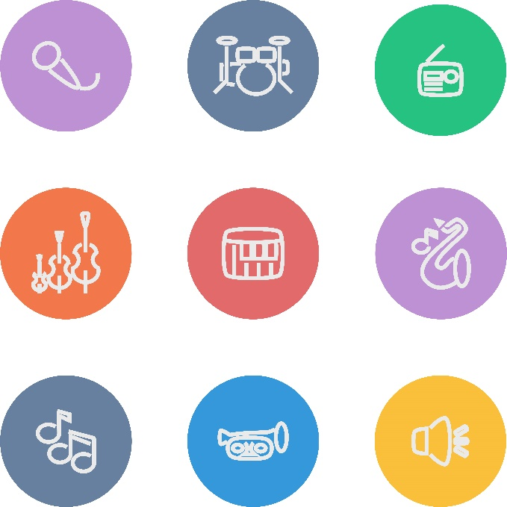
For use with the curriculum framework published in 2019

Copyright © UCLES September 2019
Cambridge Assessment International Education is part of the Cambridge Assessment Group. Cambridge Assessment is the brand name of the University of Cambridge Local Examinations Syndicate (UCLES), which itself is a department of the University of Cambridge.

UCLES retains the copyright on all its publications. Registered Centres are permitted to copy material from this booklet for their own internal use. However, we cannot give permission to Centres to photocopy any material that is acknowledged to a third party, even for internal use within a Centre.

Contents

Contents 3
Introduction 4
Unit 2.1 Animal voices 7
Unit 2.2 Water, water, everywhere 13
Unit 2.3 Musical food 19
Unit 2.4 Light and dark 24
Unit 2.5 Celebration 29
Sample lesson 1 34
Sample lesson 2 37

Introduction

This document is a scheme of work created by Cambridge Assessment International Education for Cambridge Primary Music Stage 2.

It contains:
- suggested units showing how the learning objectives in the curriculum framework can be grouped and ordered
- at least one suggested teaching activity for each learning objective
- a list of subject-specific language that will be useful for your learners
- sample lesson plans.

You do not need to use the ideas in this scheme of work to teach Cambridge Primary Music Stage 2. It is designed to indicate the types of activities you might use, and the intended depth and breadth of each learning objective. These activities may not fill all of the teaching time for this stage. You may choose to use other activities with a similar level of difficulty.

The accompanying teacher guide for Cambridge Primary Music will support you to plan and deliver lessons using effective teaching and learning approaches. You can use this scheme of work as a starting point for your planning, adapting it to suit the requirements of your school and needs of your learners.

Long-term plan
This long-term plan shows the units in this scheme of work and a suggestion of how long to spend teaching each one. The suggested teaching time is based on 30 hours of teaching for Music Stage 4. You can adapt the time, units and order of the units based on the requirements of your school and the needs of your learners.

Unit and suggested order | Suggested teaching time
Unit 2.1 Animal voices | 6 hours
Unit 2.2 Water, water, everywhere | 6 hours
Unit 2.3 Musical food | 6 hours
Unit 2.4 Light and dark | 6 hours
Unit 2.5 Celebration | 6 hours
Total | 30 hours

Sample lesson plans
You will find two sample lesson plans at the end of this scheme of work. They are designed to illustrate how the suggested activities in this document can be turned into lessons. They are written in more detail than you would use for your own lesson plans. The Cambridge Primary Music Teacher Guide has information on creating lesson plans.

Other support for teaching Cambridge Primary Music Stage 2
Cambridge Primary centres receive access to a range of resources when they register. The Cambridge Primary support site at https://primary.cambridgeinternational.org is a password-protected website that is the source of the majority of Cambridge-produced resources for the programme. Ask the Cambridge coordinator or exams officer in your school if you do not already have a log-in for this support site.

Included on this support site are:
- the Cambridge Primary Music Curriculum Framework, which contains the learning objectives that provide a structure for your teaching and learning
- grids showing the progression of learning objectives across stages
- the Cambridge Primary Music Teacher Guide, which will help you to implement Cambridge Primary Music in your school
- templates for planning
- worksheets for short teacher training activities that link to the teacher guide
- assessment guidance (to support classroom assessment)
- links to online communities of Cambridge Primary teachers.

Resources for the activities in this scheme of work
We have assumed that you will have access to these resources:
- paper, pens and pencils for learners to use, including manuscript paper
- space for learners to work in different groupings (individual, pair, groups, whole-class) on different types of activity (listening to music, composing, rehearsing, performing)
- a range of musical instruments, for example, tuned and untuned percussion
- equipment for playing recorded music to learners
- audio or video recording equipment
- music portfolios where learners can record their music making at all stages of development.

Other suggested resources for individual units and/or activities are described in the rest of this document. You can swap these for other resources that are available in your school.

Websites
There are many excellent online resources suitable for teaching Cambridge Primary Music. Since these are updated frequently, and many are only available in some countries, we recommend that you and your colleagues identify and share resources that you have found to be effective for your learners.

Approaches to teaching Cambridge Primary Music Stage 2
The learning objectives are organised into two strands which aim to integrate embodied learning in a holistic way.
- Making Music
- Making Sense of Music

Music portfolios
A music portfolio allows learners to document their experiments, rehearsals, performances and reflections which will help them to reflect on their progress and next steps. Learners should add to their portfolio regularly and this can be done either formally or informally. Depending on the availability of music technology it is likely that this portfolio will be a combination of audio/video recordings of rehearsals and performances, compositions (recordings and/or notations) and learner’s reflections (either written or recorded).

Teaching songs.
When teaching songs, or parts of songs, it is recommended that you use repetition to help learners remember the melody. A simple way to do this is for you to sing a line (phrase) and then ask learners to sing it back. If learners do not sing it back correctly at first, simply repeat the process until they can. For example, in a four-phrase melody, you could sing one phrase, then two together, then the whole song to gradually build learners’ memory. To support this process, you may also wish to use hand signs (e.g. sol-fa and Kodály-Curwen hand signs) when learners are learning or performing a song. Sol-fa gives every pitch a name and an accompanying hand sign to help learners build a picture of how a melody is constructed and the relationships between notes. The names for the notes are ‘do, re, mi, fa, so, la, ti, do’. You may want to research this further if you would like to use it with your learners.

Teaching notation
Not all styles of music use notation and understanding musical notation is not required in order to be a musician. However, having an awareness of notation is a useful skill for many learners, particularly those who go on to study for qualifications in music. Notation includes written representations (e.g. stave music) or ways to name notes (e.g. C D E or do, re, mi). By introducing ‘sound before symbol’ learners participate in lots of practical music making, which allows then to begin to hear notes in their head (internalised sounds), before they come to understand and use notation as a way to represent those sounds.

Differentiation and extension activities
For learners who require more challenge, try adding extra parts within the same piece of music that the class is learning. These parts could be instrumental or vocal and involve different rhythms (e.g. clapping one rhythm while singing another) or tunes (e.g. a new harmony line).

Unit 2.1 Animal voices

Unit 2.1 Animal voices

Outline of unit:
In this unit, learners will explore animal sounds and movements as the stimuli for creativity and the development of fundamental musical concepts, such as pulse and pitch. They will experiment with different voices and be introduced to the names for so and mi, their representation as hand signs and on a two-line stave.

Recommended prior knowledge/previous learning:
Although the learning builds on elements covered in Stage 1, no prior knowledge is needed.

Language:
- words to describe different voices, (e.g. high, low, fast, slow, quiet, strong, whispering, angry, sad, laughing)
- thinking voice
- baton
- conductor
- parachute
- so and mi
- pulse

Learning objectives | Suggested teaching activities and resources | Comments/Teaching notes
2MM.01 Participate in music making with an increasing awareness of others.  2MM.03 Explore and combine sounds in response to a range of given or chosen stimuli.  2MS.01 Listen and respond to music through asking and answering questions and making sounds and movement. | Sing ‘Have you brought your singing voice?’ Learners respond by singing back ‘Yes I have, yes I have’. Use this song to explore different voices, such as high, low, fast, slow, quiet, strong, whispering, angry, sad, laughing and thinking.  Repeat using animal sounds, for example: ‘Have you brought your duck voice?’, ‘Quack, quack, quack, quack’; ‘… mouse voice?’, ‘Squeak, squeak, squeak, squeak’; ‘lion voice?’ ‘Roar, roar, roar, roar’. Add actions to suit each animal.  Ask learners which animal sounds and voices they liked. Split the class into four groups and assign an animal to each one. Sing ‘Have you brought your animal voice?’ Each group makes the sound and movement for their animal.  ‘Have You Brought …’  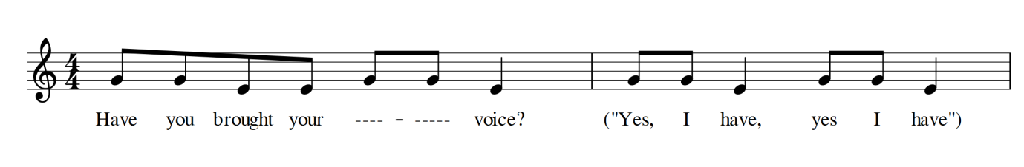  Use the different voices to sing familiar songs from Stage 1. Discuss with learners how they sound.  Ask learners to sit in a circle. One learner, the doggy, pretends to be asleep (eyes closed) in the middle of the circle, next to an object representing their bone. During the song, a chosen learner secretly takes the bone and returns to their place in the circle. The doggy sings the line ‘Someone stole it from my home’ solo, whilst the bone thief sings the line ‘I stole your bone’, using any of the above voices. At the end of the song, the doggy can then open their eyes. They have three guesses to see who stole the bone.  ‘Doggy Doggy’  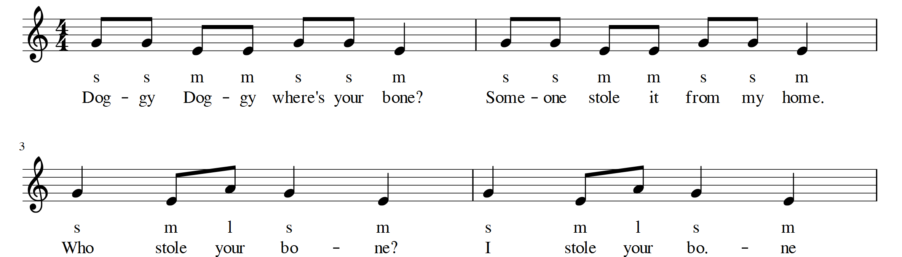  Standing in a circle, sing a song about an animal together, with a chosen learner controlling the dynamics with a stick or baton from the middle of the circle. Tell learners that this is the conductor and they should watch them to see how strongly or quietly they should sing. When the stick or baton is high in the air, they sing with their strongest voices. When it is close to the ground, they use a quiet, whispering voice. When it touches the ground, they use a thinking voice.  Split the class into two and sing a song together. Give one learner in each group a stick or baton and tell these learners that they are the conductor for that group.  Ask half of the class to sing ‘Have you brought your singing voice?’ and half the class to sing the first half of ‘Doggy Doggy’, with a learner from each group controlling the dynamics.  All of the so/mi songs in this scheme of work can be sung together at the same time for this activity.  Resources:  - An object to represent a bone  - Sticks/batons | This activity provides a range of stimuli and sounds which can be used in creative ways by you and learners. It encourages more shy learners to sing as part of a group. It also encourages them to explore timbres, vowel sounds, diction and vocal technique. Laughing voice is particularly good for singing technique.  ‘Thinking voice’ means silently running through the song in your head and is very important for developing inner hearing, i.e. aural ability and memory. Encourage learners to tap their head gently with their finger as they think.  Initially, encourage learners to use large gross motor movements to the pulse, which can then be refined into clapping and even finer motor movements, such as tapping your nose with your little finger.  The scores are for your use at this stage, and should not be shared with learners yet, according to the principle of sound before symbol. The songs, their scores and recordings can be freely found online.  The notes are G and E (so and mi), unconsciously preparing learners for naming these notes later in the unit.  ‘Doggy Doggy’ encourages learners to listen to the pitch, timbre and physical location of the voices of other learners in the class.  A similar game can be played for the song ‘Here Sits a Mousie’, with learners stealing the mouse's cheese.  Avoid using the word ‘loud’ as it encourages learners to shout. The word ‘strong’ is used here, and this is what the Italian term ‘forte’ means. Learners should be developing the sense of everyone singing at the same volume. The changing volumes encourage learners to develop their ability to listen to other groups singing contrasting parts.  Once your class is doing this fairly easily, you can consider breaking into smaller groups.  You may find it useful to sing one part along with learners and have a strong singer from the group leading the other part. Once secure, see if learners can sing without your help and do not sing along with them.  Learners can write down their favourite songs, and make recordings. Musical sketchbooks or portfolios should be an informal part of everyday life in the music room, using audio recordings if at all possible.
2MM.01 Participate in music making with an increasing awareness of others.  2MM.02 Contribute to performances with mostly accurate timing and awareness of pulse and melodic shape. | Chant a song together with a familiar refrain, using big movements to show the pulse. For example, chant ‘Teddy Bear’, encouraging learners to chant and move in time together.  ‘Teddy Bear’  (Chant and follow the instructions for the actions.)  Teddy bear, teddy bear, touch the ground.  Teddy bear, teddy bear, turn around.  Teddy bear, teddy bear, climb upstairs.  Teddy bear, teddy bear, say your prayers.  Teddy bear, teddy bear, switch off the light.  Teddy bear, teddy bear, say goodnight.  Using a song/chant, or recorded music, encourage learners to use all their limbs and their head, separately and in combinations together, to show the pulse each time you repeat the song. Encourage learners to create their own pulse movements.  Decide on a common pulse movement and lead learners in doing the movements together. Regularly change the pulse action, every four bars or so.  This can then be extended into a game. Choose a learner to be the detective. The detective goes to the side of the room whilst someone is chosen as the leader. The detective then has until the song finishes to work out which learner is leading the pulse actions. The leader should regularly change the action, and this is what the detective should look for.  Play passing games, passing an item around the circle to the pulse of a song or recorded music. Examples include pass the parcel (game) and ‘Cherry Pie’ (song).  Practise a range of traditional so/mi songs, focusing on intonation and accurate pulse. Freely available examples include ‘Cherry Pie’, ‘The Lemonade Song’ and ‘See Saw’.  Resources:  - Recorded music (optional)  - Items to pass around in passing games | Start with gross motor movement and refine this over the six hours to clapping and fine motor movements such as tapping fingers together.  Encourage learners who have a secure pulse to model this to other learners. Do not worry if some learners are not able to keep a steady pulse at first, as it takes time for some learners.  ‘Teddy Bear’ is a simple chant with actions, and a great early game to do with your class. The repeated ‘Teddy bear’ refrain means a lot of learners will join in, and some learners will soon start to memorise the words in between. Once a few learners are starting to do this, prompt them with actions instead of saying the words, although you may need to join in with ‘Teddy Bear’ to keep the class in time. Eventually, remove any teacher support from the activity and see if learners can lead it. You may need to lead the pulse for several lessons before you ask learners to lead.  Rhythmic activities are fine to do with any recorded music with a strong pulse, but ideally, avoid singing along to backing tracks or recordings too much at this stage, as it masks learners’ voices and may not be at an appropriate pitch (approximately from middle C to the next C above).  Do not use songs which are too fast for these exercises.
2MM.01 Participate in music making with an increasing awareness of others.  2MM.02 Contribute to performances with mostly accurate timing and awareness of pulse and melodic shape.  2MS.03 Recognise that there is a link between sounds and symbols. | After singing a range of so/mi songs, introduce songs and games that demonstrate high and low pitches. For example, these songs can be used together with parachute games or other actions:  ‘High Low’  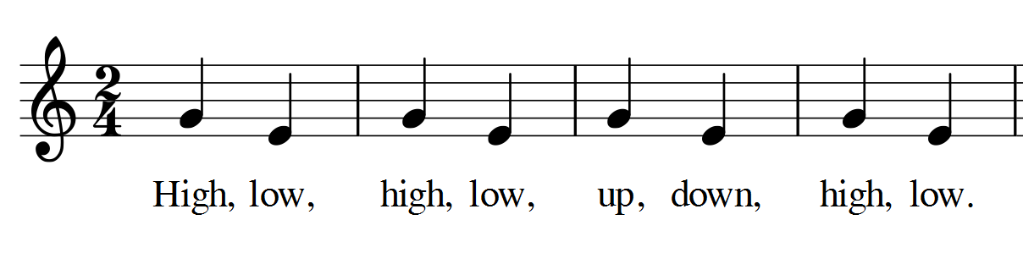  ‘Reach for the Sky’  Ask learners:  - Which note does each song start on?  - The high note or the low note?  Hum or play on an instrument and see if learners can show you with the parachute where it starts (i.e. the parachute goes up on the higher note, so, and down on the lower note, mi).  Repeat this without the parachute and, once secure, add the sol-fa, then replace the movements with Kodály-Curwen hand signs for so and mi and introduce learners to the names for the notes.  so mi  Ask learners to sing songs whilst clapping the pulse.  Once familiar, learners may represent the songs with a line. For example:  Reach for the Sky High Low  Practise singing so/mi songs using sol-fa and hand signs.  Resources:  - Parachute or alternative, e.g. a bedsheet | Parachute games give learners a common experience of tactile, visual and kinaesthetic cognition of pitch, tempo and pulse, leading to very secure sense of common pulse and sense of teamwork. You can buy a classroom parachute or easily make your own out of light fabric, e.g. large bedsheets.  On the word ‘sky’, everyone should let go of the parachute. This leads to the very satisfying effect of the parachute floating up to the ceiling.  Ensure that the minor 3rd, so/mi interval is being modelled accurately for learners.  Ensure that the so hand sign is higher than the mi hand sign.  These could be turned into artwork, e.g. the teeth of a crocodile or a slithering snake.  Think of other ways you can show the high and low pitches.  You may wish to develop a library of so/mi songs and games.
2MM.02 Contribute to performances with mostly accurate timing and awareness of pulse and melodic shape.  2MS.01 Listen and respond to music through asking and answering questions and making sounds and movement.  2MS.03 Recognise that there is a link between sounds and symbols. | Using a two-line stave, show learners the song ‘Hey, Hey’.  After singing the song, ask learners:  - What is the high note called? (so)  - What is the low note called? (mi)  - Which note does the song start on? (so)  Ask learners to stand in a circle. Any learner who wants to can sing the song, changing the word ‘monkey’ to a different animal and doing the pulse actions, which may include clapping. They sing solo and then the rest of the class copy. | If learners do not model accurate pitch and pulse when taking their solo, do not point this out to them, as it can affect their confidence and does not show them how to correct errors. At this stage we want learners to sing in a way which is not self-conscious. However, as the teacher, you should be aware of intonation errors and when necessary, model the correct pitch, or ask a learner to. It is important not to get learners to repeat inaccuracies of others, as this will reinforce inaccurate singing. Simply model the correct way to learners and ask them to copy you.  Only ask for volunteers, never force a reluctant learner to sing.  Ensure learners are singing this rather than simply making animal noises.
02MM.03 Explore and combine sounds in response to a range of given or chosen stimuli.  2MM.04 Begin to demonstrate basic organisation of musical ideas when contributing to improvisations and compositions. | Zoo soundscape  Organise learners into groups of six. Split each group into three pairs. Each pair must choose an animal which they will make the sound for. For example:  Pair 1 – Snapping crocodiles  Pair 2 – Stomping and shrieking elephants  Pair 3 – Tweeting birds.  Demonstrate a few examples to learners. Each group should make their sound together (ideally to a pulse), with movement. Give learners time to practise this in their groups and finish by presenting to the rest of the class.  Ask the other learners the following questions after each performance:  - Can you guess what the animals were?  - Can you describe the sounds (e.g. cow = low, long)?  - What did they sound like together?  You may use instruments (including objects that can be used to make sounds such as pots, pans, plastic containers and jingling keys) for this activity. Encourage learners to think about what animals the instruments might represent and play them to a steady pulse.  If using pitched instruments, use any combination of pentatonic notes CDEGA to create a pleasant harmonic sound with no clashing notes. However, some dissonance may be used for effect, e.g. using the notes C and C# to represent the ‘Jaws’ theme for sharks, or to create a more sinister sound.  Resources:  - Instruments (optional) | Celebrate any very musical performances, i.e. those with a strong pulse whose movements reflect the contours of the melody, by asking the whole class to copy the learners’ noises and actions.  This activity prepares learners for experimenting with sounds in similar activities in Unit 3.

Unit 2.2 Water, water, everywhere

Unit 2.2 Water, water, everywhere

Outline of unit:
In this unit, learners will explore how to represent water in sound and movement. They will continue to sing so/mi songs with actions.

Recommended prior knowledge/previous learning:
Singing so/mi interval, the note names so and mi, and their Kodály-Curwen hand signs.

Language:
- words to describe the sound of water (e.g. splash, pitter-patter, whoosh)
- melody
- pitch
- rest

Learning objectives | Suggested teaching activities and resources | Comments/Teaching notes
2MM.01 Participate in music making with an increasing awareness of others.  2MM.03 Explore and combine sounds in response to a range of given or chosen stimuli.  2MM.04 Begin to demonstrate basic organisation of musical ideas when contributing to improvisations and compositions.  2MS.02 Offer and accept suggestions for improvement to work. | Discuss with learners:  - Where do we find water? (e.g. in bottles, the sea, from taps, puddles)  - What different sounds can water make? (e.g. splashing in a puddle, waves crashing on the beach, the pitter-patter of raindrops, windscreen wipers, toilet flushing etc.)  - What water sounds can we make with our voices? (e.g. sound effects of drips with the tongue on top of the mouth, the ‘shhhhhh’ of a river or shower, onomatopoeia (splash, whoosh etc.)  - What water sounds can we make with our hands or bodies? (e.g. rubbing hands together, running on the spot or simulating raindrops by drumming the fingers)  Experiment with organising these sounds into groups, bringing different groups in and out at the conductor's signal to create textures and improvised structures. Encourage learners to make their sounds to a common pulse.  Discuss with learners what worked well.  Which combinations do you prefer and why? | Learners can draw pictures to represent the sounds.  Learners can discover their own water sounds as homework.  A fun activity would be to digitally record these sounds, and layer and compose with them using a software sequencer.  Allow learners to conduct.
2MM.01 Participate in music making with an increasing awareness of others.  2MM.02 Contribute to performances with mostly accurate timing and awareness of pulse and melodic shape. | 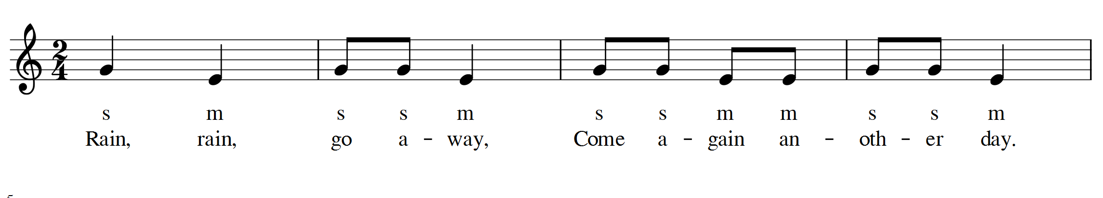  Sing the song ‘Rain, Rain’ sitting in a circle, wiggling fingers of both hands high in the air for the high notes, and on the ground for the low notes. Then sing in sol-fa, replacing the actions with Kodály-Curwen hand signs (see Unit 2.1).  Ask learners:  - How many notes are in the song? (two)  - What is the high note called? (so. Point this out on the score.)  - What is the low note called? (mi)  Display the following to the class and sing them together, following the sol-fa.  On the board, write:  so so so  mi mi  so so so so  mi mi mi  Show learners the score as shown here, and sing the song together whilst following the score. Allow learners to take solo turns to show the high and low notes of ‘Rain, Rain’ with their fingers as they read. Ask other learners in the group if the movements match the pitch.  Resources:  - ‘Rain Rain’ displayed on two-line stave (as above) | Compare to ‘Hey, Hey’ from Unit 2.1 (identical melody). Can learners sing both songs at the same time?  This provides visual reinforcement of the activities in 2.1.  Draw the score on the board and point to it as learners sing out loud. Once this is secure, let learners who are reading the notation accurately lead the activity. Practise using thinking voice to read the songs too.
2MS.01 Listen and respond to music through asking and answering questions and making sounds and movement.  2MS.03 Recognise that there is a link between sounds and symbols. | Sing ‘Rain is Falling Down’. (Do not show this score to learners. It is for your use only.)  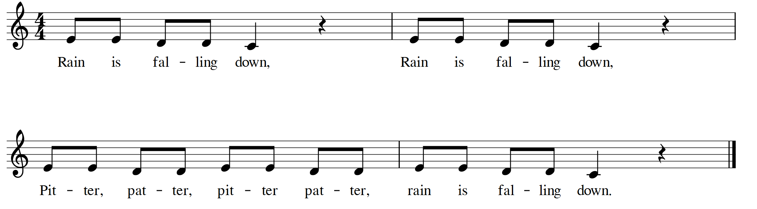  Sing the song with the class, this time wiggling fingers high in the air for the highest note (mi-E) in front of them for the middle note (re-D) and on the floor for the low note (do-C).  Ask learners:  - What were we showing with our hands? (the pitch)  - There were two pitches in the last song. How many are there in this song?  Repeat the song asking learners to put their fingers to their lips every time they hear a gap in the music.  Try this activity with more songs containing clear rests, such as ‘Hot Cross Buns’ or ‘Peas Pudding Hot’.  When learners are identifying the rests clearly, use the thinking voice for the ‘shh’ sound instead, and name this as a ‘rest’. | Introduce the learners to being able to sing the melody without using either the sol-fa notes (mi, re, do), letter names (EDC) or score. This supports a sound before symbol approach.  If learners are singing securely and confidently, this song can be sung as a round, with the second group entering on beat three, on the word ‘down’.
2MM.01 Participate in music making with an increasing awareness of others.  2MM.02 Contribute to performances with mostly accurate timing and awareness of pulse and melodic shape.  2MS.03 Recognise that there is a link between sounds and symbols. | Sing the song ‘Once a Man Fell in a Well’ and play the game. (Do not show the score to learners.)  Learners stand in two teams, each in a straight line, at either end of the classroom, with a bucket between them in the middle of the room. They pass a ball down the line to the pulse. If the ball reaches the end of the line, it is passed back down. Whoever is holding the ball when the song finishes can take a shot into the bucket for their team.  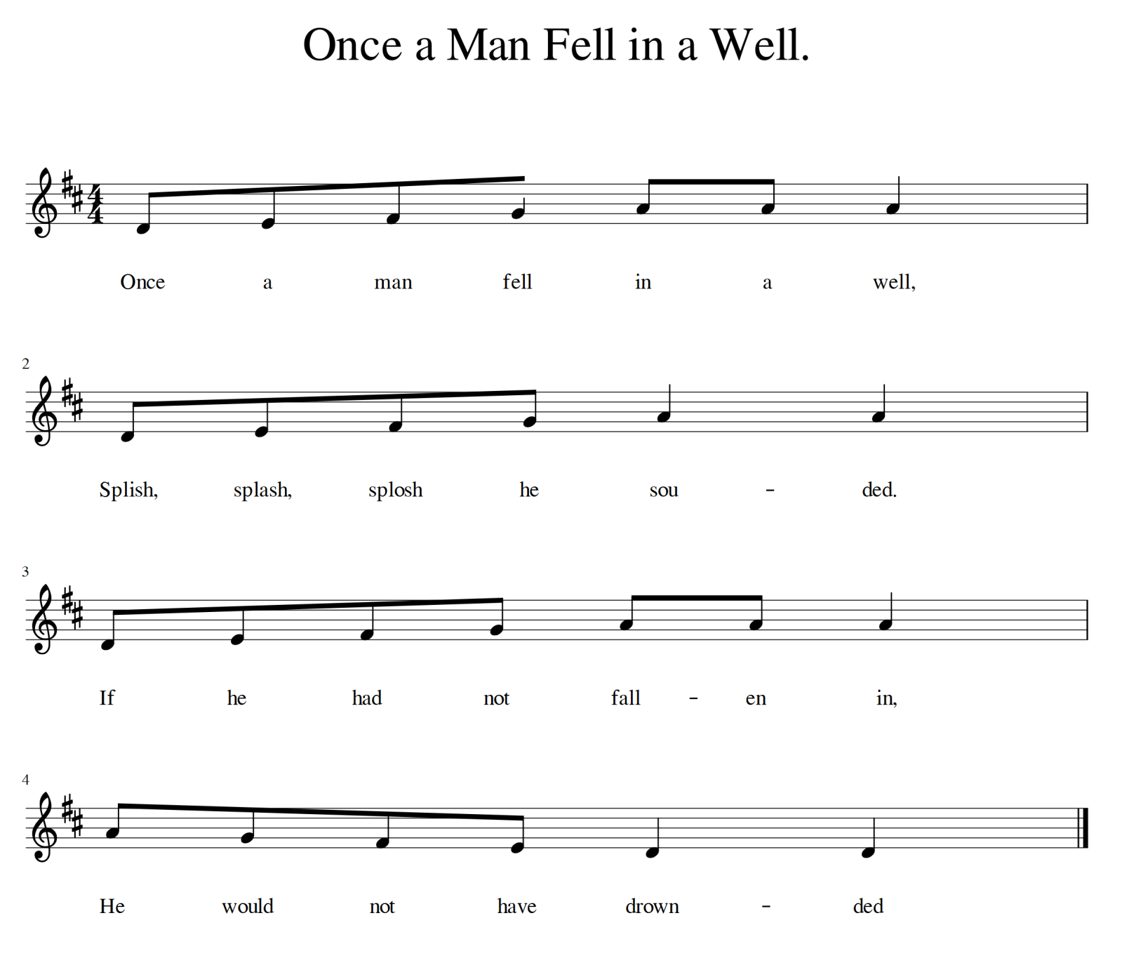  sound  Sing the song again as a whole class, starting in a crouching position and moving up and down with the melody shape.  How does the melody work? (low to high three times, then high to low at the end)  Resources:  - Two balls (or anything which can be passed and thrown)  - A bucket or hoop | This game can be played competitively, with one line against the other (first to score three goals wins), or cooperatively (e.g. three goals will rescue the man from the well).  There are opportunities for storytelling.  How did the man end up in the well?  What happened to him?  This song is a traditional children’s song and it is easy to find audio versions from a range of online sources.  Introduce the learners to being able to sing the melody without using either the sol-fa notes (do, re, mi, fa, so), letter names (CDEFG) or score. This supports a sound before symbol approach.
2MM.01 Participate in music making with an increasing awareness of others.  2MM.02 Contribute to performances with mostly accurate timing and awareness of pulse and melodic shape.  2MS.03 Recognise that there is a link between sounds and symbols. | Stand in a large circle with everyone holding a parachute (or sheet). Starting high on the first beat, sing a simple song, e.g. ‘Draw a Bucket of Water’, while moving the parachute up and down to the pulse, and if appropriate, the pitch.  ‘Draw a Bucket of Water’  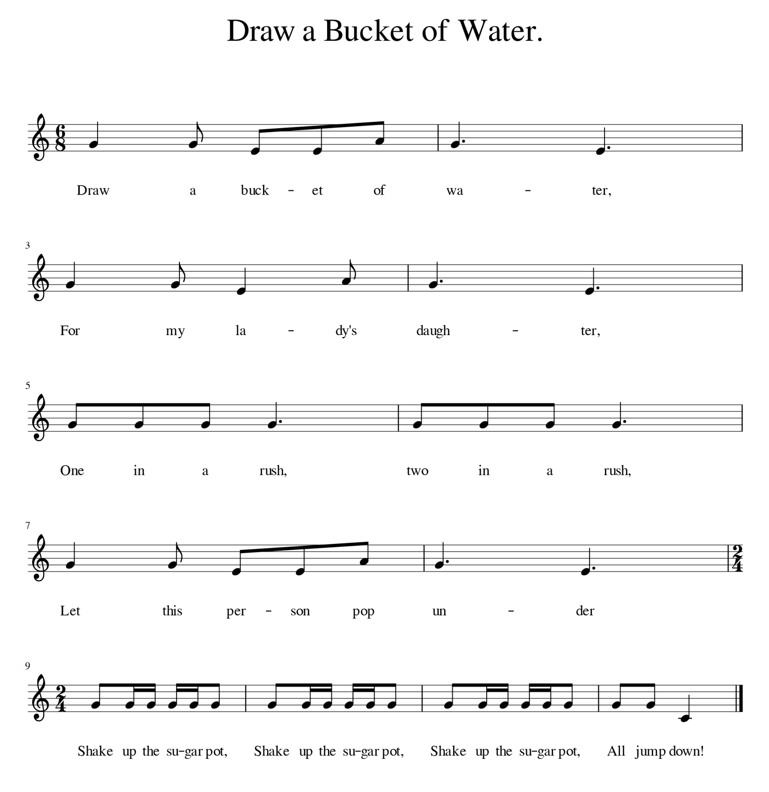  Select one learner to skip around the circle, tapping each person on the shoulder in time to the pulse. On ‘Let this person go under’, the person whose shoulder was tapped last goes under the parachute to the opposite side, whilst learners chant ‘Shake up the sugar pot’ and shake the parachute up high. On ‘All jump down’, learners let go of the parachute.  Resources:  - Parachute or alternative, e.g. a bedsheet | Ensure that the pulse falls on the following syllables (in bold):  Draw a bucket of wa-ter,  For my lady's daugh-ter,  One in a rush, two in a rush,  Let this person pop un-der.  This song is in the time signature 6/8, which involves two beats per bar split into groups of three quavers (ti-ti-ti) on each beat, rather than groups of two quavers (ti-ti). You should be comfortable with this as the teacher but learners are not yet ready to conceptualise this. Learners should, however, be able to keep a pulse in this time signature, as it is common in children's songs (and creates a good rhythm for skipping games).  At this stage you are introducing them to the sound, according to the principles of sound before symbol and in preparation of unfamiliar elements (in the next unit).
2MM.02 Contribute to performances with mostly accurate timing and awareness of pulse and melodic shape.  2MS.01 Listen and respond to music through asking and answering questions and making sounds and movement.  2MS.02 Offer and accept suggestions for improvement to work. | Using the parachute, listen to recorded music featuring water, and as a class, move the parachute up and down in time to the music.  After each piece, ask learners:  - Was the pulse fast or slow, or somewhere in the middle?  - Were we all moving in time to the pulse of the music?  - How can we improve for the next piece of music?  Model accepting suggesting for improvement and applying this to the next piece of work.  Suggested recordings of music featuring water:  Frederic Chopin, ‘Raindrop’ Prelude No. 15 in D-flat major, Op.28  Camille Saint-Saëns, ‘VII Aquarium’ from The Carnival of the Animals  Arthur Freed and Nacio Herb Brown, ‘Singin' in the Rain’  Bedřich Smetana, ‘Vltava’ (river) from Má Vlast  Claude Debussy, ‘Poissons d’Or’ (Goldfish), ‘Ondine’ (Water Siren)  Traditional US, ‘Wade in the Water’  Jacques Ibert, ‘Reflets dans l’eau’ (Reflections in the Water)  Resources:  - Parachute or alternative, e.g. a bedsheet | Choose pieces which you feel confident will work with the parachute (see suggestions).

Unit 2.3 Musical food

Unit 2.3 Musical food

Outline of unit:
In this unit, learners will be introduced to rhythms using ta, ti-ti and sh (rest). They will match these to the syllables in food names and combine them into simple compositions to perform together.

Recommended prior knowledge/previous learning:
Chanting and singing in time to the pulse.

Language:
- rhythm
- rap
- syllable
- symbol

Learning objectives | Suggested teaching activities and resources | Comments/Teaching notes
2MM.02 Contribute to performances with mostly accurate timing and awareness of pulse and melodic shape. | A variety of songs and chants can be used to help learners to keep a pulse when singing different rhythms.  ‘Chop, Chop’  (Sitting in a circle, chant with learners.)  Chop, chop, choppity chop  Chop off the bottom and chop off the top  What there is left we shall put in the pot  Chop, chop, choppity chop.  Use the following actions:  Chop, chop, choppity chop (chop right hand against the palm of the left to the pulse – four chops)  Chop off the bottom and (two low chops in the air to the pulse)  Chop off the top (two high chops in the air to the pulse)  What there is left we shall (stir the pot in time to the pulse)  put in the pot  Chop, chop, choppity chop (chop right hand against the palm of the left to the pulse – four chops)  ‘Jelly on a Plate’  (Standing up, chant the rhyme together, inventing appropriate pulse actions.)  Jelly on a plate  Jelly on a plate  Wibble, wobble, wibble, wobble  Jelly on a plate. | Encourage learners to keep to the pulse with a single chop on ‘choppity’ (the pulse) rather than a chop on each syllable (the rhythm).  You can try this chant with other foods and noises, e.g. ‘sausage in a pan’ and ‘sizzle, sizzle, sizzle, sizzle’.
2MM.02 Contribute to performances with mostly accurate timing and awareness of pulse and melodic shape.  2MS.01 Listen and respond to music through asking and answering questions and making sounds and movement. | Walk on the spot to the pulse saying ‘walk, walk, walk, walk’, which learners immediately copy.  Run on the spot saying ‘running, running, running, running’, which learners immediately copy.  Use combinations for learners to copy, e.g. ‘walk, walk, running, walk’.  Repeat, changing the words to ‘ta, ta, ta, ta’ (walk) and ‘ti-ti, ti-ti, ti-ti, ti-ti’ (running).  Use combinations for learners to copy - e.g. ‘ta, ti-ti, ti-ti, ta’ of ‘ti-ti, ta, ta, ta’.  Hum ‘ti-ti’. Ask learners:  How many hums did you hear on ‘ti-ti’? (two)  Repeat for ‘ta’ (one)  Using a drum or table, tap a steady pulse of tas. Learners must walk or run around the space to the pulse accordingly.  Repeat with a steady run of ti-tis. Learners should work out they should be running  Resources:  - Drum or table | Aim to keep a constant, even pulse throughout this activity.  Ensure the majority of learners are doing each part of the activity securely before moving on to the next.  When running, some learners will get carried away and run too fast. Remind them to run at the same speed as the music. You may need to model this or ask other learners to do so.
2MM.01 Participate in music making with an increasing awareness of others.  2MM.02 Contribute to performances with mostly accurate timing and awareness of pulse and melodic shape.  2MM.03 Explore and combine sounds in response to a range of given or chosen stimuli. | Sitting in a circle, establish ‘knee, knee, clap, rest’ rhythmic ostinato.  Beat 1 2 3 4  Action Knee Knee Clap Rest  Taking turns one by one whilst keeping the rhythm, learners sing their favourite food to so/mi. This may take some practising.  Learners can then decide the category of food, e.g. meat, fruit, vegetables, green foods, snacks. | ‘Ostinato’ means a short phrase or pattern that is repeated. Learners do not need to know the term at this stage. ‘Rest’ means do nothing on beat four.  Do not worry if not everyone is singing so/mi for their food name or doing it exactly on the clap or precisely in tune, but try to maintain a strong group sense of pulse and pitch. Start off reasonably slowly, as learners will be likely to speed up.  This activity builds on similar activities in earlier units and prepares for material in Stage 3.
2MM.01 Participate in music making with an increasing awareness of others.  2MM.02 Contribute to performances with mostly accurate timing and awareness of pulse and melodic shape.  2MM.03 Explore and combine sounds in response to a range of given or chosen stimuli.  2MM.04 Begin to demonstrate basic organisation of musical ideas when contributing to improvisations and composition.  2MS.01 Listen and respond to music through asking and answering questions and making sounds and movement.  2MS.03 Recognise that there is a link between sounds and symbols. | Arrange four chairs at the front of the class to represent four beats.  Demonstrate and explain to learners that:  - if one person is seated on a chair, that is a ta  - if two people are seated on a (i.e. the same) chair, that is a ti-ti  - if nobody is seated on a chair, that is a rest, which is a sh.  Once this is established, choose eight learners to stand behind the chairs in pairs.  Count down from five whilst pairs decide whether to make a ta, a ti-ti or a sh on their chair. When you reach zero, pairs sit on or stand behind their chairs according to their decision. When pairs are settled, count in the rest of the learners and read the rhythm together.  Repeat until all learners have had a turn at the front.  Next, see if learners can create familiar rhythms, from your rhythm syllables, e.g. ti-ti, ti-ti, ti-ti, ta.  Next, substitute the tas and ti-tis for foods from earlier activities. See if learners can notate the food rhythms, e.g. ‘Bread, butter, crisps, jam’ using the chairs.  Next, ask if any learners can tell what you are clapping. Clap a rhythm and see if learners can organise other learners to create the rhythm on the chairs.  Finally, introduce the symbols for ta, ti-ti and sh.  Ta = Ι  Ti-ti = Π  Sh = Z  Resources:  - Four chairs  - Items to show ta, ti-ti rhythms in stick notation, e.g. sticks, matchsticks or chopsticks (optional) | This activity teaches rhythmic notation in a physical, active way.  To count in learners, use whatever you feel comfortable with, e.g. ‘Ready Steady, off you go’ or ‘1, 2, 3, Go’. However, make sure this is done to a clear pulse at the right tempo.  Consider all the different ways you can represent ta, ti-ti and sh, e.g. with your hands/arms or with sticks/matchsticks/ chopsticks, to make four-beat rhythms.
2MM.01 Participate in music making with an increasing awareness of others.  2MM.02 Contribute to performances with mostly accurate timing and awareness of pulse and melodic shape.  2MM.03 Explore and combine sounds in response to a range of given or chosen stimuli.  2MS.02 Offer and accept suggestions for improvement to work.  2MS.03 Recognise that there is a link between sounds and symbols. | Ask learners:  - Which foods fit with ti-ti and have two sounds (syllables)? (e.g. cus-tard, hot-dog, bur-ger, ap-ple, but-ter)  - Which foods fit with ta and have one sound (syllable)? (e.g. bread, eggs, milk)  Ask learners to compose a rap in groups of four, each learner contributing a four-beat line, e.g. ‘Crisps, bananas, jam, custard’.  Using only ta and ti-ti foods, it may look something like this:  Bread, eggs, milk, apples,  Custard, yoghurt, peas, thyme,  Soya, carrots, beans, pears,  Sausage, parsley, lemon, lime.  Keeping a steady pulse together and, keeping in time as a group, each learner has to say their four foods to the pulse.  Ask learners to perform their food combinations to a recorded drumbeat or a steady pulse on one or two instruments or tables. Once secure, each learner may move to pitched and unpitched percussion to play their parts simultaneously as ostinatos.  For example, one learner could repeatedly drum the rhythm for ‘crisps, custard, lemon, figs’ (ta, ti-ti, ti-ti, ta), while another learner plays their rhythm on pitched instruments, using the pentatonic scale notes (CDEGA) in any combination.  After each group has performed, ask the other learners questions such as:  - Were they playing/singing together?  - Were they singing at the same pitch?  - Were they in time to the pulse?  - What was good about the performance?  - What could they do to make it even better?  Resources:  - Instruments (optional)  - Recorded hip hop backing drumbeat (optional) | Ensure each learner is thinking of four foods before they play the game.  Make sure there is only a ta and ti-ti rhythm on each beat (i.e. no ‘strawberries’ or ‘hamburgers’.  You may wish to create a 4x4 table to help learners if they wish to write their rap down.  You may also wish at this stage to use a live or recorded drum track, e.g. a programmed hip hop beat.  Ostinatos are repeated rhythmic loops. Here they last for four beats. They can be played on different instruments for very different effects.  Unpleasant clashes occur in music when notes which are too close together are heard at the same time. Using the pentatonic scale (CDEGA, do, re, mi, so, la) avoids any clashes. Ideally, use chime bars, bells or other instruments where the F and B notes can be removed.

Unit 2.4 Light and dark

Unit 2.4 Light and dark

Outline of unit:
In this unit, learners listen and respond to recorded light and dark music, exploring how it makes them feel. They continue to use ta, ti-ti and sh rhythms and stick notation.

Recommended prior knowledge/previous learning:
Ta, ti-ti and sh rhythms.

Language:
- words to describe light and dark music (e.g. calming, quiet, peaceful, playful, joyous, unsettling, loud, sad)

Learning objectives | Suggested teaching activities and resources | Comments/Teaching notes
2MM.02 Contribute to performances with mostly accurate timing and awareness of pulse and melodic shape.  2MS.01 Listen and respond to music through asking and answering questions and making sounds and movement. | Light and dark music  ‘Light’ may describe major key music which provokes feelings such as calming, quiet, peaceful, playful and joyous.  ‘Dark’ may include unsettling, loud or sad music, but may also have calm, still qualities.  Some music might sound dark to some learners but light to others. For example, Beethoven's ‘Moonlight Sonata’ suggests light within darkness. Although the first movement is fairly slow, quiet and calm, the third movement is very fast and dramatic with extremes of dynamics.  Play recorded examples of light and dark music. Give learners a range of (silent) items to choose from to move to the music with, e.g. chiffon scarves, handkerchiefs, ribbons or parachutes.  Ask learners to show with their faces whether the music feels happy or sad. After the piece, ask learners to discuss what they liked about the music.  Discuss with learners whether each example was dark or light.  Music Dark Light Both  Suggested recordings for ‘dark’ music:  Sergei Prokofiev, ‘Montagues and Capulets’ from Suite No.2, Romeo and Juliet  Franz Schubert, ‘Der Doppelgänger’  Bill Withers, ‘Ain't No Sunshine’  Arnold Schoenberg, ‘Verklärte Nacht’  Gustav Holst, ‘Mars’ from The Planets suite  John Williams, ‘The Imperial March’ (Darth Vader’s Theme) from Star Wars  Miles Davis, ‘ ‘Round Midnight’  Suggested recordings for ‘light’ music:  Claude Debussy, ‘Clair de Lune’  Bob Marley, ‘Sun is Shining’  Camille Saint-Saëns, ‘VII Aquarium’ from The Carnival of the Animals  Linda Ronstadt, ‘Winter Light’  Louis Armstrong, ‘What a Wonderful World’  Resources:  - Items to move with, e.g. chiffon scarves, handkerchiefs, ribbons or parachutes | This activity requires sensitive classroom management to ensure learners move in a focused and musical way. For example, you may need frequently to encourage learners not to run as fast as they can, but to match their footsteps to the music. Rather than pointing out individual learners, try to model the elements you want to see.  Encourage learners to move freely around the room to the music and, where appropriate, to move to the pulse. When learners use movements that match the music well (e.g. marching to the ‘Imperial March’, or taking small steps for plucked strings), ask other learners to copy them.  The suggested pieces and suites contain very obvious passages of dark and light music, and many have both. All of them will be good for learners to move to and to discuss whether the music is light, dark or both.  Encourage learners to form their own opinions and explain why they think a piece or passage is light, dark or both.
2MS.01 Listen and respond to music through asking and answering questions and making sounds and movement.  2MS.03 Recognise that there is a link between sounds and symbols. | Choose a dark or light piece of recorded music which contains only ta and ti-ti rhythms, such as ‘In the Hall of the Mountain King’ from Peer Gynt Suite by Grieg (dark) and ask learners to move to the rhythm of the music.  Example: ‘In the Hall of the Mountain King’  Tell learners the accompanying story, and that they are to be the trolls chasing Peer Gynt. At first, they move slowly, matching the music with their feet, but when it gets too fast, they match with their hands instead. When they hear the loud stabs in the music, that is when they have reached the King, but it is too late. Peer Gynt has escaped!  Score out the different sections so that learners can follow the stick notation for the rhythmic parts.  Say the ta and ti-ti rhythm syllables along with the music as you lead, pointing to each syllable as you say it:  Part 1  Π Π Π Ι ti-ti, ti-ti, ti-ti, ta  Π Ι Π Ι ti-ti, ta, ti-ti, ta  Π Π Π Π ti-ti, ti-ti, ti-ti, ti-ti  Π Π Ι Z ti-ti, ti-ti, ta, sh  Part 2  Π Π Π Ι ti-ti, ti-ti, ti-ti, ta  Π Ι Π Ι ti-ti, ta, ti-ti, ta  Π Π Π Ι ti-ti, ti-ti, ti-ti, ta  Π Ι Ι Z ti-ti, ta, ta, sh  Resources:  - Recording of Grieg’s ‘In the Hall of the Mountain King’ (or alternative)  - Rhythms displayed in large font  - Items to show ta, ti-ti rhythms in stick notation, e.g. sticks, matchsticks or chopsticks (optional)  - Flashcards (optional) | Peer Gynt falls in love with a girl but is not allowed to marry her. He escapes to the mountains but is captured by trolls who take him back to their hall. Peer Gynt attempts escape as he is chased by the trolls. He runs into the terrifying Troll King, but eventually escapes.  Practise pointing out the tas and ti-tis along to the music. You do not have to go all the way through the piece. You may choose to practise the rhythms before attempting it with the score.  Once learners are performing this well, you could ask them to lead pointing the stick notation to the pulse.  Learners may also write down the rhythms in stick notation, or their own rhythms.  You can also mix up the phrases and see if learners can put it in the right order as they listen.  You may also reinforce learning with use of manipulatives such as sticks, matchsticks or chopsticks to represent the rhythms in stick notation.  Practise reading stick rhythms using stacks of four-beat flashcards. e.g.  Π Π Π Ι
2MM.01 Participate in music making with an increasing awareness of others.  2MM.02 Contribute to performances with mostly accurate timing and awareness of pulse and melodic shape.  2MS.03 Recognise that there is a link between sounds and symbols. | ‘Star Light’  This is an example of light music.  Learn the song as a class. While the class sings the song, a volunteer draws a star on the board and puts their finger in the middle. At the end of the song, they sing their wish, e.g. ‘I wish for a motorbike’.  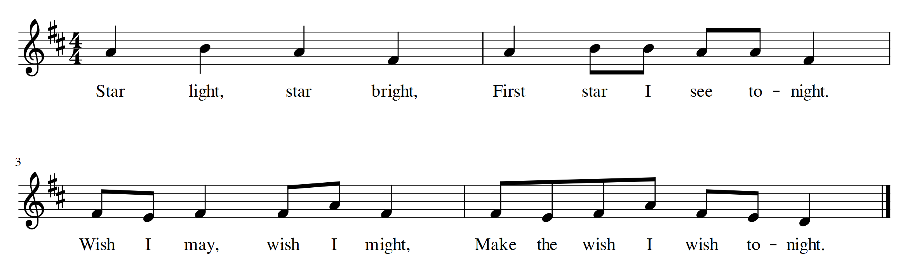  Sing the song using the rhythm syllables and following the stick notation.  Stick Notation Rhythm syllables  Ι Ι Ι Ι ta, ta, ta, ta  Ι Π Π Ι ta, ti-ti, ti-ti, ta  Π Ι Π Ι ti-ti, tai, ti-ti, ta  Π Π Ι Ι ti-ti, ti-ti, ta, ta  Once secure, draw two pictures on the board: one of a star and one of a drum.  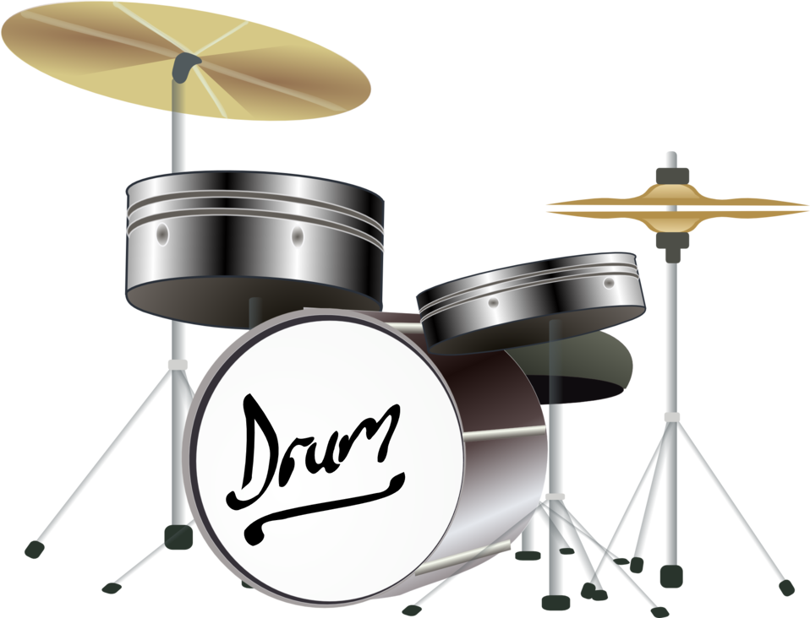  When pointing at the drum, learners should sing the rhythm syllables.  When pointing at the star, learners should sing the lyrics of the song. | This prepares learners for so, la, mi songs in Stage 3.  This score is for your use. Do not show it to learners as they have not learned the notes do, re and la.  The song is traditional and therefore freely available in audio versions online.  This part of the game can be extended to include singing in thinking voice but not sol-fa at this stage.  Repeat this activity with different songs about dark and light containing ta/ti-ti/sh rhythms, e.g ‘Twinkle Twinkle’.
2MM.01 Participate in music making with an increasing awareness of others.  2MM.02 Contribute to performances with mostly accurate timing and awareness of pulse and melodic shape.  2MM.04 Begin to demonstrate basic organisation of musical ideas when contributing to improvisations and compositions.  2MS.03 Recognise that there is a link between sounds and symbols. | Practising songs and skills  - Using any song from this unit, sing it in light and dark ways. Choose words which might describe singing in a dark or evil/sinister way. Ask learners to suggest or demonstrate what voices they can use. For example, they could use an angry or growling voice for dark, a high-pitched baby voice for light, or a soft, gentle, lullaby version of a song for light.  - Mark the ‘Rain, Rain’ song on the floor on a two-line floor stave (two parallel lines) made out of tape. Learners jump the song, i.e. jump on the top line for so and the bottom line for mi). You can also try this with any so/mi songs you have covered so far.  - Play games with rhythms written on a ball. For example, write four ta, ti-ti rhythms on a ball. Learners read one of the rhythms, then sing somebody's name and throw them the ball. The learner catches the ball, reads a rhythm, sings somebody's name and throw them the ball. Repeat.  - Compose and perform ta, ti-ti, sh patterns organised into groups of four beats, e.g.  Ι Π Π Ι  Ι Ι Ι Z  Π Ι Π Ι  Ι Ι Ι Z  Resources:  - Tape  - Ball | This is a useful activity for assessing how well learners are reading the rhythms, identifying how individual learners are reading and singing, in the fun form of a game.

Unit 2.5 Celebration

Unit 2.5 Celebration

Outline of unit:
In this unit, learners will select their favourite work from the year to revise, refine and perform as part of a final celebration. In addition, they will collect, learn and compose celebratory songs.

Recommended prior knowledge/previous learning:
So/mi rhythms and songs.

Language:
- feedback
- call
- response

Learning objectives | Suggested teaching activities and resources | Comments/Teaching notes
2MM.04 Begin to demonstrate basic organisation of musical ideas when contributing to improvisations and compositions.  2MS.01 Listen and respond to music through asking and answering questions and making sounds and movement.  2MS.02 Offer and accept suggestions for improvement to work. | Working in groups of four to six, learners choose a piece of their work from the previous units to revise, refine and perform as part of a final celebration.  Discuss with learners how we should choose our songs.  - Do we choose the song we like the best?  - Or do we choose the one we can perform the best?  Many of the songs work well as canons and rounds, so this may be an option for some learners to try, e.g. ‘Rain is Falling Down’ to prepare for work in Stage 3.  Learners may wish to perform one of the Unit 2 songs on an instrument.  They may wish to work on a song adding the pulse or simple ta, ti-ti rhythms on percussion, or compose their own music.  Set a date for the performance, choose the songs, invite as many parents and teachers as you can and ask learners to work out when they can practise between now and the concert.  Resources:  - Instruments (optional) | You will need to spend some time singing songs and going over work from previous units to remind learners before they make their choices.  It is important that learners revisit the work from previous lessons rather than performing other pieces, although you may consider allowing learners to perform other pieces in addition.  You may need to support composition with structure and guidance.  You may need to support learners with finding so and mi on an instrument (e.g. G and E on a piano).
2MM.01 Participate in music making with an increasing awareness of others.  2MM.02 Contribute to performances with mostly accurate timing and awareness of pulse and melodic shape.  2MS.02 Offer and accept suggestions for improvement to work. | Support learners to practise in lessons and independently for in-class performances in preparation for their final concert. Encourage learners to practise at home, in the playground, or at lunchtimes if school instruments are available.  On the board, write suggestions from the class on how a good music audience should behave and come to an agreement.  Once established, ask learners to perform their pieces for the rest of the class.  After each performance, ask the learners who form the audience questions, such as:  - Were they playing/singing together?  - Were they singing at the same pitch?  - Were they in time to the pulse?  - What was good about the performance?  - What could they do to make it even better?  - Did any movement match the music?  Ask the performers:  - What did they enjoy about the performance?  - How did they feel?  - What are they going to do to make it even better?  - Did the other learners behave as a good audience should?  Resources:  - Recording and play-back equipment (optional) | You may wish to make recordings of early attempts at songs and pieces, and compare them to recordings taken at the performance. Ask learners what has improved. This is very useful for assessing progress.  Be careful not to directly criticise learners' singing or musicianship and ensure that learners give their feedback in a positive way.  You may print out the questions and ask learners to write down answers in their music portfolios.  Encourage learners to use vocabulary such as pitch, pulse, high and low.
2MM.01 Participate in music making with an increasing awareness of others.  2MM.02 Contribute to performances with mostly accurate timing and awareness of pulse and melodic shape.  2MS.02 Offer and accept suggestions for improvement to work. | Learners perform their final concert.  Afterwards, ask learners:  - How did you feel before/during/after the concert?  - What was your favourite part?  - Would you do anything differently?  - Did the audience enjoy the show?  - Did the audience give any feedback?  - What did they think of the recording? (optional)  - What other jobs need to be done for a concert, other than performing? (e.g. lighting, sound, food, selling tickets and organising a venue)  Resources:  - Instruments  - Recording equipment (optional)  - Performance space and related facilities for the audience | You may print out the questions and ask learners to write down answers in their music journals.  Making a recording of the concert will be useful to share and discuss with learners.
2MM.01 Participate in music making with an increasing awareness of others.  2MM.02 Contribute to performances with mostly accurate timing and awareness of pulse and melodic shape.  2MS.03 Recognise that there is a link between sounds and symbols. | Encourage learners to think of all the celebrations we have in life, e.g. weddings, birthdays, harvest celebrations and celebration of achievements.  Ask learners:  Can you think of any music for any of these occasions? (e.g. ‘Happy Birthday’ or harvest songs).  Sing these songs whilst clapping or walking to the pulse. Encourage learners to create their own dance routines and movements.  Example: Perform the song ‘John Kanaka’.  Learn the song together as a class. Next, split the class in two, with half of the class singing the call (i.e. lines one and three) and the other half answering with the response. Once confident with the material, solo singers can sing the calls with the rest of the class providing the response.  Look at the following extracts with the class:  ‘I heard, I heard’  ‘To-day, to-day’  Explain that they use the notes so and mi.  Ask learners:  Can anybody work out the note names and sing them? (mi, so, mi, so) | These activities can be used at any time in this unit.  This score and sol-fa is for your use only. Audio versions are widely available.  This is a great song for building singing confidence.  Although printed in the key of D here, (D = Do) the piece can be sung in the key of C if you wish to make it easier to play with instruments.  Do = C  Re = D  Mi = E  So = G  Do not name all these notes to learners yet. Simply extract the so/mi refrains as described.  Learners may need prompting, e.g. by asking Does the song start on the low note (mi) or the high note (so)?
2MM.01 Participate in music making with an increasing awareness of others.  2MM.02 Contribute to performances with mostly accurate timing and awareness of pulse and melodic shape.  2MM.04 Begin to demonstrate basic organisation of musical ideas when contributing to improvisations and compositions.  2MS.03 Recognise that there is a link between sounds and symbols. | Write some lyrics for a celebration song using only ta, ti-ti, sh rhythms, for learners to add so/mi melodies to.  Present the song in stick notation and ask learners to write and sing a so or a mi above each stick. For example:  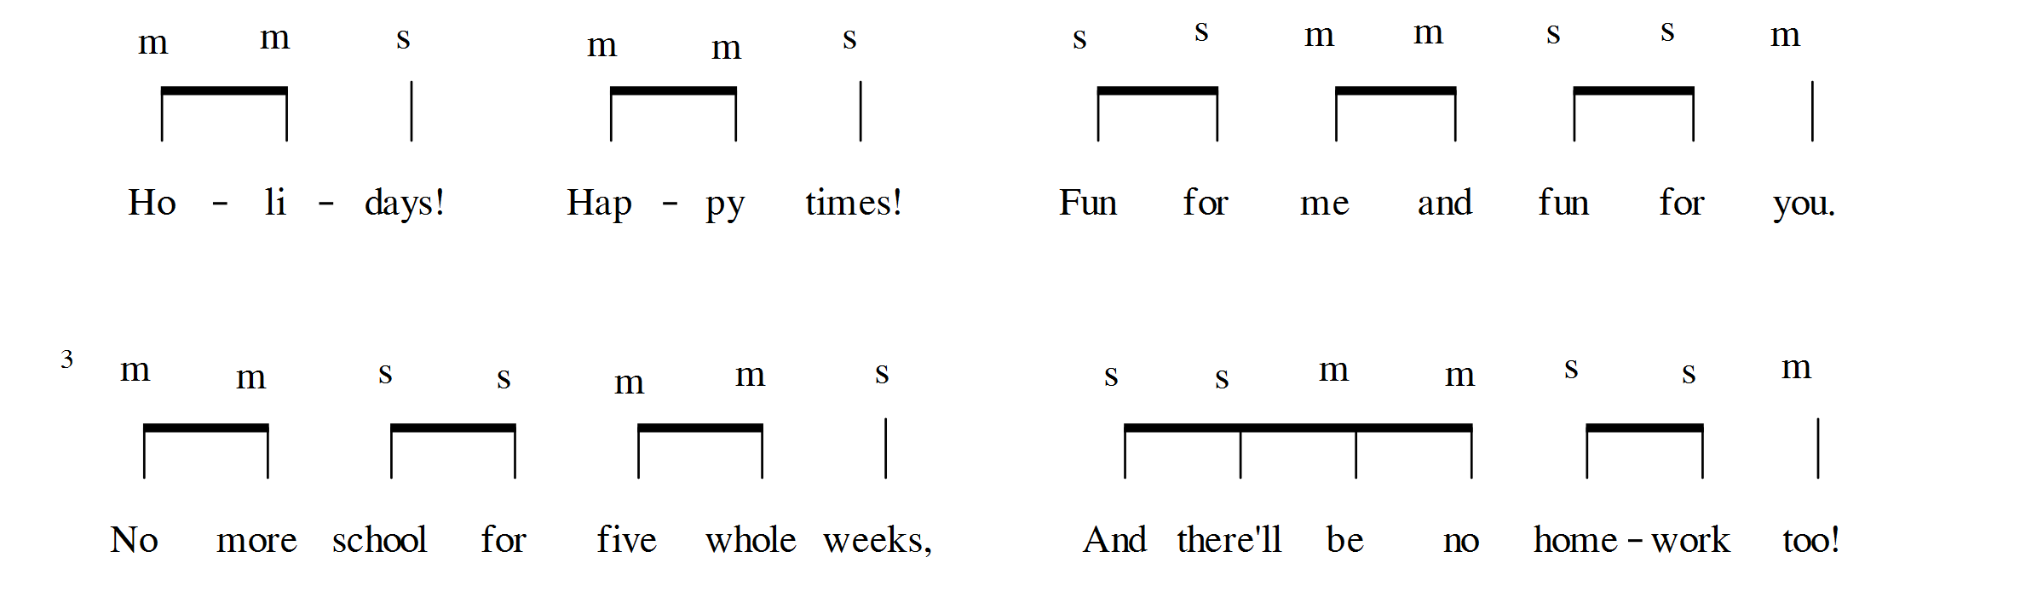  Ask learners to sing their song in three different ways:  - singing the tune that they have composed (using so and mi)  - singing the words to their own created tune  - singing the rhythm syllables (ti-ti and ta)  Working in pairs, learners teach each other their songs and sing them together. | Some learners may write their own lyrics to their so/mi melody with your support. For other learners, you may need to provide the lyrics and/or support them with the melody.  This can be completed on paper, but make sure learners are thinking musically and can sing what they have written with accurate timing. Recordings will encourage learners to think musically. Both written work and recordings can be added to learners’ musical journals.  You may need to practise the rhythm many times with learners to make it secure before they add sol-fa.

Sample lesson 1

CLASS:

DATE:
Learning objectives | 2MM.01 Participate in music making with an increasing awareness of others.  2MM.02 Contribute to performances with mostly accurate timing and awareness of pulse and melodic shape.  2MS.01 Listen and respond to music through asking and answering questions and making sounds and movement.
Lesson focus /  success criteria | This lesson focuses on associating pulse and melodic shape to movement as well as aural and visual stimuli in the context of so/mi songs. The lesson has activities to consciously practise and reinforce a common and individual sense of pulse, whilst preparing learners for basic music reading of pitch, including hand signs and sol-fa in later lessons. The link between sound and movement, and sound and vision, can later be applied to recognising the links between sounds and symbols.  The activities are designed to develop confidence for singing solo and as a whole class, increasing learners’ awareness of their role and the voices of others.  Learners will now begin to reflect on whether they can show the pulse, as well as high and low notes, accurately.
Previous learning | Learners should understand the meaning of the terms ‘pulse’ and ‘pitch’ and be able to demonstrate them.  Learners should already be familiar with a few songs only using so and mi.
Plan
Lesson | Planned activities | Notes
Introduction | Sing a circle song as learners enter or as the lesson begins, to sit learners in a circle.  For example:  (Sing ‘Make a circle’ to the tune of ‘Frere Jacques’.)  Make a circle, make a circle,  Big and round, big and round.  Everybody hold hands, everybody hold hands,  All around, all around.  (Repeat until learners are standing in a circle, holding hands. Once the circle is formed, learners can stop holding hands.)  Sing ‘Hello everyone’ to so and mi notes, for each syllable, and invite learners to copy you, standing tall for the high notes and crouching for the low notes.  For example:  ‘Hel- lo ev- 'ry one’  ( so, mi, so, so, mi )  (stand, crouch, stand, stand, crouch)  Try the same melody with different animal voices (e.g. ‘quack, quack’, ‘squeak, squeak’, ‘roar, roar’), encouraging learners to sing as high and low as you and to sing together with good posture (as slouching is not good for singing). Do not sing in a voice with an unclear pitch such as whispering or growling. You may sing at different speeds.  Learners may not match your pitch at this stage. If they sing together but at a different pitch, repeat ‘Hello everyone’ at the pitch they sing it. Then try changing the pitch to see if they pick up on it and match you. Do not worry too much about pitch at this stage. It is more important that learners use their singing voices, sense of pulse and an unconscious awareness of high and low pitches. Encourage learners (and any other adults present) to listen carefully and sing the same as you.  You may let confident volunteers sing ‘Hello everyone’ in an animal voice for the class to copy. | Do not sing in sol-fa yet as this has not yet been presented to learners.  Make sure you pitch notes at an easy range for learners to sing.  This activity prepares the melody and game for ‘Hey, Hey’, as well as acting as a warm up.
Main activities | Sing ‘Hey, Hey’ (Do not show this score to learners.)  Model a couple of turns yourself (you sing, learners copy), doing an animal and pulse action, and then invite learners to take a turn. Do not force or cajole reluctant volunteers, but insist that learners listen carefully to everybody's turn.  Show learners the high and low pitches again by singing the song. This time, stand tall for the high notes and crouch down for the low notes. Ask learners:  What was I showing by standing and crouching?  (Accept ‘high and low’ as an answer but explain that the word ‘pitch’ means how high or low we sing).  Sing the instruction ‘sit down’ and sing ‘Hey, Hey’ again, performing a large, simple movement to the pulse and ask learners to copy you. Ask learners:  What was I showing with this action? (the pulse)  Choose an item to pass around the circle, to the pulse, as you sing ‘Hey, Hey’. At the end of the song, the learner holding the object gets to choose the voice for the next repeat.  Remind learners that the pulse stays steady throughout. After singing the song a few times, encourage learners to watch the pulse around the circle. Ask learners questions, such as:  - Did the pulse stay the same, or did it go faster or slower?  - Where in the circle did the pulse go slower or too quickly?  Get out a parachute, encouraging learners to remain seated in the circle. When they are ready to pick it up, invite them to hold it and sing the instruction ‘Stand up’.  Ask them to perform ‘Hey, Hey’ again, this time using the parachute to show the pulse and high/low pitch. Ask the class:  Did it start on the high or the low note? (high)  Play or sing ‘High, Low’ and ‘Reach for the Sky’.  ‘High, Low’  ‘Reach for the Sky’  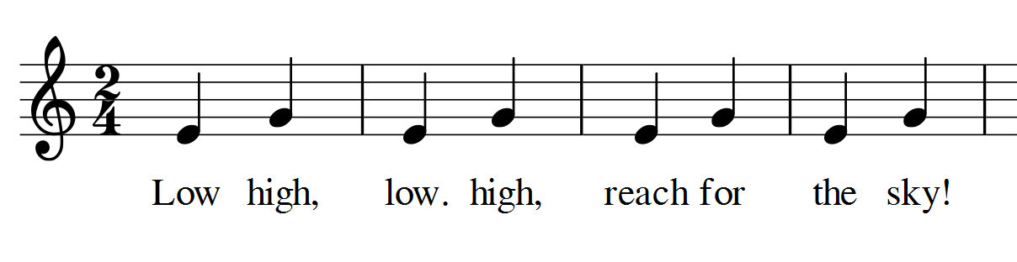  Ask learners:  Which note does each song start on?  The high note or the low note?  Hum or play on an instrument and see if learners can show you with the parachute where it starts.  Sing the songs a few times, moving the parachute up and down.  Repeat with smaller groups with small parachutes. | If the pitching of so/mi starts to waver, lead a couple of turns yourself, or ask an accurate singer to do so.  Do not point out individuals, but areas of the circle, and encourage learners to do the same.  These games can be played without a parachute, e.g. with a sheet or by learners raising and lowering their arms to mime moving a parachute.
End/Close/ Reflection/ Summary | Ask individual volunteers to perform ‘High, Low’, ‘Hey, Hey’ or ‘Reach for the Sky’ with their eyes closed and moving an imaginary parachute.  Ask other learners:  - Were they keeping to a pulse?  - Were they showing and singing high and low correctly?  - Was it a fast or slow pulse? | Asking learners to complete the activity with their eyes closed is useful for informal teacher assessment, to see which learners are copying others and which learners have internalised the pitch and pulse.

Reflection
Use the space below to reflect on your lesson. Answer the most relevant questions for your lesson.
Were the learning objectives and lesson focus realistic? What did the learners learn today?
What was the learning atmosphere like?
What changes did I make from my plan and why?
If I taught this lesson again, what would I change?
What two things really went well (consider both teaching and learning)?
What two things would have improved the lesson (consider both teaching and learning)?
What have I learned from this lesson about the class or individuals that will inform my next lesson?

Next steps
What will I teach next based on learners’ understanding of this lesson?

Sample lesson 2

CLASS:

DATE:
Learning objectives | 2MM.01 Participate in music making with an increasing awareness of others.  2MM.02 Contribute to performances with mostly accurate timing and awareness of pulse and melodic shape.
Lesson focus /  success criteria | UNIT 1.4 Light and Dark.  Practising reading rhythms from stick notation.
Prior knowledge / Previous learning | ‘Star Light’ song, ta, ti-ti rhythm syllables and stick notation.
Plan
Lesson | Planned activities | Notes
Introduction | Chant ‘Hel-lo ev'ryone’ (ta, ta, ti-ti, ta) whilst clapping the four pulses and ask the class to copy you. On the board or display, show learners the following rhythms:  Ι Ι Ι Ι  Ι Π Π Ι  Π Ι Π Ι  Π Π Π Ι  Ι Ι Π Ι  Ask learners:  Which rhythm did I say? (the bottom one, or number 5)  If learners struggle to recognise the rhythm, go through each one, reading the rhythm and then comparing it to ‘hel-lo ev’ryone’.  Rub out/remove the bottom line:  Ι Ι Π Ι  Tell learners that this is the rhythm of a song they already know. See if any learners already recognise it, but make sure they only put their hand up, or whisper the answer to you, so that others can carry on guessing.  Read the rhythm syllables to the stick notation together. Again, without them telling anyone the answer, see if any more learners can name the songs.  If a large number of learners still do not know the answer, hum the melody of ‘Star Light’ for learners. Tell them that, after a countdown of three, you want them to all shout out the answer together.  Perform your favourite quick vocal warm-ups and ask learners to stand with good posture. | Π
Main activities | Repeat singing ‘Star Light’ with dark and light voices suggested by learners, following the stick notation. Dark voices could include scary and troll-like, and light voices could include baby and singing voice.  ‘Star Light’ rhythm (stick notation):  Ι Ι Ι Ι  Ι Π Π Ι  Π Ι Π Ι  Π Π Π Ι  ‘Star Light’ score (for your use only):  Invite a few learners to sing wishes, then sing the rhythm syllables to the tune of the song together, following the stick notation. Point out each beat as learners sing using a baton or stick.  Rub out the first two lines from the board, so that you are left with:  Π Ι Π Ι  Π Π Π Ι  Ask learners to chant the rhythm syllables. Say to learners that this is very similar to a new song you are thinking of, but one of the ti-tis needs to change to a ta. Ask learners:  Can you work out which one it is?  Hum the rhythm of ‘Copy Cat’ as you point to each syllable as you hum it. Ask learners:  Is it the same?  See if any learners can spot that the third ti-ti in the final line needs to change to a ta.  Change the ti-ti to a ta so that you are left with the rhythm of ‘Copy Cat’:  Π Ι Π Ι  Π Π Ι Ι  See if the whole class, groups or individuals can read the rhythm from the board.  Below is the score and sol-fa for ‘Copy Cat’, for your use only. The score and audio versions are freely available online.  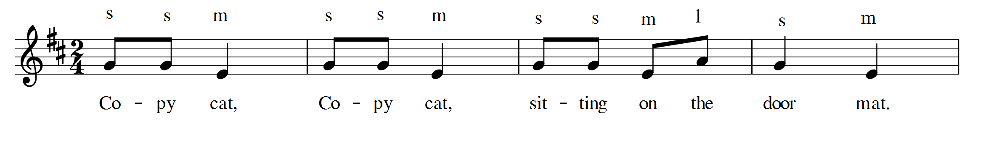  Sing ‘Copy Cat’ for learners. Explain that you are going to play a game with them. First, they have to copy what you do. Make sure you do pulse actions, as you sing.  After learners have copied you a few times, ask them:  With my actions, was I showing the pulse or the rhythm? (pulse)  Next, sing ‘Copy Cat’, this time doing an action exactly to the rhythm (ti-ti, ta, ti-ti, ta, ti-ti, ti-ti, ta, ta).  Ask learners:  What was different about my actions that time?  Accept answers such as ‘there were more hits’ or ‘there were more syllables/claps on each beat’ but guide learners to use the words ‘rhythm’ and ‘pulse’. Learners may notice that the pulse stays the same, whilst the rhythm matches the words. Do not accept ‘it was faster’ to describe the rhythm. Explain and demonstrate how the speed was the same.  See if learners can tell the difference between the pulse and the rhythm as you demonstrate both versions of ‘Copy Cat’.  This can then become an extra dimension to the game. Learners copy you if it is the pulse, but do not copy if it is the rhythm. Once learners show a good understanding of the game, allow individual learners to lead the game. | Show learners the stick notation, but not the score.
End/Close/ Reflection/ Summary | Before the lesson, prepare a number of four-beat rhythms in stick notation and write them on a football or similar item.  Standing in a circle and using this ball, learners must read a rhythm, sing somebody's name, and then throw them the ball. That person has to read a rhythm and then choose somebody else. Repeat until all learners have had a turn. If learners speak the name rather than singing it, ask them to throw the ball again. | This is a useful classroom assessment activity for the lesson and should be recorded by audio and video if possible.

Reflection
Use the space below to reflect on your lesson. Answer the most relevant questions for your lesson.
Were the learning objectives and lesson focus realistic? What did the learners learn today?
What was the learning atmosphere like?
What changes did I make from my plan and why?
If I taught this lesson again, what would I change?
What two things really went well (consider both teaching and learning)?
What two things would have improved the lesson (consider both teaching and learning)?
What have I learned from this lesson about the class or individuals that will inform my next lesson?

Next steps
What will I teach next based on learners’ understanding of this lesson?

Cambridge Assessment International Education
The Triangle Building, Shaftsbury Road, Cambridge, CB2 8EA, United Kingdom
t: +44 1223 553554 f: +44 1223 553558
e: info@cambridgeinternational.org www.cambridgeinternational.org

Copyright © UCLES September 2019

