Scheme of Work
Cambridge Primary
Music 0068
Stage 3

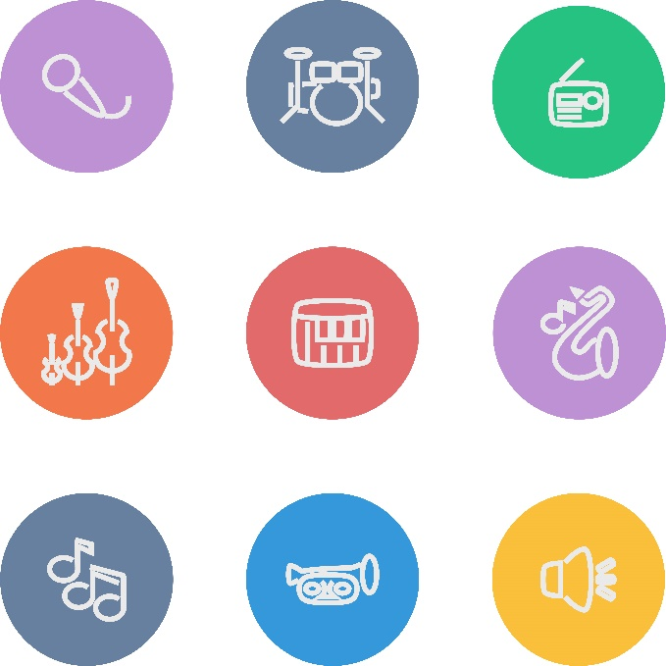
For use with the curriculum framework published in 2019

Copyright © UCLES September 2019
Cambridge Assessment International Education is part of the Cambridge Assessment Group. Cambridge Assessment is the brand name of the University of Cambridge Local Examinations Syndicate (UCLES), which itself is a department of the University of Cambridge.

UCLES retains the copyright on all its publications. Registered Centres are permitted to copy material from this booklet for their own internal use. However, we cannot give permission to Centres to photocopy any material that is acknowledged to a third party, even for internal use within a Centre.

Contents

Contents 3
Introduction 4
Unit 3.1 Rhythm and pulse 6
Unit 3.2 Soundscapes, layering sounds and rounds 14
Unit 3.3 Ostinato and texture 18
Unit 3.4 The hummingbird sings 24
Unit 3.5 Celebration 29
Sample lesson 1: 34
Sample lesson 2: 37

Introduction

This document is a scheme of work created by Cambridge Assessment International Education for Cambridge Primary Music Stage 3.

It contains:
- suggested units showing how the learning objectives in the curriculum framework can be grouped and ordered
- at least one suggested teaching activity for each learning objective
- a list of subject-specific language that will be useful for your learners
- sample lesson plans.

You do not need to use the ideas in this scheme of work to teach Cambridge Primary Music Stage 3. It is designed to indicate the types of activities you might use, and the intended depth and breadth of each learning objective. These activities may not fill all of the teaching time for this stage. You may choose to use other activities with a similar level of difficulty.

The accompanying teacher guide for Cambridge Primary Music will support you to plan and deliver lessons using effective teaching and learning approaches. You can use this scheme of work as a starting point for your planning, adapting it to suit the requirements of your school and needs of your learners.

Long-term plan
This long-term plan shows the units in this scheme of work and a suggestion of how long to spend teaching each one. The suggested teaching time is based on 30 hours of teaching for Music Stage 3. You can adapt the time, units and order of the units based on the requirements of your school and the needs of your learners.

Unit and suggested order | Suggested teaching time
Unit 3.1 Rhythm and pulse | 6 hours
Unit 3.2 Soundscapes, layering sounds and rounds | 6 hours
Unit 3.3 Ostinato and texture | 6 hours
Unit 3.4 The hummingbird sings | 6 hours
Unit 3.5 Celebration | 6 hours
Total | 30 hours

Sample lesson plans
You will find two sample lesson plans at the end of this scheme of work. They are designed to illustrate how the suggested activities in this document can be turned into lessons. They are written in more detail than you would use for your own lesson plans. The Cambridge Primary Music Teacher Guide has information on creating lesson plans.

Other support for teaching Cambridge Primary Music Stage 3
Cambridge Primary centres receive access to a range of resources when they register. The Cambridge Primary support site at https://primary.cambridgeinternational.org is a password-protected website that is the source of the majority of Cambridge-produced resources for the programme. Ask the Cambridge Coordinator or Exams Officer in your school if you do not already have a log-in for this support site.

Included on this support site are:
- the Cambridge Primary Music Curriculum Framework, which contains the learning objectives that provide a structure for your teaching and learning
- grids showing the progression of learning objectives across stages
- the Cambridge Primary Music Teacher Guide, which will help you to implement Cambridge Primary Music in your school
- templates for planning
- worksheets for short teacher training activities that link to the teacher guide
- assessment guidance (to support classroom assessment)
- links to online communities of Cambridge Primary teachers.

Resources for the activities in this scheme of work
We have assumed that you will have access to these resources:
- paper, pens and pencils for learners to use, including manuscript paper
- space for learners to work in different groupings (individual, pair, groups, whole-class) on different types of activity (listening to music, composing, rehearsing, performing)
- a range of musical instruments, for example, tuned and untuned percussion
- equipment for playing recorded music to learners
- audio or video recording equipment
- music portfolios where learners can record their music making at all stages of development.

Other suggested resources for individual units and/or activities are described in the rest of this document. You can swap these for other resources that are available in your school.

Websites
There are many excellent online resources suitable for teaching Cambridge Primary Music. Since these are updated frequently, and many are only available in some countries, we recommend that you and your colleagues identify and share resources that you have found to be effective for your learners.

Approaches to teaching Cambridge Primary Music Stage 3
The learning objectives are organised into two strands which aim to integrate embodied learning in a holistic way.
- Making Music
- Making Sense of Music

Music portfolios
A music portfolio allows learners to document their experiments, rehearsals, performances and reflections which will help them to reflect on their progress and next steps. Learners should add to their portfolio regularly and this can be done either formally or informally. Depending on the availability of music technology it is likely that this portfolio will be a combination of audio/video recordings of rehearsals and performances, compositions (recordings and/or notations) and learner’s reflections (either written or recorded).

Teaching songs.
When teaching songs, or parts of songs, it is recommended that you use repetition to help learners remember the melody. A simple way to do this is for you to sing a line (phrase) and then ask learners to sing it back. If learners do not sing it back correctly at first, simply repeat the process until they can. For example, in a four-phrase melody, you could sing one phrase, then two together, then the whole song to gradually build learners’ memory. To support this process, you may also wish to use hand signs (e.g. sol-fa and Kodály-Curwen hand signs) when learners are learning or performing a song. Sol-fa gives every pitch a name and an accompanying hand sign to help learners build a picture of how a melody is constructed and the relationships between notes. The names for the notes are ‘do, re, mi, fa, so, la, ti, do’. You may want to research this further if you would like to use it with your learners.

Teaching notation
Not all styles of music use notation and understanding musical notation is not required in order to be a musician. However, having an awareness of notation is a useful skill for many learners, particularly those who go on to study for qualifications in music. Notation includes written representations (e.g. stave music) or ways to name notes (e.g. C D E or do, re, mi). By introducing ‘sound before symbol’ learners participate in lots of practical music making, which allows then to begin to hear notes in their head (internalised sounds), before they come to understand and use notation as a way to represent those sounds.

Differentiation and extension activities
For learners who require more challenge, try adding extra parts within the same piece of music that the class is learning. These parts could be instrumental or vocal and involve different rhythms (e.g. clapping one rhythm while singing another) or tunes (e.g. a new harmony line).

Unit 3.1 Rhythm and pulse

Unit 3.1 Rhythm and pulse

Outline of unit:
In this unit learners will recognise and understand the importance of rhythm and pulse. Through a range of activities, they will make music and be able to contribute to performances with growing awareness and accuracy of timing, using body percussion and a range of untuned percussion instruments.

Recommended prior knowledge/previous learning:
This unit builds on learners’ prior learning about untuned percussion. Learners should be confident in using instruments. They should have some skills in listening to music and responding to it through asking and answering questions, making sounds and movement, performing and other creative activities.

Language:
- rhythm
- pulse
- beat
- crotchet (ta)
- quaver (ti-ti)
- tempo
- duration
- silence
- timbre

Learning objectives | Suggested teaching activities and resources | Comments/Teaching notes
34MM.02 Contribute to performances with mostly accurate timing and with increasingly accurate tuning, control, and expression. | Listen to a variety of music and ask learners to march in time with the beat.  Experiment with stopping the music so learners stop and then start again.  Listen to music of different tempos (speeds) so learners can feel the beat and move with the music.  Introduce learners to crotchets and quavers. Show learners two soft toys, for example, a mother bear and a baby bear. Explain and demonstrate to learners that the mother bear walks in1-beat (crotchet or ta) steps and the baby bear walks in $\frac{1}{2}$-beat (quaver or ti-ti) steps.  Learners explore how the mother bear and the baby bear move in time to different pieces of music. You may wish to hold up a character and ask learners walk around the room using the correct step, alternating between characters so learners have to alternate between walking in 1-beat and $\frac{1}{2}$-beat steps.  Resources:  - Variety of music to play to learners  - Two different toys | You may wish to use this activity to help your learners find the beat and pulse of a piece of music.  You may introduce your learners to crotchets and quavers using any soft toys or other props: one large, which walks in 1 beat steps, and one small, which walks in$\frac{1}{2}$ beat steps.
34MM.01 Participate in unison and part singing or playing.  34MM.02 Contribute to performances with mostly accurate timing and with increasingly accurate tuning, control, and expression. | Ask learners to sit in a circle and clap a steady beat to create a pulse. Practise this until all learners are clapping in time.  Ask learners to pause clapping. Explain that they are now going to add a spoken part to the pulse. Learners introduce themselves and the person to their right, while keeping in time with the pulse, using a sentence such as ‘My name is … and this is …’  Ask learners to begin clapping a steady beat again to create a pulse and then demonstrate the first introduction ‘My name is … and this is …’  The learner to your right then says their name and introduces the learner to their right, and so on until the full circle of learners have spoken.  This activity could be repeated with other sentences. For example, ‘My favourite food is … What is yours?’ | Where learners find it hard to coordinate clapping the pulse and speaking at the same time, they may wish to just say their name in time to the pulse, while the rest of the class continues to clap.  Encourage learners to speak clearly and to keep in time with the beat.
34MM.01 Participate in unison and part singing or playing.  34MM.02 Contribute to performances with mostly accurate timing and with increasingly accurate tuning, control, and expression. | Clap a rhythm and ask the class to clap it back to you. Repeat this with a variety of different rhythms.  Then choose a phrase such as ‘Do not clap this one back’ and clap a rhythm as you speak the words. Ask learners to repeat saying the phrase whilst clapping the rhythm several times so that everybody recognises this rhythm. Once learners are familiar with this rhythm, explain that this is now the ‘forbidden rhythm’ and if they hear it, they must not clap it back.  Continue clapping different rhythms for the class to clap back, sometimes using the ‘forbidden rhythm’. If a learner hears the ‘forbidden rhythm’ they must not clap it back.  This activity could be extended by creating new ‘forbidden rhythms’. You could also ask learners to be the leader and clap the rhythms for the rest of the class to respond to. | This activity can be played as a game. You may wish to give learners 10 points each and if they clap back the ‘forbidden rhythm’ they lose a point. Or, if learners make a mistake, they could kneel on one knee, then kneel on two knees, then sit cross legged, etc. so that they are getting lower and lower but still joining in and practising the rhythms.
34MM.03 Experiment with and combine sounds for a given purpose. | Show learners a simple repeated rhythmic pattern (ostinato), using different ways of making sound using your body. For example, you may clap a rhythm, tap it on your legs, tap it on your head, stamp it with your feet, and so on.  You may wish to explore timbre with your learners. Ask learners questions to discuss as a class:  - How is the sound different when I tap the rhythm on my head compared to when I stamp it with my feet?  - Which sounds are louder and which are quieter?  Then ask learners to explore other ways of creating sound using their body in pairs or small groups.  Ask learners:  - How else could you create sound using your body?  - Do you have a favourite body percussion sound?  Select groups of learners to share their body percussion ideas with the class.  Then ask learners to individually create a short rhythm they could perform using body percussion sounds. Once each learner has created and practised their rhythm, ask learners to stand in a circle. Each learner performs individually, one after the other, to create a class body percussion piece. | Encourage learners to be creative and explore new ways to make sound with their body.  This activity could be recorded so learners can view or listen to their body percussion composition.
34MM.03 Experiment with and combine sounds for a given purpose.  34MS.03 Explore simple ways of scribing their own and others’ music, making the link between sounds and symbols. | Introduce learners to a rhythm grid with images, explaining that each box is worth one beat. For example:  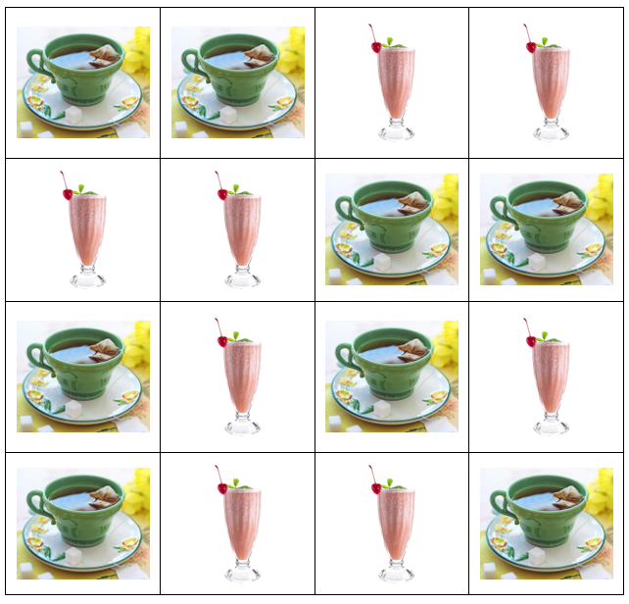  Explain to learners that in this rhythm grid the image of the tea represents 1 beat (crotchet or ta) and the image of the milkshake represents two $\frac{1}{2}$ beats (quaver or ti-ti).  Demonstrate to learners how the top row of the grid could be clapped (ta, ta,  ti-ti, ti-ti), whilst saying the words ‘Tea, Tea, Milkshake, Milkshake’. Ask learners to clap and repeat the first row back.  Once learners have understood how the rhythm grid works, explore as a class the patterns created by reading the grid in different directions. For example, starting from the top left and working down row by row, going down column by column, going diagonally, and so on.  This activity could be extended by asking learners to create their own rhythm grids using pictures of food, drinks, toys and so on.  Resources:  - Rhythm grids | This grid can be adapted to use images appropriate to suit your learners.  You may wish to experiment with adding different timbres for each image. For example, tea as clap or woodblock, milkshake as finger click or shaker, etc.
34MM.01 Participate in unison and part singing or playing.  34MS.03 Explore simple ways of scribing their own and others’ music, making the link between sounds and symbols. | Introduce learners to the rhythm grid below, explaining the notation and that each box is worth one beat.           Demonstrate to learners how to perform the rhythm from the rhythm grid and then perform from the grid by clapping as a whole class.  Ask learners:  - What do you notice about this rhythm grid?  - How many beats are there?  - How would you describe the rhythm we clapped?  Learners may notice that there are eight crotchet beats or that this rhythm grid creates a steady beat. Learners may comment on whether they are keeping in time as a class or whether the speed (tempo) is changing.  Show learners the following rhythm grid:          Ask learners:  - What do you notice about this rhythm grid?  - How is it different to the previous rhythm grid? How is it the same?  Ensure learners understand that beat three is silent, the other beats are all still crotchets and there are still eight beats in total. Perform this new grid as a class.  Then show learners the following rhythm grid:          Ask learners:  - What do you notice about this rhythm grid?  - How is it different to the previous rhythm grid? How is it the same?  Ensure learners understand there are two notes (quavers) in beat six. This means we clap twice in one beat. They should notice beat three is still silent and there are still eight beats in total. Perform this new grid as a class.  Show learners other rhythm grids using a combination of crotchets, quavers and rests, for example:               Learners work in pairs or small groups to practise reading the rhythm grids and clapping each of the rhythms together.  This activity could be extended by providing learners with empty eight beat rhythm grids for them to scribe their own rhythms.  Resources:  - Rhythm grids | Learners can perform the rhythms using clapping, other body percussion or untuned percussion instruments.
34MM.01 Participate in unison and part singing or playing.  34MM.02 Contribute to performances with mostly accurate timing and with increasingly accurate tuning, control, and expression.  34MM.03 Experiment with and combine sounds for a given purpose.  34MM.04 Contribute short fragments to improvisations and compositions which respond coherently to a range of given or chosen stimuli.  34MS.01 Listen and respond to music, beginning to use technical language accurately to describe features of the music.  34MS.03 Explore simple ways of scribing their own and others’ music, making the link between sounds and symbols. | Show learners the rhythm grid below:            Select two learners to perform the rhythm grid in parts. One learner performs the top row whilst the other learner simultaneously performs the bottom row.  Ask learners:  - What do you notice about the rhythms?  - Which beat did you clap together? (beat five)  - Which beat did neither of you clap? (beat four)  Show learners another rhythm grid which includes quavers. Split the class into two groups and perform the rhythm grid in two parts. One half of the class performs the top row whilst the other half performs the bottom row:               Then ask learners to work in pairs to create their own rhythmic composition using crotchets (ta), quavers (ti-ti) and rests. Their composition needs two parts and they scribe their composition using rhythm grids with two rows:  Encourage learners to experiment with sound and create a performance using body percussion or untuned percussion instruments. Learners perform their composition to the rest of the class.  This activity could be extended by asking learners to join another pair of learners to make a small group. They try combining their compositions to create a four-part rhythm grid and perform this together.  Ask learners:  - Was the composition nice to listen to?  - What could have been better?  - Can you improve the four-part composition?  Encourage learners to consider how they could adapt their composition to make improvements. For example, they may add more rests if they felt there were too many people clapping at once.  Resources:  - Rhythm grids | You may provide an empty rhythm grid for learners to use or ask them to create their own. This activity works best with learners working in pairs or small groups but could be demonstrated first as a whole class first.  Once learners have created their rhythm grid they rehearse and perform it.

Unit 3.2 Soundscapes, layering sounds and rounds

Unit 3.2 Soundscapes, layering sounds and rounds

Outline of unit:
In this unit learners will learn about soundscapes, layering sounds and rounds. Learners will focus on singing (including in rounds), being playful, experimenting and improvising with sounds, using voices and musical instruments. Learners will begin to understand how melodies and rhythms are constructed, making connections between sound and symbol, and becoming further aware of roles within a group.

Recommended prior knowledge/previous learning:
Awareness of pitch and rhythm

Language:
- soundscape
- dynamics (volume)
- texture (layers)
- rounds
- pitch
- silence
- timbre

Learning objectives | Suggested teaching activities and resources | Comments/Teaching notes
34MM.01 Participate in unison and part singing or playing.  34MM.03 Experiment with and combine sounds for a given purpose.  34MS.03 Explore simple ways of scribing their own and others’ music, making the link between sounds and symbols. | Tell learners a farm environment is being represented using images, shapes and words. Show learners a graphic score of a farm soundscape, such as the one below:  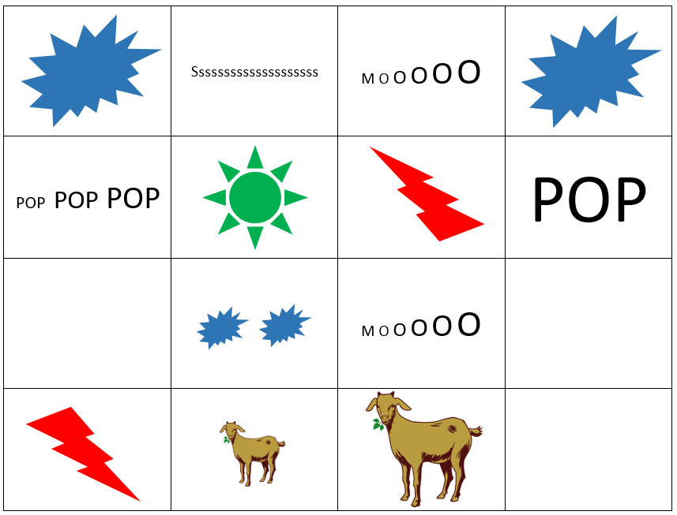  Ask learners to discuss in pairs:  - What sounds do you think the pictures represent?  - Would the music change in volume (dynamics) at any point? Why or why not?  - How might this soundscape be performed?  Performing in unison  As a whole class, experiment with different sounds for the different symbols and images and agree on how each line of the soundscape should be performed. Perform the soundscape all together (in unison), a line at a time.  Performing in parts  When learners are confident with the sounds in each line of the soundscape, try performing the soundscape as four separate parts. Divide the class into four groups and ask each group to perform a different line of the soundscape simultaneously.  Performing a round  When learners are confident with performing the soundscape as four separate parts try performing the soundscape as a round. Divide the class into four groups. Group 1 start and perform each line in turn. Group 2 enters when Group 1 is at the end of the first line. Group 3 enters when Group 2 are at the end of the first line and Group 4 enters when Group 3 are at the end of the first line.  Resources:  - Graphic scores | Encourage learners to create sounds to represent a real or imaginary environment.  Examples of sounds that you may share could be:  A sound of a chicken  A sound of a cockerel  A sound pattern going from high  to low pitches, or from quiet to  loud  You may try this is a variety of ways to explore different performances.
34MM.04 Contribute short fragments to improvisations and compositions which respond coherently to a range of given or chosen stimuli.  34MS.02 Demonstrate an understanding of how work can be improved to suit intentions.  34MS.03 Explore simple ways of scribing their own and others’ music, making the link between sounds and symbols. | Ask learners to work in small groups to create their own graphic score of a soundscape. Learners decide on a location for their soundscape, for example a zoo, a park, a beach, etc.  Ask learners to discuss the following:  - What types of sounds would be suitable in your soundscape?  - How would these be shown using images, shapes or words?  - Will any part need to be quieter or louder?  Learners create their own soundscape using voices and instruments and score it using a grid, like that in the farm soundscape example above.  You may wish to encourage learners to think about how they will vary their performance using dynamics (volume), different timbres (different sounds created by instruments), different textures (layers) and use of silence.  Resources:  - Blank 4 × 4 grids (optional) | You may wish to provide your learners with a blank 4 × 4 grid or ask them to create their own for this activity. Learners can then create a graphic score to represent their soundscape.
34MM.04 Contribute short fragments to improvisations and compositions which respond coherently to a range of given or chosen stimuli.  34MS.02 Demonstrate an understanding of how work can be improved to suit intentions. | Explain to learners that they are going to create a class song. First, as a class, they are going to create the words (lyrics) for their song.  Ask learners:  - What is your class song going to be about?  - Will any of the lines of your class song rhyme?  Once a topic has been chosen, ask learners to work in pairs to write a line for the class song.  After a set time ask pairs of learners to get into groups of four to share their work and ideas: Can you create two lines for the class song that would work together?  Then each group shares their ideas with the class. Collate ideas on the board and put the lyrics together to create their class song.  Ask learners:  - Do you have any ideas about how the words for your class song can be improved?  Resources:  - Starting points for learner compositions in various formats such as pictures, audio clips, poems, props (optional) | You may wish to help structure the song. For example, each verse could have 4 lines. Decide how many verses you wish your learners to create for their class song. You may wish to aim for one verse and then extend this if possible, to develop and challenge your learners.  Poems, props and pictures could be used as starting points for creating words.
34MM.01 Participate in unison and part singing or playing.  34MM.02 Contribute to performances with mostly accurate timing and with increasingly accurate tuning, control, and expression.  34MM.04 Contribute short fragments to improvisations and compositions which respond coherently to a range of given or chosen stimuli. | As a class, tell learners to speak the words to the class song. Ask learners:  - Is there a natural rhythm?  - Can you clap the rhythm of the words of the song as you speak them?  Ask learners to individually explore melodies to fit the words of the song. They could sing or use instruments to explore different ideas.  Ask if any learners would like to share their ideas for the melody to the rest of the class. As a class, explore and select a melody for your class song.  Sing the class song altogether, with agreed rhythm, melody and lyrics.  Resources:  - Simple backing track (optional). This could be a recording or something played on a keyboard or guitar for instance.  - Simple music technology for audio recordings (optional) | You may wish to provide a backing track or accompaniment for learners to work alongside.  You may wish to use simple music technology for audio recordings.  Music portfolio: learners can add recordings of the rehearsals and performances, and their reflections, to their music portfolio.  You can support learners with this activity by offering pre-existing ideas and musical elements to use. For example, providing a collection of specific pitches and asking learners to put them in a particular order to create their melody.  Another way to support learners to compose a melody is to use colours to represent notes on a keyboard or xylophone. Learners choose a colour for each word in the lyrics and play the notes represented by these colours.

Unit 3.3 Ostinato and texture

Unit 3.3 Ostinato and texture

Outline of unit:
Learners will build on their understanding of how melodies and rhythms are constructed and explore how an ostinato or a repeated pattern can be used as a starting point. They will begin to use technical language, such as ostinato, texture, ground bass and basso continuo, to describe the features of music. They will make music by participating in unison and part singing or playing.

Recommended prior knowledge/previous learning:
Awareness of pitch and rhythm; confidence with singing

Language:
- ostinato
- texture
- ground bass
- basso continuo
- riff
- loop

Learning objectives | Suggested teaching activities and resources | Comments/Teaching notes
34MS.01 Listen and respond to music, beginning to use technical language accurately to describe features of the music.  34MM.01 Participate in unison and part singing or playing.  34MM.03 Experiment with and combine sounds for a given purpose. | Introduce learners to the musical terms: ostinato, riff and loop.  Play learners a song with a rhythmic repeated pattern (ostinato), for example, ‘We Will Rock You’ by Queen. This song has a ‘stamp-stamp-clap’ pattern. Encourage learners to join in. This pattern can be performed throughout the song as a repeated pattern.  Divide the class into four groups. Each group explores ostinato using body percussion, following a different pattern:  Group 1 Stamp- Stamp Clap Stamp- Stamp Clap  Group 2 Clap Tap head Clap Tap head  Group 3 Tap thighs Tap thighs Tap thighs  Group 4 Tap chest Tap chest- Tap chest  Once learners are confident with their group’s pattern, ask them to perform their parts all together as a class. Ask learners:  - What can you tell me about the different sounds that are created?  Explain to learners that texture in music is the layer of sounds, for example, a thick texture may have all four parts performing at the same time. A thin texture may have each part performing individually. As a class, explore different textures, for example, learners can perform their patterns as a round to build up the texture. Start with Group 1 and point to each group as a visual cue for when they can start their pattern.  Organise learners into groups of four or eight (with two learners to a part). Ask learners to compose their own body percussion piece using different repeated patterns (ostinatos).  Give each group time to rehearse and then to perform to the rest of the class.  Resources:  - An audio recording of a song with a rhythmic repeated pattern | An ostinato is a repeated pattern of notes. In pop music it is referred to as a riff or loop. All three words mean the same thing.  Encourage learners to join in with the repeated pattern.
34MS.01 Listen and respond to music, beginning to use technical language accurately to describe features of the music.  34MM.01 Participate in unison and part singing or playing.  34MM.03 Experiment with and combine sounds for a given purpose.  34MS.03 Explore simple ways of scribing their own and others’ music, making the link between sounds and symbols. | Play learners examples of Samba music. Introduce learners to the different types of instruments used in Samba. You could show pictures or videos if the instruments themselves are unavailable.  Explain to learners that in Samba music each instrument has its own ostinato to play.  Introduce learners to spoken parts that reflect an ostinato for each instrument and clap the pattern for each instrument. For example:  Part 1 e.g. surdo 1, 2, 3, music  Part 2 e.g. tambourim I can play, I can play  Part 3 e.g. shaker/chocalho Shake it, shake it, shake it, shake it  Part 4 e.g. agogô/bell High, low low, high, low low  Ask the whole class to speak through each part. Ask learners:  - What can you tell me about the parts?  - Does one part act as a timekeeper to create a steady beat (pulse)? If so, which one?  Divide the class into four groups, with each group taking one part. Part 1 begins to clap or say their part, creating a steady beat. Then bring the other parts in one at a time. If available, this could be repeated using the relevant instruments.  Tell learners that they will compose their own Samba ostinato. As a class, choose four different words. These could be foods, colours or places, for example: Apple, Pear, Potatoes, Cauliflower.  Put these together into four different ostinatos, for example:  Apple Apple Apple Apple Apple Apple Apple Apple  Pear Pear  Potatoes Potatoes  Cauliflower Cauliflower Cauliflower  Perform this as a class and experiment with different ways of bringing each part in and out.  This activity could be extended by asking learners to compose rhythmic ostinatos to produce a Samba piece in smaller groups, before rehearsing and performing to the rest of the class.  Resources:  - Recordings of Samba music  - Samba instruments or pictures of Samba instruments | You could explore the following instruments used in Samba music: surdo, repinique, ganzá, chocalho, tamborim, agogô  The surdo pattern is ta, ta, ta, ti-ti or crotchet, crotchet, crotchet, 2 quavers.  The tambourim pattern is ti-ti, ta, ti-ti, ta or 2 quavers, crotchet, 2 quavers, crotchet.  The shaker pattern is ti-ti, ti-ti, ti-ti, ti-ti or 8 quavers.  The agogô pattern is ta, ti-ti, ta, ti-ti or crotchet, 2 quavers, crotchet, 2 quavers.  You could explore texture here by bringing parts in and out. You may wish to have a signal to do this. In Samba music, a leader would act as a conductor and may give a signal to stop or start a section.
34MS.01 Listen and respond to music, beginning to use technical language accurately to describe features of the music.  34MM.02 Contribute to performances with mostly accurate timing and with increasingly accurate tuning, control, and expression.  34MM.01 Participate in unison and part singing or playing. | Play a classical ostinato for learners, for example, Pachelbel’s Canon. Ask learners:  - Can you identify whether the music sounds happy (major) or sad (minor)?  - Can you hear the repeated pattern played by the bass instruments (ground bass)? Can you hum these notes?  - Which instruments can you hear?  Once learners have identified the ground bass part, encourage them to choose a sound, e.g. ‘la’, or a phrase, e.g. ‘I love music, I love music’, and sing the repeated pattern phrase.  Once learners are confident with the ground bass part, experiment with adding extra layers. such as:  - rhythmic ostinato with percussion instruments or body percussion  - a simple drone (for example, the notes D and A for Pachelbel’s Canon) using a pitched instrument  Resources:  - A recording of a classical or baroque piece containing an ostinato, for example, Pachelbel’s Canon | Pachelbel’s Canon is the first movement of ‘Canon and Gigue in D major’ composed by German Baroque composer Johann Pachelbel. It was originally scored for three violins and basso continuo.  You may wish to explain to learners that ground bass is a long repeating pattern played by bass instruments and basso continuo is the name of the group of instruments playing this bass part. This can be a keyboard part (organ or harpsichord) with one other instrument (cello or bassoon). Basso continuo is from the baroque period- see above comment.  A drone is a repeating single note or chord.  Using audio recording equipment you may wish to record learners’ performances.  Music portfolio: learners can add recordings of the rehearsals and performances, and their reflections, to their music portfolio.
34MS.01 Listen and respond to music, beginning to use technical language accurately to describe features of the music.  34MM.04 Contribute short fragments to improvisations and compositions which respond coherently to a range of given or chosen stimuli. | Play learners a recording of another song that uses ostinato, for example ‘Mars’, one of the seven movements from Gustav Holst’s The Planet Suites. Ask learners to draw a picture or write words whilst the music is playing to show what they think the music might be about.  Give learners rhythmic notation of the ostinato heard right at the beginning and throughout the majority of the movement:  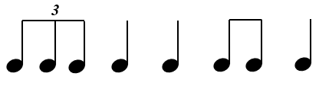  Ask learners to clap this ostinato while the music is played. Once they are confident with the pattern, ask them to perform it using body percussion, untuned and tuned instruments.  Using the rhythm of this ostinato, learners may try to compose their own melody and drone accompaniment.  Resources:  - A recording of another song that uses ostinato, for example, ‘Mars’, one of the seven movements from Gustav Holst’s The Planet Suites | You may wish to provide your learners with a set of notes to use such as a pentatonic scale: C D E G A.  A drone part can be created using notes D and A together.
34MM.01 Participate in unison and part singing or playing.  34MM.02 Contribute to performances with mostly accurate timing and with increasingly accurate tuning, control, and expression.  34MM.04 Contribute short fragments to improvisations and compositions which respond coherently to a range of given or chosen stimuli.  34MM.03 Experiment with and combine sounds for a given purpose.  34MS.02 Demonstrate an understanding of how work can be improved to suit intentions.  34MS.03 Explore simple ways of scribing their own and others’ music, making the link between sounds and symbols. | Encourage learners to reflect on the different ways ostinatos have been used in the music they have encountered in this unit.  Ask learners to create their own ostinato. Remind learners they could start by creating a rhythmic ostinato by using phrases or their favourite foods, for example:  Juice, Juice, Water, Juice  (ta, ta, ti-ti, ta or crotchet, crotchet, 2 quavers, crotchet)  Apples, pears, yoghurts, cake  (ti-ti, ta, ti-ti, ta or 2 quavers, crotchet, 2 quavers, crotchet)  Tell learners that they are going to experiment with their ostinato in different ways, for example:  Varying pitch  Learners can experiment with playing their ostinato using different pitches.  Adding texture  To create texture, learners can add different layers to their ostinato composition, such as:  - playing the ostinato using two or more notes at the same time (finding notes that complement each other and/or clash in sound)  - using two or more instruments to play the ostinato.  Challenge learners by asking:  - Can you create different moods for your ostinato?  - Can all instruments play together and then experiment with layers by taking out and adding in instruments?  Performance  Once learners have rehearsed their ostinato compositions, give them time to perform them to the rest of the class. You may wish to record learners’ performances using audio recording. Some learners may wish to experiment with notating their work using graphic or traditional notation.  Resources:  - Simple music technology for audio recordings (optional) | You may wish to give some guidance about which notes to use (pentatonic scales, simple scales) or leave this open for experimentation.  Music portfolio: learners can add recordings of the rehearsals and performances, and their reflections, to their music portfolio.  You may ask learners to give feedback on other group performances such as two things that went well and something that the group may wish to think about to improve their composition or performance. This may be in the form of two stars and a wish.

Unit 3.4 The hummingbird sings

Unit 3.4 The hummingbird sings

Outline of unit:
In this unit learners will learn mostly through whole class and group learning. They will use their voices in different ways, including humming, to create and perform music; they will also consider the impact of different lyrics. Learners will begin to understand how melodies and rhythms are constructed, using bodies and other mediums to make connections between sound and symbol; they will also further their awareness of roles within a group.

Recommended prior knowledge/previous learning:
Awareness of pitch, rhythm and texture; confidence with singing

Language:
- crotchet (ta)
- quaver (ti-ti)
- pulse
- pitch
- rounds
- dynamics
- texture

Learning objectives | Suggested teaching activities and resources | Comments/Teaching notes
34MM.01 Participate in unison and part singing or playing.  34MS.01 Listen and respond to music, beginning to use technical language accurately to describe features of the music. | Play learners a recording of a piece of music which includes humming, such as the ‘Humming Chorus’ from Madama Butterfly. As they listen, ask learners to write some key words that best describe the music, such as, calm, peaceful, etc. Learners could also draw images to represent the music:  - How would you draw the humming sound?  - What quality does it have?  Ask learners to consider the style of music, and where and when it might be performed.  After a vocal warm up, as a class, listen to the ‘Humming Chorus’ again. Ask learners to:  - move their hands or fingers to the shape of the music  - hum as they move around the room as a butterfly  - use their body to represent the pitch changes in the melody (for example, stand when higher and kneel when lower).  Challenge learners to hum the first and/or second phrase of the ‘Humming Chorus’ alongside the recording.  Resources:  - An audio recording of a piece of music which includes humming, such as the ‘Humming Chorus’ from Madama Butterfly | The Humming Chorus is from Puccini’s Madama Butterfly, which premiered in 1904. Puccini wrote the opera in Italy, but it is based in Japan. It is based on a short story ‘Madame Butterfly’ by John Luther Long. The humming chorus is a moment of calm and the finale from Act 2.  You may wish to follow a score as you listen and focus learning on the first two phrases. Each phrase is eight bars long.
34MM.01 Participate in unison and part singing or playing.  34MM.02 Contribute to performances with mostly accurate timing and with increasingly accurate tuning, control, and expression.  34MM.03 Experiment with and combine sounds for a given purpose. | After a vocal warm up, introduce a new short song, such as ‘AEIOU’:  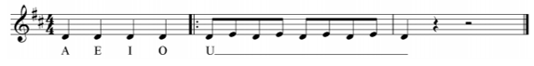  As a class, ask learners to perform the music in different ways. For example:  - clap the rhythm (ta, ta, ta, ta, ti-ti, ti-ti, ti-ti, ti-ti, ta)  - hum the melody  - speak the lyrics  - sing the tune  - sing the tune with their eyes closed  - sing the tune quietly  - sing whilst marching to the beat (pulse).  Ask learners to discuss the shape of the music:  - What do you notice about the pitches used? (Only two pitches are used, the first four notes are the same and the tune starts and ends on the same pitch)  Challenge learners to sing the song without taking a breath in the middle. Ask learners to sing facing a partner. The partner gives feedback on the performance, particularly focusing on when they did or did not breathe. Repeat the activity so the second learner also has the opportunity to perform and receive feedback.  Ask each pair to join another pair to make groups of four. In their groups, learners create and rehearse their own performance of the song. Learners may wish to try singing quietly, humming, singing loudly or performing the piece as a round.  Give learners time to perform their ‘AEIOU’ group creations for the rest of the class. Following the performance, ask learners to consider what went well in their performance and things they may do differently next time.  Resources:  - A new short song, such as ‘AEIOU’ | This song uses English language vowel sounds. The vowels are the sounds that are heard in songs. You may wish to make use of your local language if this will help learners with their creativity.  You may wish to teach learners this song using a call and response technique, where you sing a phrase and then learners copy you.  You may wish to make an audio recording of learner performances.  Music portfolio: learners can add recordings of the rehearsals and performances, and their reflections, to their music portfolio.
34MM.03 Experiment with and combine sounds for a given purpose.  34MM.04 Contribute short fragments to improvisations and compositions which respond coherently to a range of given or chosen stimuli.  34MS.03 Explore simple ways of scribing their own and others’ music, making the link between sounds and symbols. | After a vocal warm up, play learners a recording of a repetitive chant or song, for example, ‘Boom Chicka Boom’:  I said boom chicka-boom! (Echo: boom chicka-boom)  I said boom chicka-boom! (Echo: boom chicka-boom)  I said boom chicka-rocka-chicka-rocka-chicka-boom! (Echo: boom chicka-rocka-chicka-rocka-chicka-boom)  Uh huh! (Echo: Uh huh)  Oh yeah! (Echo: Oh yeah)  One more time (Echo: One more time)  This time a little louder/ a little quieter/ robot style  Ask learners to sit in a circle and pat their knees to create a simple pulse. Introduce the song through call and response, with learners performing the echo of what you say.  As learners become more familiar with the song, chant using different volumes and pitches (quiet, loud, high, low, etc.) and using different voices (baby voice, rock star, robot, etc.).  Practise replacing the lyrics with humming sounds. Sit all learners in a circle and perform the song, replacing the lyrics with humming sounds at different pitches to represent each syllable. Ask learners to repeat back the humming in the echo section.  Split learners into small groups, with one learner in each group leading the humming song. Give learners the opportunity to perform for the rest of the class.  Learners could create a picture to show their humming creations. This could use images or symbols to represent the sounds. This may be a graphic score, grid notation or simple images to show how the pitches change.  Resources:  - A recording of a repetitive chant or song, for example, ‘Boom Chicka Boom’  - Simple music technology for audio recordings (optional) | This is a popular call and response camp song chant. You may wish to listen to examples online.  You may wish to take the lead part and encourage learners to perform the echo. However, once learners are more familiar with the song you can encourage one of them to take the lead.  You may wish to demonstrate this to your learners until they have the confidence to try this themselves. Once they are confident, learning could be extended by creating smaller groups to do this activity. Groups could then perform their humming creations based on the chosen song, which you may wish to record.  Music portfolio: learners can add recordings of the rehearsals and performances, and their reflections, to their music portfolio.
34MM.03 Experiment with and combine sounds for a given purpose.  34MS.03 Explore simple ways of scribing their own and others’ music, making the link between sounds and symbols.  34MM.01 Participate in unison and part singing or playing.  34MM.02 Contribute to performances with mostly accurate timing and with increasingly accurate tuning, control, and expression. | After a vocal warm up, introduce learners to a new song that only has two or three notes, such as ‘Snail Snail’:  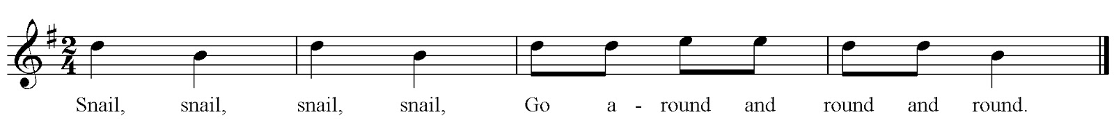  Snail, snail, snail, snail, Go a- round and round and round.  Ask learners to listen to you humming the tune. Sitting in a circle, ask learners to tap their knees to create a steady pulse as you continue humming the tune.  Next, ask learners to use their hands to demonstrate the shape of the music as you hum. Learners could also try standing for the orange notes (so), crouching or kneeling for the blue notes (mi) and raising their arms for the green notes (la).  Ask learners to perform the song in different ways, for example:  - humming the tune  - singing the song with lyrics  - singing the song as they move slowly around the room like a snail.  Introduce the spiral game. Ask learners to stand in a circle and hold hands. The leader lets go of one person’s hand to create the end of the spiral. As a class, sing the song and walk in a circle. The leader walks towards the middle to create a spiral shape. The leader may then wish to lead learners out of the circle again.  Resources:  - A new song that only has two or three notes, such as ‘Snail Snail’  - Simple music technology for audio recordings (optional) | ‘Snail Snail’ is a simple song using three pitches: so, mi and la. Encourage learners to practise, play and experiment with the song as a whole class before trying the spiral game activity.
34MM.01 Participate in unison and part singing or playing.  34MM.03 Experiment with and combine sounds for a given purpose.  34MM.04 Contribute short fragments to improvisations and compositions which respond coherently to a range of given or chosen stimuli.  34MS.02 Demonstrate an understanding of how work can be improved to suit intentions. | After a vocal warm up, listen to a short song with a simple melody, such as the traditional nursery song ‘Three Blind Mice’. Listen to the song again and encourage learners to hum along.  Next sing nonsense syllables to the tune of ‘Three Blind Mice’. For example:  Bloo, blah, blee! [repeat]  Bloo, blah blah, blee! [repeat]  Be bloo-be-doo-berry, doodle dee! [repeat twice more]  Be bloo, blah, bee! [repeat]  Ask learners to create their own lyrics to the tune of ‘Three Blind Mice’. They could also consider creating actions or a game to go with their song, similar to the spiral game for ‘Snail Snail’. This activity could be done either as a whole class, pairs or small groups.  Give learners the opportunity to perform for the rest of the class. Using audio recording you may wish to record learners’ performances.  Resources:  - Recording of a song with a simple melody, such as ‘Three Blind Mice’  - Simple music technology for audio recordings (optional) | You may use an audio or video recording of this song.  You may wish to reassure learners that this activity may look funny. It may make everyone laugh and this is not a bad way to start a singing session. These nonsense sounds will certainly get learners' lips and tongues working, and hopefully make everyone smile! You may wish to play ‘Three Blind Mice’ at the same time to build confidence in the melody part.  Music portfolio: learners can add recordings of the rehearsals and performances, and their reflections, to their music portfolio.  You may wish for learners to give feedback on other group performances, such as two things that went well and something that the group may wish to think about to improve their composition or performance. This may be in the form of two stars and a wish.

Unit 3.5 Celebration

Unit 3.5 Celebration

Outline of unit:
In this unit, learners will select their favourite work from the year to revise, refine and perform as part of a final celebration.

The focus should be on singing, being playful, experimenting and improvising with sounds, including rounds, using voices and musical instruments. Learners will begin to understand how melodies and rhythms are constructed, using bodies and other mediums to make connections between sound and symbol, becoming further aware of roles within a group.

Recommended prior knowledge/previous learning:
Awareness of rhythm and pitch; group listening, composing and performing skills

Language:
- pitch
- pulse
- rhythm
- dynamics
- texture
- rounds
- tempo
- timbre

Learning objectives | Suggested teaching activities and resources | Comments/Teaching notes
34MS.02 Demonstrate an understanding of how work can be improved to suit intentions. | Explain to learners that in this unit they will choose a piece of their work from the previous units to revise, refine and perform as part of a final celebration.  You can encourage learners to keep a diary about their work as they refine and rehearse their final piece. As a class consider the example diary:  Lesson / Date What we did What went well What we might try next  1 Listened to our rhythm grid performance. We thought about how we performed. We completed a grid about what was good. To perform and try to change volume so we have loud/quiet sections.  2 Performed our original piece. As a group we worked out which parts to play quietly and loudly. We worked well as a group and agreed on which part to perform quietly/loudly. We played through our performance. We think we should try different instruments to make it clearer which parts are loud/quiet.  3 We explored different instruments. We tried lots of instruments and agreed which to use in our performance. We need to change our score to show the new instruments.  4 We made a new score. We tried different ways to show our new sounds. We need to think about how to make our performance a round.  5 We tried to create a round. We listened well to each other and (name) took on the role of leader/conductor. Perform to the rest of the class.  Discuss with learners how they will create their own learning diary. | You may wish to provide a diary for learners to consider the strength of their work, areas that are less convincing, areas for development and their targets for next lesson.  You may wish to display this exemplar diary to your learners.
34MS.01 Listen and respond to music, beginning to use technical language accurately to describe features of the music.  34MS.02 Demonstrate an understanding of how work can be improved to suit intentions. | Ask learners to review their performances and compositions from each of the four previous units and ask learners:  - What was your favourite activity? Why?  - How did it make you feel?  - If you could make one change to your performance what would it be?  This information could be captured in a self-assessment sheet:  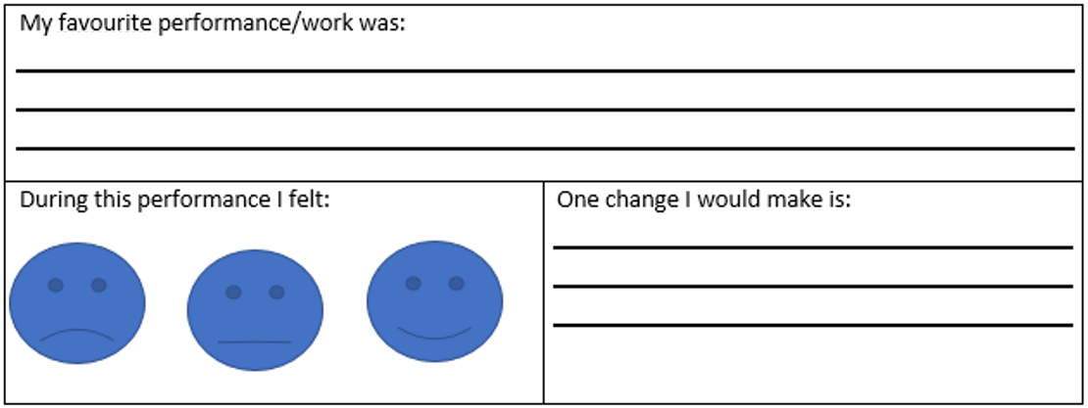  Learners consider which work they would like to develop for a class concert. Once they have decided which piece they will work on, they review a recording of their initial performance and/or rhythm grid, soundscape or score of their composition. To support their reflection, you could provide ideas, for example:  - We sang/played clearly.  - We sang/played in time.  - We used different dynamics.  - We performed as a round.  - We made a good score.  - My favourite part was …  - One change I would make is … | You may wish to use recordings, examples of notated compositions or re-teach favourites from each unit.  You may wish to display this to learners for them to consider when reflecting on prior learning.  You may wish to take a class vote and select the most popular for the whole class to work on. Alternatively, you could allow groups to select the work to refine and rehearse. This may produce more variety for a class concert.
34MM.01 Participate in unison and part singing or playing.  34MM.02 Contribute to performances with mostly accurate timing and with increasingly accurate tuning, control, and expression.  34MS.02 Demonstrate an understanding of how work can be improved to suit intentions. | Show learners two images: one of someone slouching and one of someone standing up straight. Ask your learners to consider:  - Which posture makes for a better performance?  Ask learners to stand and demonstrate good posture:  - standing feet shoulder width apart  - relaxing  - imagining being pulled upright with a piece of string like a puppet  - breathing – breathe in for 4 and hum out for 4; then breathe in for 4 and out for 8; then breathe in for 6 and out for 12.  Choose a song they performed from a previous unit and ask learners to give a performance as a class demonstrating their good posture.  Ask learners to consider:  - What else contributes to a good performance?  Ask learners to write some ideas as individuals, groups or a whole class. If necessary, you can support learners thinking by providing examples of good and bad performances as stimulus.  Ask learners to consider the question:  - What makes a good audience in a concert?  You may wish to ask them to write their initial thoughts on a piece of paper. Next, ask learners to consider whether the following are true or false for a good audience:  - sits quietly (true)  - interrupts and asks questions (false)  - does not scream or shout out (true, unless asked to do so)  - fidgets and moves around (false)  - laughs at appropriate times (true)  - claps at the end of the music (true)  - looks around and does not pay attention (false)  - plays on electronic devices (false)  - listens (true).  Ask learners to create a poster titled ‘What makes a good audience’ that can be used as a visual reminder for the audience during performances.  Resources:  - Images of someone slouching and someone standing up straight | The song could be sung twice: once with bad posture and once with good posture to demonstrate the difference good posture makes.  You may wish learners to consider things like: singing/playing in time/tune, being confident in their performance so they know what is going to happen next, having variety such as changing dynamics - loud/quiet sections, singing/playing clearly.
34MS.02 Demonstrate an understanding of how work can be improved to suit intentions.  34MS.01 Listen and respond to music, beginning to use technical language accurately to describe features of the music.  34MM.01 Participate in unison and part singing or playing.  34MM.02 Contribute to performances with mostly accurate timing and with increasingly accurate tuning, control, and expression. | Give learners the opportunity to perform for other learners in their class. Tell learners that this is a class concert made up of their performances.  During the concert, encourage learners to reflect on and consider the following:  - one change they would make to the concert  - how they felt during the concert  - a memorable moment in the concert  - how they felt during their performance  - how they felt after the concert  - their favourite performance.  After the performance ask learners to write their responses and share as appropriate with the rest of the class.  Resources:  - Simple music technology for audio recordings (optional) | You may wish to display these questions on a board during the class concert and allow learners a worksheet or blank piece of paper to make notes.  You may wish to make a recording of the class performance.  Music portfolio: learners can add recordings of the rehearsals and performances, and their reflections, to their music portfolio.

Sample lesson 1:

CLASS:

DATE:
Learning objectives | 34MM.01 Participate in unison and part singing or playing.  34MM.02 Contribute to performances with mostly accurate timing and with increasingly accurate tuning, control, and expression.  34MS.03 Explore simple ways of scribing their own and others’ music, making the link between sounds and symbols.
Lesson focus | In this lesson, learners will explore crotchets and quavers through ta and ti-ti sounds using rhythm grids. They should be able to:  - follow a simple ta beat rhythm grid in one direction  - perform and explore rhythm grids using ta and ti-ti rhythms  - create their own rhythm grids.
Previous learning | Learners have explored finding the pulse of a piece of music and can maintain a simple pulse. They have explored body percussion rhythms and are aware of how to read notation from a grid.
Plan
Lesson | Planned activities | Notes
Introduction | Tell the learners that during the lesson they will be exploring rhythm and pulse and will learn to read and perform music from a rhythm grid. Explain they will be clapping and may use body percussion and untuned percussion instruments.  As a warm-up, ask learners to sit in a circle and clap a steady beat to create a pulse. Practise this until all learners are clapping in time.  Ask learners to pause clapping. Then clap a rhythm and ask the class to clap it back to you. Repeat this with a variety of different rhythms. You could also ask learners to be the leader and clap the rhythms for the rest of the class to respond to. | This activity is best done in a circle so that each learner can see the leader.
Main activities | Introduce learners to the rhythm grid below, explaining the notation and that each box is worth one beat.           Demonstrate to learners how to perform the rhythm from the rhythm grid and then perform from the grid by clapping as a whole class.  Ask learners:  - What do you notice about this rhythm grid?  - How many beats are there?  - How would you describe the rhythm we clapped?  Learners may notice that there are eight crotchet beats or that this rhythm grid creates a steady beat. Learners may comment on whether they are keeping in time as a class or whether the speed (tempo) is changing.  Show learners the following rhythm grid:          Ask learners:  - What do you notice about this rhythm grid?  - How is it different to the previous rhythm grid? How is it the same?  Ensure learners understand that beat three is silent, the other beats are all still crotchets and there are still eight beats in total. Perform this new grid as a class.  Then show learners the following rhythm grid:          Ask learners:  - What do you notice about this rhythm grid?  - How is it different to the previous rhythm grid? How is it the same?  Ensure learners understand there are two notes (quavers) in beat six. This means we clap twice in one beat. They should notice beat three is still silent and there are still eight beats in total. Perform this new grid as a class.  Show learners other rhythm grids using a combination of crotchets, quavers and rests, for example:               Learners work in pairs or small groups to practise reading the rhythm grids and clapping each of the rhythms together.  This activity could be extended by providing learners with empty eight beat rhythm grids for them to scribe their own rhythms. They could also use body percussion or untuned percussion instruments if available and explore changing the timbre of the sounds. | Resources:  - Display board or printed rhythm grids  - Untuned percussion instruments (optional)  - Paper, pens and pencils
End/Close/ Reflection/ Summary | Ask for pairs or groups to volunteer to give a performance. This could be a performance of a provided two-part rhythm grid or of their own rhythm grid composition.  Ask the rest of the learners to give feedback on other group performances such as two things that went well and something that the group may wish to think about to improve their composition or performance. This may be in the form of two stars and a wish.  Ask learners to discuss their learning from today’s lesson with a partner:  - What did you enjoy today?  - Which tasks did you find easy or difficult?  - What did you learn today?  - What is your target for the next lesson? | - Recording equipment may be required if you wish to capture some performances  - Pens/pencils

Reflection
Use the space below to reflect on your lesson. Answer the most relevant questions for your lesson.
Were the learning objectives and lesson focus realistic? What did the learners learn today?
What was the learning atmosphere like?
What changes did I make from my plan and why?
If I taught this lesson again, what would I change?
What two things really went well (consider both teaching and learning)?
What two things would have improved the lesson (consider both teaching and learning)?
What have I learned from this lesson about the class or individuals that will inform my next lesson?
Next steps
What will I teach next based on learners’ understanding of this lesson?

Sample lesson 2:

CLASS:

DATE:
Learning objectives | 34MM.01 Participate in unison and part singing or playing.  34MM.02 Contribute to performances with mostly accurate timing and with increasingly accurate tuning, control, and expression.  34MS.03 Explore simple ways of scribing their own and others’ music, making the link between sounds and symbols.
Lesson focus /  success criteria | In this lesson, learners will explore different sounds vocally and learn a new song: ‘Snail Snail’. They should be able to:  - explore different vocal sounds, such as humming, and copy them in class activities.  - perform a simple song and identify it has three pitches  - demonstrate changes in pitch using their hands or body  - sing accurately with correct tuning and timing  - perform a piece in different ways, such as while moving with the music.
Prior knowledge / Previous learning | Learners have awareness of rhythm and pitch and can identify ta and ti-ti rhythms used in ‘Snail Snail’. They have growing confidence in vocal work as a class. Learners have explored graphic scores and grid notation.
Plan
Lesson | Planned activities | Notes
Introduction | Tell learners that during the lesson they will be exploring different sounds they can make vocally and learning a new song. They will be performing this song in different and creative ways.  As a warm-up, ask learners to breathe in for the count of four, and then breathe out creating a humming sound to the count of four. You may wish to experiment with different lengths such as:  - breathe in for 6, and hum out for 10  - breathe in for 6, and hum out for 12  - breathe in for 2, and hum out for 12.  Challenge learners to keep their humming sound the same all the way through, so it is not louder at the beginning than at the end.  Ask learners to imagine they are on a rollercoaster and show an image to visualise the ‘rollercoaster’, for example:  Using a sound such as ‘Whee’, ask learners to change their pitch to represent going higher and lower on the rollercoaster ride as you follow the peaks and troughs of the visual with your finger. Repeat the activity, but this time going very slowly.  Ask learners to create their own ‘rollercoaster’ visual. In groups, learners can take it in turns to lead the activity. | Resources:  - Board or display to show rollercoaster image
Main activities | Introduce learners to a new song that only has two or three notes, such as ‘Snail Snail’:  Snail, snail, snail, snail, Go a- round and round and round.  Ask learners to listen to you humming the tune. Sitting in a circle, ask learners to tap their knees to create a steady pulse as you continue humming the tune.  Next, ask learners to use their hands to demonstrate the shape of the music as you hum. Learners could also try standing for the orange notes (so), crouching or kneeling for the blue notes (mi) and raising their arms for the green notes (la).  Ask learners to perform the song in different ways, for example:  - humming the tune  - singing the song with lyrics  - singing the song as they move slowly around the room like a snail.  Introduce the spiral game. Ask learners to stand in a circle and hold hands. The leader lets go of one person’s hand to create the end of the spiral. As a class, sing the song and walk in a circle. The leader walks towards the middle to create a spiral shape. The leader may then wish to lead learners out of the circle again. | ‘Snail Snail’ is a simple song using three pitches: so, mi and la. Encourage learners to practise, play and experiment with the song as a whole class before trying the spiral game activity.  Resources:  - A new song that only has two or three notes, such as ‘Snail Snail’  - Simple music technology for audio recordings (optional)
End/Close/ Reflection/ Summary | Identify different areas of the room for green, amber and red. Tell learners you will read out some activities from today’s lesson and they need to stand in the area of the correct colour: green meaning they were confident, amber meaning they felt okay, and red meaning they think they need more practice.  Read some lesson activities to the class, for example:  - Humming in the warm up exercises at the start of the lesson  - Singing in the rollercoaster warm up exercise at the start of the lesson  - Identifying when the pitch changes in a song  - Performing ‘Snail Snail’ in time with others  - Performing ‘Snail Snail’ in tune with others  - Singing ‘Snail Snail’ while moving around the room  Ask learners to discuss their learning from today’s lesson with a partner.  - What did you enjoy today?  - Which tasks did you find easy or difficult?  - What did you learn today?  - What is your target for the next lesson?

Reflection
Use the space below to reflect on your lesson. Answer the most relevant questions for your lesson.
Were the learning objectives and lesson focus realistic? What did the learners learn today?
What was the learning atmosphere like?
What changes did I make from my plan and why?
If I taught this lesson again, what would I change?
What two things really went well (consider both teaching and learning)?
What two things would have improved the lesson (consider both teaching and learning)?
What have I learned from this lesson about the class or individuals that will inform my next lesson?
Next steps
What will I teach next based on learners’ understanding of this lesson?

Cambridge Assessment International Education
The Triangle Building, Shaftsbury Road, Cambridge, CB2 8EA, United Kingdom
t: +44 1223 553554 f: +44 1223 553558
e: info@cambridgeinternational.org www.cambridgeinternational.org

Copyright © UCLES September 2019

