Scheme of Work
Cambridge Primary
Music 0068
Stage 4

For use with the curriculum framework published in 2019

Copyright © UCLES September 2019
Cambridge Assessment International Education is part of the Cambridge Assessment Group. Cambridge Assessment is the brand name of the University of Cambridge Local Examinations Syndicate (UCLES), which itself is a department of the University of Cambridge.

UCLES retains the copyright on all its publications. Registered Centres are permitted to copy material from this booklet for their own internal use. However, we cannot give permission to Centres to photocopy any material that is acknowledged to a third party, even for internal use within a Centre.

Contents

Contents 3
Introduction 4
Unit 4.1 The power of rhythm 7
Unit 4.2 The sound of the rainforest 14
Unit 4.3 Creating characters 21
Unit 4.4 How does the music tell a story? 26
Unit 4.5 Celebration 32
Sample lesson 1 39
Sample lesson 2 41

Introduction

This document is a scheme of work created by Cambridge Assessment International Education for Cambridge Primary Music Stage 4.

It contains:
- suggested units showing how the learning objectives in the curriculum framework can be grouped and ordered
- at least one suggested teaching activity for each learning objective
- a list of subject-specific vocabulary and language that will be useful for your learners
- sample lesson plans.

You do not need to use the ideas in this scheme of work to teach Cambridge Primary Music Stage 4. It is designed to indicate the types of activities you might use, and the intended depth and breadth of each learning objective. These activities may not fill all of the teaching time for this stage. You may choose to use other activities with a similar level of difficulty.

The accompanying teacher guide for Cambridge Primary Music will support you to plan and deliver lessons using effective teaching and learning approaches. You can use this scheme of work as a starting point for your planning, adapting it to suit the requirements of your school and needs of your learners.

Long-term plan
This long-term plan shows the units in this scheme of work and a suggestion of how long to spend teaching each one. The suggested teaching time is based on
30 hours of teaching for Music Stage 4. You can adapt the time, units and order of the units based on the requirements of your school and the needs of your learners.

Unit | Suggested teaching time
Unit 4.1 The power of rhythm | 6 hours
Unit 4.2 The sound of the rainforest | 6 hours
Unit 4.3 Creating characters | 6 hours
Unit 4.4 How does the music tell a story? | 6 hours
Unit 4.5 Celebration | 6 hours
Total | 30 hours

Sample lesson plans
You will find two sample lesson plans at the end of this scheme of work. They are designed to illustrate how the suggested activities in this document can be turned into lessons. They are written in more detail than you would use for your own lesson plans. The Cambridge Primary Music Teacher Guide has information on creating lesson plans.

Other support for teaching Cambridge Primary Music Stage 4
Cambridge Primary centres receive access to a range of resources when they register. The Cambridge Primary support site at https://primary.cambridgeinternational.org is a password-protected website that is the source of the majority of Cambridge-produced resources for the programme. Ask the Cambridge Coordinator or Exams Officer in your school if you do not already have a log-in for this support site.

Included on this support site are:
- the Cambridge Primary Music Curriculum Framework, which contains the learning objectives that provide a structure for your teaching and learning
- grids showing the progression of learning objectives across stages
- the Cambridge Primary Music Teacher Guide, which will help you to implement Cambridge Primary Music in your school
- templates for planning
- worksheets for short teacher training activities that link to the teacher guide
- assessment guidance (to support classroom assessment)
- links to online communities of Cambridge Primary teachers.

Resources for the activities in this scheme of work
We have assumed that you will have access to these resources:
- paper, pens and pencils for learners to use, including manuscript paper
- space for learners to work in different groupings (individual, pair, groups, whole-class) on different types of activity (listening to music, composing, rehearsing, performing)
- a range of musical instruments, for example, tuned and untuned percussion
- equipment for playing recorded music to learners
- audio or video recording equipment
- music portfolios where learners can record their music making at all stages of development.

Other suggested resources for individual units and/or activities are described in the rest of this document. You can swap these for other resources that are available in your school.

Websites
There are many excellent online resources suitable for teaching Cambridge Primary Music. Since these are updated frequently, and many are only available in some countries, we recommend that you and your colleagues identify and share resources that you have found to be effective for your learners.

Approaches to teaching Cambridge Primary Music Stage 4
The learning objectives are organised into two strands which aim to integrate embodied learning in a holistic way.
- Making Music
- Making Sense of Music

Music portfolios
A music portfolio allows learners to document their experiments, rehearsals, performances and reflections which will help them to reflect on their progress and next steps. Learners should add to their portfolio regularly and this can be done either formally or informally. Depending on the availability of music technology it is likely that this portfolio will be a combination of audio/video recordings of rehearsals and performances, compositions (recordings and/or notations) and learner’s reflections (either written or recorded).

Teaching songs.
When teaching songs, or parts of songs, it is recommended that you use repetition to help learners remember the melody. A simple way to do this is for you to sing a line (phrase) and then ask learners to sing it back. If learners do not sing it back correctly at first, simply repeat the process until they can. For example, in a four-phrase melody, you could sing one phrase, then two together, then the whole song to gradually build learners’ memory. To support this process, you may also wish to use hand signs (e.g. sol-fa and Kodály-Curwen hand signs) when learners are learning or performing a song. Sol-fa gives every pitch a name and an accompanying hand sign to help learners build a picture of how a melody is constructed and the relationships between notes. The names for the notes are ‘do, re, mi, fa, so, la, ti, do’. You may want to research this further if you would like to use it with your learners.

Teaching notation
Not all styles of music use notation and understanding musical notation is not required in order to be a musician. However, having an awareness of notation is a useful skill for many learners, particularly those who go on to study for qualifications in music. Notation includes written representations (e.g. stave music) or ways to name notes (e.g. C D E or do, re, mi). By introducing ‘sound before symbol’ learners participate in lots of practical music making, which allows then to begin to hear notes in their head (internalised sounds), before they come to understand and use notation as a way to represent those sounds.

Differentiation and extension activities
For learners who require more challenge, try adding extra parts within the same piece of music that the class is learning. These parts could be instrumental or vocal and involve different rhythms (e.g. clapping one rhythm while singing another) or tunes (e.g. a new harmony line).

Unit 4.1 The power of rhythm

Unit 4.1 The power of rhythm

Outline of unit:
In this unit learners will recognise and understand the power of rhythm, working mostly through whole class and group learning. The focus should be on singing, including rounds, being playful, experimenting using voices and body percussion. Learners will begin to understand how rhythms are constructed, using bodies and visual symbols to make connections between sound and symbol, becoming further aware of roles within a group.

Recommended prior knowledge/previous learning:
This builds on prior learning of rhythmic work on crotchets (ta) and quavers (ti-ti), using voices and untuned percussion.

Language:
- rhythm
- pulse
- beat
- crotchet
- quaver
- semiquaver

Unit 4.1 Suggested activities

Learning objectives | Suggested teaching activities and resources | Comments/Teaching notes
34MM.01 Participate in unison and part singing or playing.  34MM.02 Contribute to performances with mostly accurate timing and with increasingly accurate tuning, control, and expression.  34MM.03 Experiment with and combine sounds for a given purpose. | Play learners a recording of a song with simple rhythms and repeated phrases such as ‘A Ram Sam Sam’. Ask learners to clap the pulse of the song as they are listening.  Play the song again and ask learners to clap the rhythm of the song.  Ask learners:  Can you identify the types of rhythms used? (ta and ti-ti)  Display the lyrics to ‘A Ram Sam Sam’:  A ram sam sam, a ram sam sam  Guli guli guli guli guli ram sam sam  A ram sam sam, a ram sam sam  Guli guli guli guli guli ram sam sam  A rafiq, a rafiq  Guli guli guli guli guli ram sam sam  A rafiq, a rafiq  Guli guli guli guli guli ram sam sam  Introduce learners to the following actions and ask them to perform the actions when they hear the lyrics:  - ‘A ram sam sam’ –clap once on ram and then tap knees twice on sam sam  - ‘Guli guli’ – spin forearms over one another  - ‘A Rafiq’ -clasp hands together or hold hands with a friend  As a class explore singing or chanting the lyrics and whilst performing these actions. Once learners are confident this could also be performed as a round.  Ask learners to work in small groups to create their own actions or body percussion patterns to accompany the song. Once learners have rehearsed their body percussion compositions, give them time to perform them to the rest of the class. You may wish to record learners’ performances using simple music technology.  Resources:  - An audio recording of a song with simple rhythms and repeated phrases such as ‘A Ram Sam Sam’  - Simple music technology for audio recordings (optional) | ‘A Ram Sam Sam’ is a children’s song from Morocco. It is a singing game and can be sung as a round.  The phrase ‘A Ram Sam Sam’ has no meaning.  In English the lyrics are:  A ram sam sam, a ram sam sam  Tell me, tell me, tell me, tell me, ram sam sam  A ram sam sam, a ram sam sam  Tell me, tell me, tell me, tell me, ram sam sam  Friend, friend,  Tell me, tell me, tell me, tell me, ram sam sam  Friend, friend,  Tell me, tell me, tell me, tell me, ram sam sam.  You may wish to explore different recordings of this song, for example:  - Donikkl und die Weißwürschtl recorded ‘Aram Sam Sam’ that reached the German charts in 2009  - Lorenz Büffel recorded ‘Aram Zam Zam’ for his double CD Apres Ski Hits 2011  - Tom Tom Club used part of the lyrics in their song ‘Wordy Rappinghood’ from their 1981 album which was later used by Uffie in collaboration with DJ Mehdi.  Music portfolio: learners can add recordings of the rehearsals and performances, and their reflections, to their music portfolio.
34MM.01 Participate in unison and part singing or playing.  34MM.02 Contribute to performances with mostly accurate timing and with increasingly accurate tuning, control, and expression.  34MM.04 Contribute short fragments to improvisations and compositions which respond coherently to a range of given or chosen stimuli.  34MS.03 Explore simple ways of scribing their own and others’ music, making the link between sounds and symbols. | After a vocal warm up, introduce a new song that uses just ta (crotchet) and ti-ti (quaver) rhythms, such as ‘Cobbler Cobbler’.  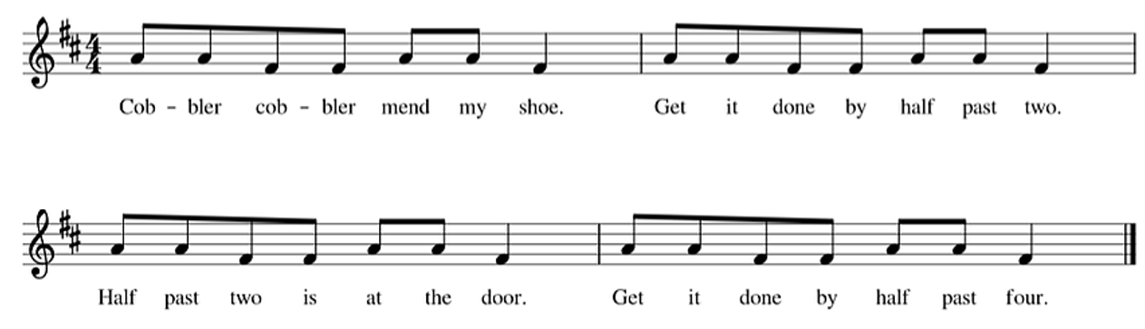  You may wish to sing this to your learners and explain how the music uses just two pitches.  Ask learners to listen to you singing the song. Sitting in a circle, ask learners to tap their knees to create a steady pulse as you continue singing. You could also challenge learners to pass a toy around the circle in time with the pulse. If learners feel confident, they could join in singing while keeping in time with the pulse.  Then ask learners to clap the rhythm of the song.  Ask learners:  Can you identify the types of rhythms used? (ta and ti-ti)  What do you notice about the rhythmic pattern? (Learners may notice the rhythm ti-ti, ti-ti, ti-ti, ta is repeated throughout)  Can you represent the rhythm used in a rhythm grid?       Ask learners to create a short repeated rhythmic pattern to accompany the song. You may wish to provide learners with empty four-beat rhythm grids for them to scribe their own rhythms to accompany ‘Cobbler Cobbler’.  For example, learners could create the following repeated pattern:      They clap the repeated pattern whilst singing ‘Cobbler Cobbler’.         Cob-bler Cob-bler mend my shoe. Get it done by half past two.         Half past two is at the door. Get it done by half past four.  Resources:  - Rhythm grids  - Toy to pass around the circle (optional) | This is a nursery rhyme about an old pair of shoes for a cobbler to fix. You may wish to explain that a ‘cobbler’ is a person whose job is to mend shoes.  You may wish to introduce learners to rhythmic notation by using flashcards showing crotchets and quavers. For example:  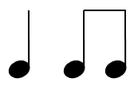  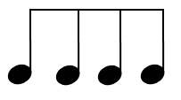  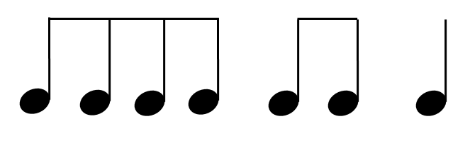  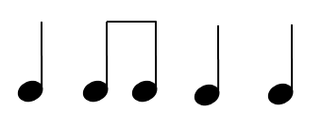  Learners may choose to use rhythmic notation to scribe their rhythmic accompaniment.
34MM.01 Participate in unison and part singing or playing.  34MM.02 Contribute to performances with mostly accurate timing and with increasingly accurate tuning, control, and expression.  34MM.03 Experiment with and combine sounds for a given purpose. | Introduce learners to a rhythm grid completed with images, explaining that each box is worth 1 beat. For example:  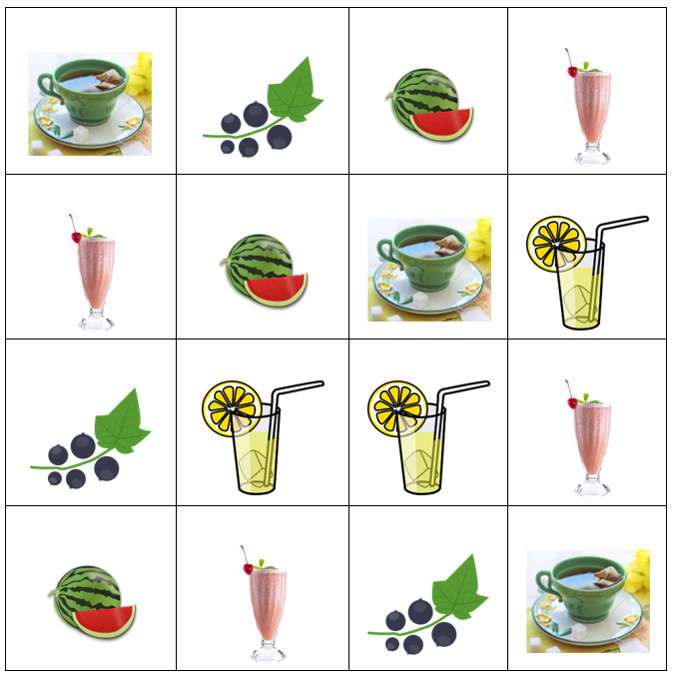  Explain to learners that in this rhythm grid:  - the image of the tea represents 1 beat (crotchet or ta)  - the image of the milkshake represents $\frac{1}{2}$ beats (quavers or ti-ti)  - the image of the watermelon represents $\frac{1}{4}$ beats (semiquavers or tika-tika)  - the image of the blackcurrant represents one quaver and two semiquavers (ti-tika)  - the image of the lemonade represents two semiquavers and one quaver (tika-ti)  Demonstrate to learners how the top row of the grid could be clapped  (ta, ti-tika, tika-tika, ti-ti), whilst saying the words “Tea, Blackcurrant, Watermelon, Milkshake”. Ask learners to clap and repeat the first row back.  Once learners have understood how the rhythm grid works, explore as a class the patterns created by reading the grid in different directions. For example, starting from the top left and working down row by row, going down column by column, going diagonally, and so on.  This activity could be extended by asking learners to create their own rhythm grids using pictures of food, drinks, toys and so on.  Resources:  - Rhythm grids; several sets of images for group work; composition grids | This grid can be adapted to use images appropriate to suit your learners.  You may wish to experiment with adding different timbres for each image. For example, tea as clap or woodblock, milkshake as finger click or shaker etc.
34MM.01 Participate in unison and part singing or playing.  34MM.02 Contribute to performances with mostly accurate timing and with increasingly accurate tuning, control, and expression.  34MM.03 Experiment with and combine sounds for a given purpose.  34MM.04 Contribute short fragments to improvisations and compositions which respond coherently to a range of given or chosen stimuli. | Introduce learners to rhythmic notation by using flashcards showing crotchet, quaver and semiquaver rhythms. For example:  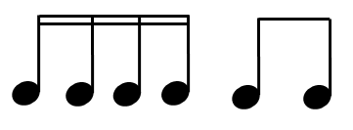  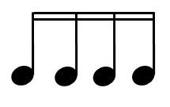  Show learners the rhythm grid from the previous activity but replaced with musical notes:  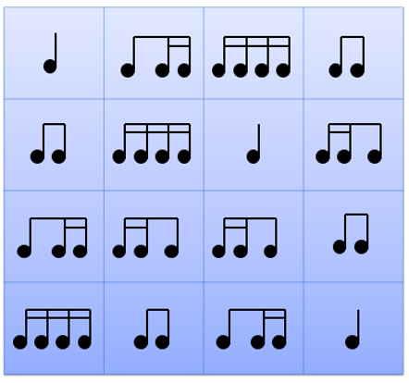  Ask learners:  Are you able to perform from the rhythmic notation?  Explore as a class the patterns created by reading rhythmic notation from the grid in different directions.  Ask learners to create their own rhythm grid using rhythmic notation. For support learners could use images instead or a combination of images and rhythmic notation.  This activity can be extended by asking learners to consider use of dynamics (volume) and timbre (different sounds created by instruments) when they perform their rhythm grids. | You may wish to cover notation on the grid with the symbols used in the previous activity. Make a game of ‘revealing’ the symbols to introduce the connection between sounds and symbol/notation.  For support, leave both the rhythm grid with pictures on the board too. Encourage learners to speak the rhythm words while performing, then whisper them and then think them without saying anything out loud.
34MM.01 Participate in unison and part singing or playing.  34MM.02 Contribute to performances with mostly accurate timing and with increasingly accurate tuning, control, and expression.  34MS.01 Listen and respond to music, beginning to use technical language accurately to describe features of the music. | After a vocal warm up, introduce a new song that uses tika-tika (semiquaver) rhythms, such as ‘Kookaburra’.  You may wish to perform this song to your learners or use a recording for a listening activity.  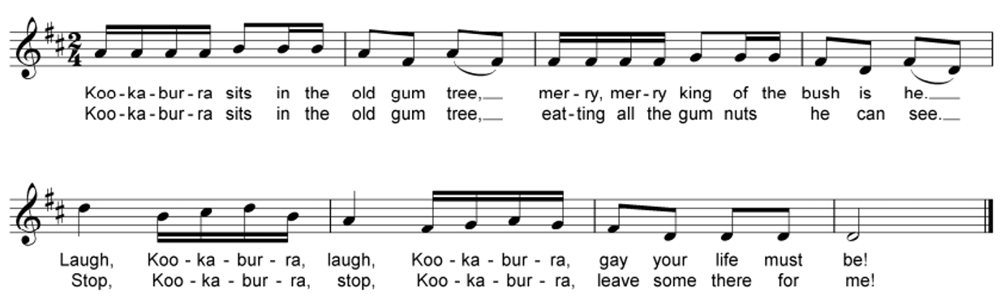  Ask learners to perform the song in different ways, for example:  - clapping, tapping or walking in time with the pulse  - clapping the rhythm  - humming the tune  - singing the song with lyrics  - singing the song as a round dividing the class into two or three groups with each group starting when the last has sung the first phrase.  Challenge learners by asking:  Can you identify the types of rhythms used in the first phrase of the song? (tika-tika, ti-tika and ti-ti. There are also singular ta rhythms plus a minim at the end of the music)  Can you draw a rhythm grid for the song using images or rhythmic notation?  Show learners the first phrase as a rhythm grid to support learners with this. For example, using images:  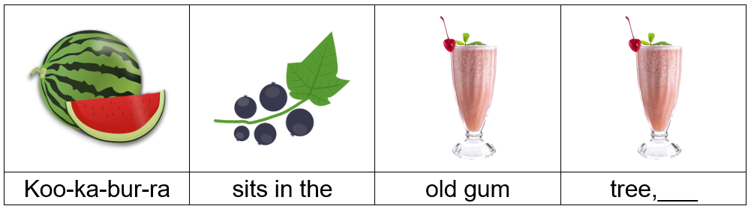  Or using rhythmic notation:  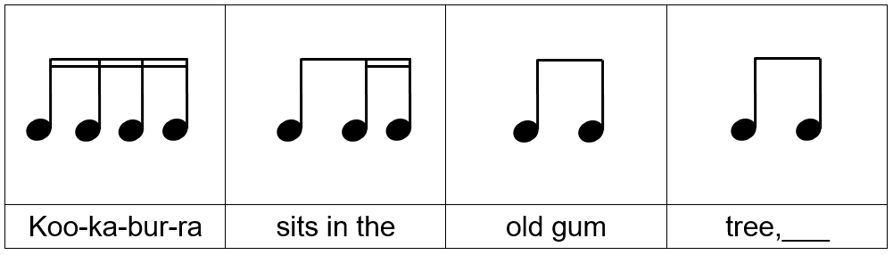 | This is an Australian nursery rhyme about the Kookaburra bird happily eating gum nuts. It can be performed as a round.  You may wish to tell learners that:  - a ‘kookaburra’ is a large Australian kingfisher bird. It is sometimes called the ‘laughing kookaburra’ because it makes a sound like the human laugh  - a ‘gum tree’ is another name for an eucalyptus tree which is very common in Australia  - the ‘bush’ is how people refer to any part of the country outside the major cities and towns in Australia.
34MS.01 Listen and respond to music, beginning to use technical language accurately to describe features of the music.  34MM.01 Participate in unison and part singing or playing.  34MM.02 Contribute to performances with mostly accurate timing and with increasingly accurate tuning, control, and expression.  34MM.03 Experiment with and combine sounds for a given purpose.  34MM.04 Contribute short fragments to improvisations and compositions which respond coherently to a range of given or chosen stimuli. | Listen to or watch a clip of a performance of a percussion piece which makes use of everyday objects as percussion instruments, for example the kitchen scene from Stomp Out Loud.  Ask learners to think about what they can hear and consider the following:  - Which everyday objects are being used? Draw a picture of them.  - Beside each picture can you write a word or short sentence to describe the sound that is made?  Ask learners to work in small groups to plan their own short performance in the style of ‘Stomp Out Loud’. Ask learners:  - Which objects or instruments will you use? Will you use a vocal part?  - What type of sound effects do you want to create? Experiment with dynamics, different timbre and sounds.  - How will you create a score for your performance?  - Can you add movement, dance moves or exaggerated gestures to your performance?  Once learners have rehearsed their compositions, give them time to perform them to the rest of the class. You may wish to record learners’ performances using simple music technology.  Resources:  - Everyday objects that can be used to make a variety of sounds; simple music technology for audio recordings (optional) | Stomp Out Loud is a musical that features the dance troupe known as Stomp. The film includes footage from the Broadway performance as well as scenes shot for the film. Music is created from ordinary objects and moments. There is limited dialogue in the film.  You may wish to play some of your chosen clip a second time and encourage the students to experiment with some of these elements before the groups begin creating.  Music portfolio: learners can add recordings of the rehearsals and performances, and their reflections, to their music portfolio.

Unit 4.2 The sound of the rainforest

Unit 4.2 The sound of the rainforest

Outline of unit:
In this unit learners will explore sounds of the rainforest. Mostly through whole class and group learning, the focus should be on being playful, experimenting and improvising with sounds, using voices and body percussion. Learners will begin to understand how soundscapes and motifs are constructed, using bodies and visual symbols to make connections between sound and symbol, becoming further aware of roles within the group.

Recommended prior knowledge/previous learning:
Learners will have confidence performing within a group and exploring sounds using voices and body percussion. They will have knowledge of notating musical ideas using graphic score.

Language:
- dynamics
- texture
- structure
- soundscape
- motif

Unit 4.2 Suggested activities

Learning objectives | Suggested teaching activities and resources | Comments/Teaching notes
34MS.01 Listen and respond to music, beginning to use technical language accurately to describe features of the music.  34MM.01 Participate in unison and part singing or playing.  34MM.02 Contribute to performances with mostly accurate timing and with increasingly accurate tuning, control, and expression.  34MM.03 Experiment with and combine sounds for a given purpose.  34MM.04 Contribute short fragments to improvisations and compositions which respond coherently to a range of given or chosen stimuli. | Show learners some images of a rainforest whilst playing audio clips of sounds of the rainforest.  Then ask learners to close their eyes and imagine they are in the rainforest.  Learners open their eyes and complete the simple sentences:  - I think a rainforest is…  - In a rainforest you might see…  - In a rainforest you might hear…  Ask learners to share their ideas with the rest of the class.  Play learners an audio recording of a choir recreating the sounds of a rainforest with their hands, such as Rainstorm performed by Perpetuum Jazzile.  Ask learners:  What could you hear?  Learners may or may not realise that it was not a real rainstorm at this point. Show learners the video clip or explain that the audio clip was a choir making the noises of the rainstorm with their bodies.  Ask learners:  What techniques did the choir use to make the different sounds of the rainstorm? Can you describe the dynamics and texture?  Tell learners they are going to create and perform their own musical rainstorm as a class. Explain to learners how to make a rainstorm using their hands, for example:  - Rub two fingers together.  - Rub hands together.  - Snap fingers.  - Clap two fingers on palm.  - Clap hands.  - Slap hands on thighs.  - Stomp feet.  To calm the weather and make the rainstorm go away, learners perform these actions in reverse order.  This activity can be extended by asking learners to work in small groups to create their own rainforest sounds.  Resources:  - Images of a rainforest  - Recordings of sounds of a rainforest | You could use examples from the internet to show learners pictures and sounds of the rainforest.  You may wish to give some facts about rainforests such as:  - they are found in tropical regions  - the daily temperature is around 25°C and it rains most days  - they are found in Africa, Asia and Central and South America.
34MM.03 Experiment with and combine sounds for a given purpose. | Introduce learners to a song about rain, such as ‘Rain, Rain, Go Away’, by singing or playing an audio recording of the song. As you are playing or singing the song use a rainstick (authentic or homemade) as accompaniment. The rain could gradually get slower and disappear as you repeat the song.  Explain to learners that a rainstick is a percussion instrument used to create the sound effects of rain. When shaken it sounds similar to the maracas. It is a long, hollow tube sealed at both ends and filled with objects such as seeds or pebbles.  Tell learners they will make their own rainsticks. Guide learners through the following instructions:  - Paint the outside of a long cardboard tube with bright colours and then leave to dry.  - Once dry decorate, perhaps by painting on dots, adding feathers, adding stickers or gems.  - Cut off the necks of two balloons. Stretch one over the end of the tube securely. (You could use paper and tape instead of a balloon.)  - Take a long piece of foil and crinkle into a long sausage shape. Fold in half and twist to create loops for the rice to fall through. Carefully put this into the tube.  - Add half a cup of rice or small stones.  - Seal the end of the rain stick with the other balloon as before (or paper and tape).  - Wrap string around the top of the rain stick and securely tie, leaving about 30cm for threading beads onto. Tie end securely to the bottom of the tube.  - Slowly turn upside down and listen to the sound of your rainstick.  As a class sing the song ‘Rain, Rain, Go Away’ using rainsticks as accompaniment.  This activity could be extended by selecting learners to conduct the rest of the class playing their rainsticks. They indicate to each learner or small groups of learners when they should begin playing their rainsticks to gradually build the storm, and then indicate when to stop as the rain fades away.  Resources:  - Rainstick (either an authentic rainstick or one made according to instructions above).  - Materials to make rainsticks including cardboard tubes, paint, tin foil, rice or stones, balloons (or paper and tape) and decoration such as string, beads, feathers or stickers. | If you are using a rainstick you have pre-made according to the instructions in the activity, you may wish to show learners a picture of an authentic rainstick or play a video to show them the sounds.  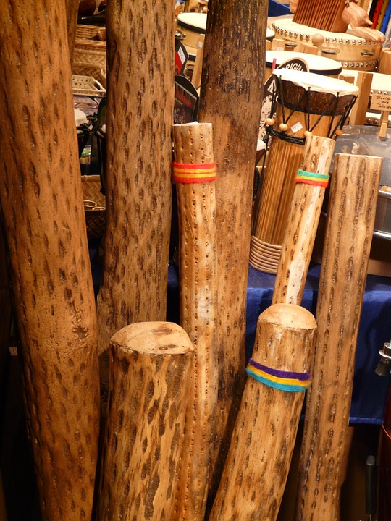  Consider exploring ways to link this with other parts of the curriculum, such as art.
34MM.03 Experiment with and combine sounds for a given purpose.  34MM.04 Contribute short fragments to improvisations and compositions which respond coherently to a range of given or chosen stimuli. | Ask learners to lie on the floor and shut their eyes as they imagine that they are in a rainforest and it is night-time. Suggest to learners that perhaps they are lying in a hammock with a mosquito net around them.  Ask learners:  What can you hear?  Ask learners to share their ideas of noises that you might hear in a jungle at night.  Show learners a soundscape of a rainforest at night, for example:  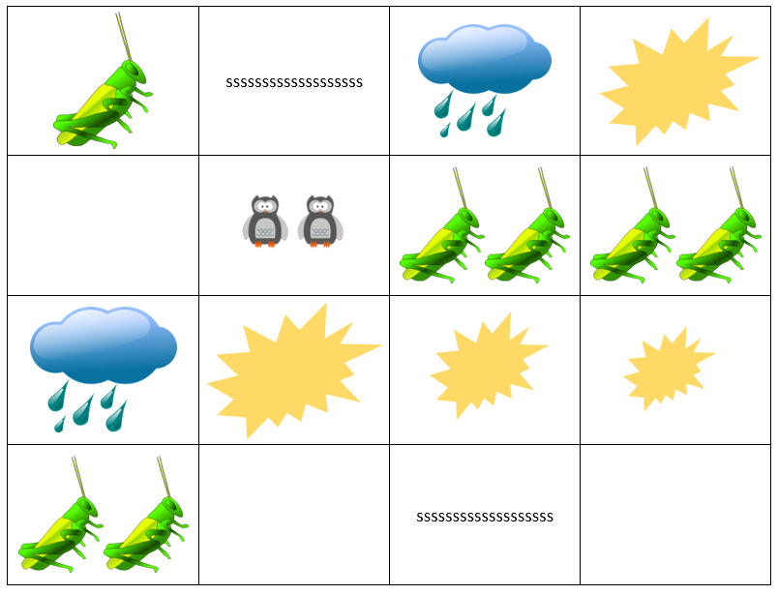  Ask learners to discuss in pairs:  - What sounds do you think the pictures represent?  - Would the music change in volume (dynamics) at any point? Why or why not?  - How might this soundscape be performed?  Performing in unison  As a whole class, experiment with different sounds for the different symbols and images and agree on how each line of the soundscape should be performed. Perform the soundscape all together (in unison), a line at a time.  Performing in parts  When learners are confident with the sounds in each line of the soundscape, try performing the soundscape as four separate parts. Divide the class into four groups and ask each group to perform a different line of the soundscape simultaneously.  Performing a round  When learners are confident with performing the soundscape as four separate parts try performing the soundscape as a round. Divide the class into four groups. Group one should start and perform each line in turn. Group two enters when Group one is at the end of the first line. Group three enters when Group two are at the end of the first line and Group four enters when Group three are at the end of the first line.  This activity can be extended by asking learners to work in small groups to create their own graphic score of a soundscape of a rainforest. You may wish to encourage learners to think about how they will vary their performance using dynamics (volume), different timbres (different sounds created by instruments), different textures (layers) and use of silence.  Resources:  - Graphic scores | The first part of this activity works well in a darkened room if possible.
34MM.01 Participate in unison and part singing or playing.  34MM.02 Contribute to performances with mostly accurate timing and with increasingly accurate tuning, control, and expression.  34MM.03 Experiment with and combine sounds for a given purpose.  34MM.04 Contribute short fragments to improvisations and compositions which respond coherently to a range of given or chosen stimuli. | Introduce learners to the concept of a motif (a short musical phrase). As a class select a phrase related to rainforests such as “Gorillas shuffling and chimpanzees squealing”, which will be the basis for creating their own musical motif.  As a class, say the phrase together and then lead your learners by adding a body percussion pattern at the same time. For example, you may tap your legs for each syllable of ‘Gorillas Shuffling’, clap your hands when you say, ‘and chimpanzees’ and then click fingers on ‘squealing’.  Try this all together as a class to build confidence with performance. Encourage learners to explore different sounds.  Ask learners:  - What does it sound like if you tap your cheeks or hit the floor?  - Does it sound the same when everyone clicks their fingers or does it create different pitches?  Ask learners to create their own body percussion pattern using the same phrase.  Once all learners have a pattern, ask learners to perform one after the other. You may wish to bring each in with a ‘1, 2 and ready to play’.  Ask learners:  Which performance worked well? Why?
34MM.01 Participate in unison and part singing or playing.  34MM.02 Contribute to performances with mostly accurate timing and with increasingly accurate tuning, control, and expression.  34MM.03 Experiment with and combine sounds for a given purpose.  34MM.04 Contribute short fragments to improvisations and compositions which respond coherently to a range of given or chosen stimuli.  34MS.02 Demonstrate an understanding of how work can be improved to suit intentions.  34MS.03 Explore simple ways of scribing their own and others’ music, making the link between sounds and symbols. | Learners work in small groups to create their own rainforest motif. Ask learners to create their own spoken phrase about the rainforest. They may wish to think about nature, animals, location and so on. Once they have agreed on a phrase, they explore different body percussion or vocal sounds to accompany their motif.  Ask learners:  - How will you create a score for your performance? (learners could use pictures, symbols and rhythmic notation to record their musical ideas)  - How will you make sure everyone in your group is involved in your performance?  After a set amount of time you may wish to ask learners to stop and listen to each group perform.  Ask learners:  - What worked well?  - What could be better?  Learners refine their ideas based on this feedback.  Ask learners:  - What changes can be made to make the performance better?  - Do all members of the group have an equal part?  - Are you all able to perform in time with one another?  - Are there any changes to tempo or dynamics?  Once learners have refined and rehearsed their work, they could perform their pieces to each other or to other audiences. You may wish to record learners’ performances using simple music technology.  Resources:  - Simple music technology for audio recordings (optional) | You may encourage learners to think about the role of each member of the group, how well they perform together as a group, whether they are in time with one another and whether they start, stop and change dynamics at the same time.  You may wish to transform the performance space into a rainforest with props and backing soundscapes, over which the learners could perform their pieces to their audience.  Music portfolio: learners can add recordings of the rehearsals and performances, and their reflections, to their music portfolio.

Unit 4.3 Creating characters

Unit 4.3 Creating characters

Outline of unit:
In this unit learners will develop awareness of how music can be used to create different moods and portray characteristics. They will experiment with creating different musical motifs for characters in a story. Working mostly through whole class and group learning, the focus should be on being playful, experimenting and improvising with sounds, using voices and musical instruments. Learners will begin to understand how melodies and rhythms are constructed, using visual symbols to make connections between sound and symbol, becoming further aware of roles within the group.

Recommended prior knowledge/previous learning:
Knowledge and understanding of rhythm and pitch, musical terms such as dynamics and tempo.

Language:
- themes
- ostinato
- rhythm
- pitch
- dynamics
- mood
- orchestra
- instrumentation

Unit 4.3 Suggested activities

Learning objectives | Suggested teaching activities and resources | Comments/Teaching notes
34MS.01 Listen and respond to music, beginning to use technical language accurately to describe features of the music. | Ask learners to name as many instruments as they can. They do this individually first and then select learners to share their ideas, collating the answers of the whole class on the board.  To support learners, you may wish to show pictures of different instruments or play audio recordings of instruments to learners so that they can identify them. For example:  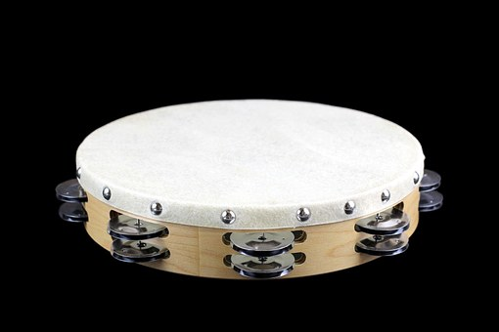  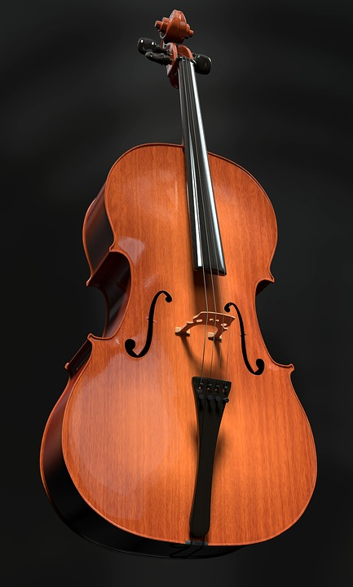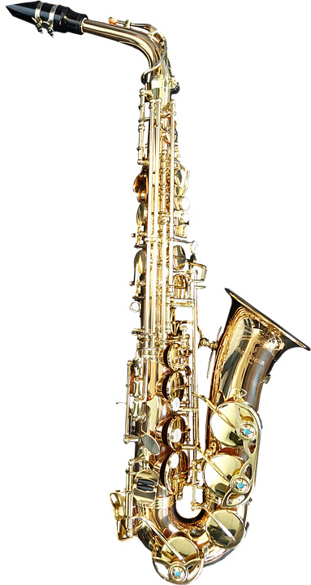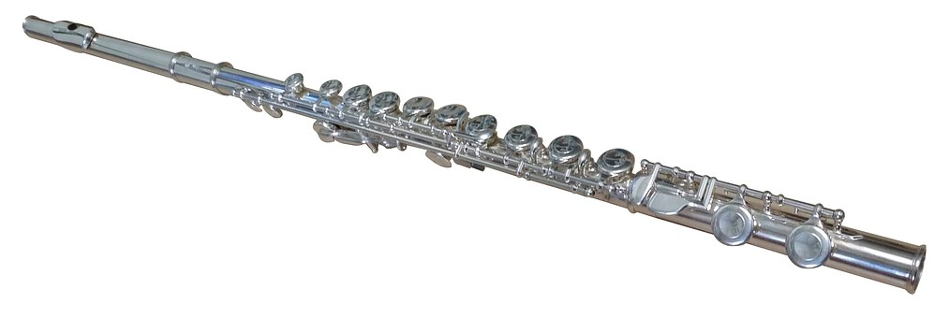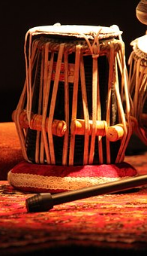  You could also play an example of an instrument and ask learners to match the sound to the picture of the instrument displayed on the board.  You may also wish to introduce learners to the different sections of the orchestra (strings, woodwind, brass and percussion) and ask them to suggest instruments that belong in each section. A simple layout of the orchestra could be displayed on the board as you do this  Play audio recordings or show learners pictures of different orchestral instruments. Ask learners:  - Can you describe the sound of each of the instruments?  - What characteristics do they have?  Resources:  - Audio recordings and/or pictures of a variety of instruments  - A picture of the layout of an orchestra (optional)
34MM.03 Experiment with and combine sounds for a given purpose.  34MS.01 Listen and respond to music, beginning to use technical language accurately to describe features of the music. | After a vocal warm up, hold up pictures of different characters from stories, nursery rhymes etc. that learners are familiar with. Ask learners to explore making sounds freely to represent each character using voice, tuned or untuned percussion instruments. Learners discuss as a class how music can portray the different moods and traits of the characters.  Play learners an audio recording of a song or extract from a song where different animals, people or characters are portrayed through the music. For example, ‘The Carnival of the Animals’ by Camille Saint-Saens.  Select three movements from ‘The Carnival of the Animals’ and play these to learners one at a time. Ask learners to identify which animal the music might be about. Encourage learners to think about what the animals might be doing and to move around the room to imitate each animal. Learners could also discuss which instruments are used in each movement and how the music is different for each animal.  Play learners another five movements from ‘The Carnival of the Animals’ and give each learner the table below:  Animal Why do you think the music is about this animal?  1 e.g. Elephant e.g. The low notes make the animal sound really big and heavy  2  3  4  5  Learners complete the table, identifying which animal the music might be about and giving reasons why they think this. As a challenge, learners could also identify the instruments being used. For support display pictures of the five animals on the board, so learners can choose which one matches which piece. Encourage learners to share their answers and their reasons for their choices.  Resources:  - Audio recording of a song or extract from a song where different animals, people or characters are portrayed through the music, such as ‘The Carnival of the Animals’ by Camille Saint-Saens | ‘The Carnival of the Animals’ is a musical suite in 14 movements, each representing a different animal, and the work lasts around 25 minutes in total.  Title Instrument(s)  1. Introduction and Royal March of the Lion String instruments and pianos  2. Hens and Roosters String instruments, piano and clarinet  3. Wild Donkeys, Swift Animals Pianos  4. Tortoises String instruments and pianos  5. The Elephant Double bass and piano  6. Kangaroos Pianos  7. Aquarium String instruments, piano, flute, glass armonica  8. Characters with Long Ears Violins  9. The Cuckoo in the Depths of the Woods Pianos and clarinet  10. Aviary String instruments, piano and flute  11. Pianists Pianos and string instruments  12. Fossils String instruments, piano, clarinet and xylophone  13. The Swan Piano and cello  14. Finale Full ensemble
34MM.03 Experiment with and combine sounds for a given purpose.  34MM.04 Contribute short fragments to improvisations and compositions which respond coherently to a range of given or chosen stimuli.  34MS.01 Listen and respond to music, beginning to use technical language accurately to describe features of the music.  34MS.02 Demonstrate an understanding of how work can be improved to suit intentions. | Explain to learners that in ‘The Carnival of the Animals’, Saint-Saens used different instruments to create sounds of different birds. Play learners the following movements:  - Movement 2: Hens and Roosters.  - Movement 9: The Cuckoo in the Depths of the Woods.  - Movement 10: Aviary.  - Movement 13: The Swan.  Ask learners to listen to each movement and think about how the composer created sounds to represent birds. Learners could write their ideas down as an individual activity or discuss in small groups.  Tell learners they are going to compose their own piece of music to represent a bird using tuned and untuned percussion instruments (or other available instruments). They work in pairs or small groups and they may choose the bird they want to compose their piece about. Support learners by suggesting they could consider using:  - a mixture of high and low pitches  - a mixture of quiet and loud sounds  - a short, repeated pattern (ostinato) using 2 notes, like the cuckoo  - a short theme with a pecking nature like a chicken.  Once each group has composed a short bird piece, they perform to one another.  Ask learners in the audience:  - Did the group’s composition sound like a bird?  - Which bird do you think they were trying to represent?  - What worked well and was there anything that could make the music sound even more like a bird?  This activity can be extended by asking learners to compose another short piece of music to represent another animal. They could use voice, body percussion, tuned and untuned percussion (or other available instruments).  Resources:  - Audio recording of a song or extract from a song where different animals, people or characters are portrayed through the music, such as ‘The Carnival of the Animals’ by Camille Saint-Saens | You could discuss the following features from each movement:  - Movement 2: The pecking theme represent chickens pecking at grain. The clarinet plays small solos above the rest of the players at intervals.  - Movement 9: The piano plays large, soft chords while the clarinet plays a single two-note ostinato, using C and A flat, mimicking the call of the cuckoo bird.  - Movement 10: High strings take a background role to provide a buzz which represents the noise of a jungle. The flute takes the part of the bird with a trilling tune. The piano plays the occasional ping and trills of other birds in the background.  - Movement 13: The romantic cello solo shows the swan elegantly gliding over water. The piano plays rippling semiquavers in one hand and rolled chords in the other to show. The chords in the baseline may represent the swan’s feet paddling under the water.
34MM.01 Participate in unison and part singing or playing.  34MM.02 Contribute to performances with mostly accurate timing and with increasingly accurate tuning, control, and expression.  34MM.03 Experiment with and combine sounds for a given purpose.  34MM.04 Contribute short fragments to improvisations and compositions which respond coherently to a range of given or chosen stimuli.  34MS.02 Demonstrate an understanding of how work can be improved to suit intentions. | Choose a story with a number of different characters that learners are familiar with, such as Jack and the Beanstalk.  As a class, recount and explore the story of Jack and The Beanstalk. Make a list of the main characters on the board as a class. You may wish to discuss key characteristics of each character in the story and the sounds the characters might make or hear. For example:  - Jack’s mum – working (chopping wood, digging garden), shouting angrily at Jack when she sees the beans  - Jack – walking the cow to the market, climbing the beanstalk  - Giant – chanting “Fee, Fi, Fo, Fum”  - Beanstalk – growing quickly and quietly overnight  Learners work in small groups to create a soundscape for a short scene involving one character or multiple characters in the story. Ask learners to decide on the vocal sounds or musical instruments to use to represent the characters and their actions. Each group rehearses and performs a short piece.  You may wish to develop staging, costumes and props to put on a performance of learners’ soundscapes or retell the story with the added soundscapes of each group.  Ask learners:  - Which pieces sounded effective and why?  - Could you spot the different characters being portrayed in the music?  - If not, what could you improve?  Encourage learners to evaluate their own and others' performances in a positive, respectful and useful way.  Resources:  - Short story with multiple characters, such as Jack and the Beanstalk  - Staging, costumes and props (optional)

Unit 4.4 How does the music tell a story?

Unit 4.4 How does the music tell a story?

Outline of unit:
In this unit learners will develop awareness of how music can be used to tell a story. Learners will begin to recognise instrumental sounds and how melodies and rhythms are constructed, with a focus on motifs. Learners will use bodies and visual symbols to make connections between sound and symbol and become further aware of roles within the group.

Recommended prior knowledge/previous learning:
This builds on prior learning of rhythmic work, group work and awareness of pitch.

Language:
- theme
- motif
- rhythm
- pitch
- mood
- character
- instruments

Unit 4.4 Suggested activities

Learning objectives | Suggested teaching activities and resources | Comments/Teaching notes
34MS.01 Listen and respond to music, beginning to use technical language accurately to describe features of the music.  34MS.03 Explore simple ways of scribing their own and others’ music, making the link between sounds and symbols. | As a class, listen to an audio recording of some music which tells a story, such as Sergei Prokofiev’s ‘Peter and the Wolf’. Explain to learners that the composer used a different instrument and wrote a different melody for each character to help us to understand them better. For example, Peter’s melody is light and happy, the cat’s is sneaky and the wolf’s is dark and scary.  Ask learners to complete the table by matching the correct instrument to each character.  Character Instrument Description  Peter Oboe  Bird String instruments  Cat French horns  Grandfather Clarinet  Duck Timpani  Wolf Flute  Hunters Bassoon  Encourage learners to also write their own words to describe the melody and character. Learners could also draw a picture of each character based on what they hear.  Ask learners:  Can you create images or symbols to represent the sounds you hear?  Select learners to share and discuss their ideas with the class.  Resources:  - An audio recording of some music which tells a story, such as Sergei Prokofiev’s ‘Peter and the Wolf’ | Sergei Prokofiev is a Russian composer who used a technique called leitmotif. A leitmotif is a melody used to represent a person, place or idea within a story.  You may wish to display the character names and instruments on a board. This table gives the correct answers:  Character Instrument  Peter String instruments  Bird Flute  Cat Clarinet  Grandfather Bassoon  Duck Oboe  Wolf French horns  Hunters Timpani
34MM.01 Participate in unison and part singing or playing.  34MM.02 Contribute to performances with mostly accurate timing and with increasingly accurate tuning, control, and expression.  34MM.03 Experiment with and combine sounds for a given purpose.  34MM.04 Contribute short fragments to improvisations and compositions which respond coherently to a range of given or chosen stimuli.  34MS.02 Demonstrate an understanding of how work can be improved to suit intentions. | Ask learners to listen to the main themes from ‘Peter and the Wolf’ for Peter (strings), the wolf (french horns) and the bird (flute).  Ask learners:  - Why did Peter’s theme make his character more likeable?  - Do you think the bird was big or small? Was the bird slow or fast?  - How did the music show that Peter was a hero?  - Describe the tempo (speed) of the wolf’s theme. What does this tell you about the wolf?  Ask learners to listen to the main themes from ‘Peter and the Wolf’ for the cat (clarinet), the duck (oboe) and the grandfather (bassoon).  For each theme ask learners to:  - move to the music choosing best actions or movements to represent each character  - use their hands to show the pitch shape of the music  - demonstrate the rhythm pattern using clapping or body percussion  - add untuned percussion to provide a steady pulse or to play one of the rhythms already identified  - hum the melody  - experiment with re-arranging the rhythmic pattern or changing the tempo (speed) to represent the character moving slowly, running etc.  Ask learners to work in small groups. They choose one of the characters from Peter and the Wolf and experiment singing or playing the main theme of the character in different ways such as quickly or slowly, loudly or quietly, high pitched or low pitched.  Ask learners:  - Which sounds work best?  - Are there any changes your group can make to make the music more effective?  Resources:  - An audio recording of each theme in a piece of music which tells a story, such as Sergei Prokofiev’s ‘Peter and the Wolf’ | You may wish to play an audio recording of each theme separately to learners so that they can identify pitch and rhythm.
34MM.01 Participate in unison and part singing or playing.  34MM.02 Contribute to performances with mostly accurate timing and with increasingly accurate tuning, control, and expression.  34MM.03 Experiment with and combine sounds for a given purpose.  34MM.04 Contribute short fragments to improvisations and compositions which respond coherently to a range of given or chosen stimuli.  34MS.03 Explore simple ways of scribing their own and others’ music, making the link between sounds and symbols. | Using phrases from ‘Peter and the Wolf’ create vocal patterns, for example:  - chirping bird  - duck waddling  - crawling cat  - swimming in the deep pond  Organise these words into three phrases that will fit to a four-beat pattern:  1 2 3 4  chirp- ing bird  Duck wadd- ling  Craw - ling cat  Swimming in the deep pond  Practise saying each phrase in the four-beat pattern as a class. Then split learners into four groups and assign one phrase to each group. Experiment with bringing groups in at different times and changing the dynamics.  Create a layered piece, deciding on the order of entry and dynamics. You could encourage a learner to take the role of conductor to bring groups in and out and to control the dynamics. The group will need to agree signals for this.  In small groups learners explore the text and create their own composition by:  - selecting phrases from the text or writing their own  - organising each phrase to fit into a four-beat pattern  - writing ideas in a grid.  1 2 3 4  Encourage learners to add percussion instruments or body percussion to their composition.  Once learners have rehearsed their compositions, give them time to perform them to the rest of the class. You may wish to record learners’ performances using simple music technology. | You may wish to have the text of the Peter and the Wolf story to read or share with learners  Alternatively, you could display key phrases of words for learners to select when they come to the composition task.  You may wish to give each group instruments with the same timbre. For example:  - group 1 – tambourines  - group 2 – woodblocks  - group 3 – shakers  - group 4 – drums  You may wish to record whole class or group performances.
34MS.01 Listen and respond to music, beginning to use technical language accurately to describe features of the music.  34MS.03 Explore simple ways of scribing their own and others’ music, making the link between sounds and symbols. | Discuss the story of Peter and the Wolf as a class. Ask learners:  - How does the music help to tell the story?  - What are the main events?  - Do the instrument choices work well?  Ask learners to create their own storyboard to tell the story of Peter and the Wolf. As they listen, they draw pictures to show what is happening in the story and the music.  Resources:  - An audio recording of some music which tells a story, such as Sergei Prokofiev’s ‘Peter and the Wolf’ | You may wish to provide your learners with a blank storyboard:  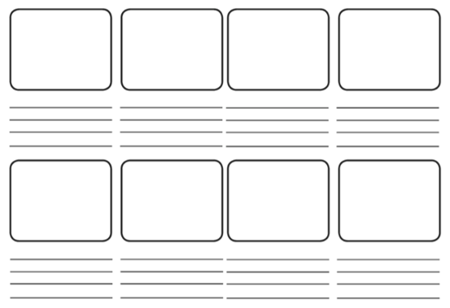
34MM.01 Participate in unison and part singing or playing.  34MM.02 Contribute to performances with mostly accurate timing and with increasingly accurate tuning, control, and expression.  34MM.03 Experiment with and combine sounds for a given purpose.  34MM.04 Contribute short fragments to improvisations and compositions which respond coherently to a range of given or chosen stimuli.  34MS.01 Listen and respond to music, beginning to use technical language accurately to describe features of the music.  34MS.02 Demonstrate an understanding of how work can be improved to suit intentions.  34MS.03 Explore simple ways of scribing their own and others’ music, making the link between sounds and symbols. | In small groups learners create their own story, which they will tell through music. Learners could decide to create their own characters or use characters from ‘Peter and the Wolf’ or the story they covered in a previous unit such as ‘Jack and the Beanstalk’.  Give each group of learners a blank storyboard to create their story:  As learners are creating their story, encourage them to consider the following questions:  - How will music help to tell this story?  - Will you use voice, body percussion and/or instruments? Which will you use for each character in your story?  - Can you use rhythmic patterns or changing tempos (speeds) to represent the characters movements and actions?  Learners compose a short piece of music or soundscape to tell their story. For support in composing music for their characters, encourage learners to use methods they used in previous units, such as making a motif in Unit 4.2 The sound of the rainforest, or composing a bird piece in Unit 4.3 Creating characters.  Once learners have rehearsed their compositions, give them time to perform them to the rest of the class. You may wish to record learners’ performances using simple music technology. Some learners may wish to experiment with notating their work using graphic or traditional notation.  Ask learners:  - Which pieces sounded effective and why?  - Could you understand the story the music was telling?  - If not, what could you improve?  Resources:  - Simple music technology for audio recordings (optional) | You may wish to provide your learners with a set of notes to use such as a pentatonic scale: C D E G A.  You may wish for learners to give feedback on other group performances such as two things that went well and something that the group may wish to think about to improve their composition or performance. This may be in the form of two stars and a wish. Ideally, provide time for learners to refine their work after considering feedback and give learners the opportunity to perform a second time and evaluate their performances  Music portfolio: learners can add recordings of the rehearsals and performances, and their reflections, to their music portfolio.

Unit 4.5 Celebration

Unit 4.5 Celebration

Outline of unit:
In this unit learners will develop their understanding of the musical elements to refine and rehearse their work, learning mostly through whole class and group learning. Learners will explore different ways to evaluate their work and develop an awareness of setting their own targets as a group to improve their work.

Recommended prior knowledge/previous learning:
Awareness of rhythm and pitch and group listening, composing and performing skills

Language:
- elements of music
- refine
- evaluate

Unit 4.5 Suggested activities

Learning objectives | Suggested teaching activities and resources | Comments/Teaching notes
34MS.01 Listen and respond to music, beginning to use technical language accurately to describe features of the music.  34MS.02 Demonstrate an understanding of how work can be improved to suit intentions. | Explain to learners that in this unit they will choose a piece of their work from the previous units to revise, refine and perform as part of a final celebration.  Learners review their performances and compositions from each of the four previous units. Ask learners:  - What was your favourite activity? Why?  - How did it make you feel?  - If you could make one change to your performance what would it be?  This information could be captured in a self-assessment sheet:  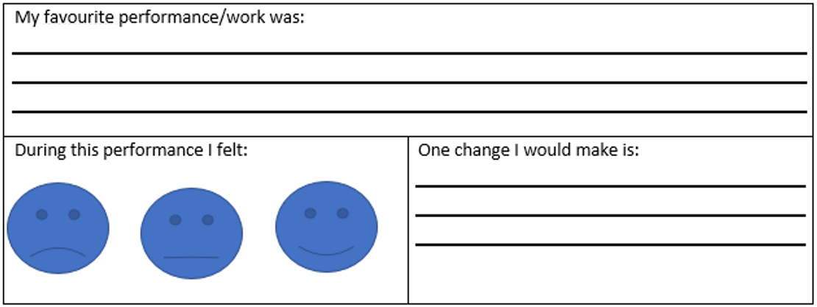  Learners consider which work they would like to develop for a class concert. Once they have decided which piece they will work on they should review a recording of their initial performance and/or rhythm grid, soundscape or score of their composition. To support their reflection, you could provide ideas, for example:  - We sang/played clearly  - We sang/played in time  - We used different dynamics  - We performed as a round  - We made a good score  - My favourite part was…  - One change I would make is…  You may wish to encourage learners to keep a note of the targets to improve their composition and performance in each lesson of the unit.  Lesson Date What I need to do in this lesson What I need to do to improve  1  2  3  4  5  Learners will require time over a series of lessons to rehearse, refine and evaluate their musical compositions and performances, before they perform in a final concert. | You may wish to use recordings, examples of notated compositions or re-teach favourites from each unit.  You may wish to display this to learners for them to consider when reflecting on prior learning.  You may wish to take a class vote and select the most popular for the whole class to work on. Alternatively, you could allow groups to select the work to refine and rehearse. This may produce more variety for a class concert.
34MS.01 Listen and respond to music, beginning to use technical language accurately to describe features of the music. | Explain to learners that the ‘Elements of Music’ are the building blocks of music and are used in every single piece of music. They will learn about some of the elements of music and then apply this to their own compositions and performances.  Explore the key words with learners. You could create a match up activity so that learners match the key word with the description.  Silence The opposite of sound  Timbre The sound of each instrument  Pitch The highness or lowness of a sound  Tempo The speed of the music – fast/slow  Duration The length of a sound – short/long  Dynamics The volume of a sound – loud/quiet  Play learners a selection of extracts of different pieces of music and ask them to identify some of the Elements of Music. Examples of pieces you could use to identify musical elements are:  Pitch ‘Peter and the Wolf’ by Sergei Prokofiev. The bird (flute) has a high-pitched melody and the Grandfather (bassoon) has a low-pitched melody.  Dynamics and tempo ‘In the Hall of the Mountain King’ by Edvard Grieg. Learners listen for the music getting louder and tempo getting faster.  As learners listen you could ask them to keep a listening journal. You may wish to provide a template of a learning journal for learners to fill in:  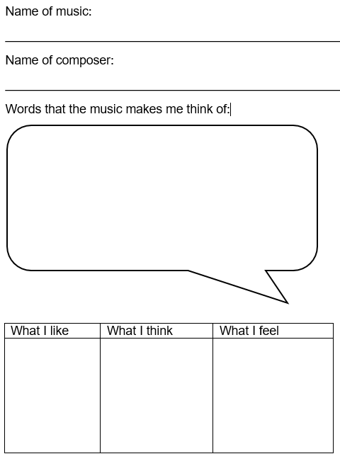 | As a challenge, you could also introduce learners to the two other elements of music below:  Texture The thickness or thinness of the music  Attack and Decay How a sound starts and stops
34MM.01 Participate in unison and part singing or playing.  34MM.02 Contribute to performances with mostly accurate timing and with increasingly accurate tuning, control, and expression.  34MM.03 Experiment with and combine sounds for a given purpose. | Using a pitched instrument play high, middle or low-pitched notes.  Ask learners to move around the room and when they hear a sound do the following actions:  - High-pitched note – stretch up  - Low-pitched note – curl up like a ball  - Middle-pitched note – cross arms together  You could also swap the actions. For example, you could ask learners to represent animals:  - high-pitched note – act like a bird  - low-pitched note – act like a cat  - middle-pitched note – act like an elephant  Encourage learners to consider how they have used pitch in the pieces they have composed and performed throughout the year. | This activity will help learners to identify pitch, which is one of the elements of music.
34MM.01 Participate in unison and part singing or playing.  34MM.02 Contribute to performances with mostly accurate timing and with increasingly accurate tuning, control, and expression.  34MM.03 Experiment with and combine sounds for a given purpose.  34MM.04 Contribute short fragments to improvisations and compositions which respond coherently to a range of given or chosen stimuli.  34MS.02 Demonstrate an understanding of how work can be improved to suit intentions. | Teach learners a simple rhythmic pattern. For example:           I like choco- late and ice cream sun- daes  Rehearse vocally and with instruments. Once learners are able to perform this explore the following pattern changing the tempo:  Largo (slow)  Accelerando (getting quicker)  Andante  (walking pace)  Allegro (fast)  Rallantando  (slowing down)  Next try changing the dynamics:  Forte (loud)  Diminuendo (getting quieter)  Piano (quiet)  Crescendo (getting louder)  Mezzo forte (moderately loud)  In small groups learners create their own rhythmic pattern and decide on the tempo and dynamic. You may wish to provide learners with blank dynamic and tempo charts for them to complete. For example:  Our Tempo:  Our Dynamics:  Encourage learners to consider how they could use dynamics and tempo to refine the piece they have chosen to perform as part of the final celebration.  Ask learners:  How could what you have learnt about dynamics and tempo improve your performance? | You may wish to explore tempo and dynamic terminology with learners using dynamic and tempo charts.
34MS.01 Listen and respond to music, beginning to use technical language accurately to describe features of the music.  34MS.02 Demonstrate an understanding of how work can be improved to suit intentions. | Learners should use their self-assessments and apply what they have learnt about the elements of music to improve their composition and performance.  Give learners the opportunity to perform for other learners in their class. Tell learners that this is a class concert made up of their performances.  During the concert, encourage learners to reflect on and consider the following:  - one change they would make to the concert  - how they felt during the concert  - a memorable moment in the concert  - how they felt during their performance  - how they felt after the concert  - their favourite performance.  After the performance ask learners to write their responses and share as appropriate with the rest of the class.  Resources:  - Simple music technology for audio recordings (optional) | You may wish to display these questions on a board during the class concert and allow learners a worksheet or blank piece of paper to make notes.  You may wish to make a recording of the class performance using simple music technology.  Music portfolio: learners can add recordings of the rehearsals and performances, and their reflections, to their music portfolio.
34MS.02 Demonstrate an understanding of how work can be improved to suit intentions. | Ask learners to complete a self-assessment of their work in this unit:  I sang or played clearly  I played in time with my group  I showed creativity  I followed directions  I showed leadership  Ask learners how they feel the group has performed overall and rank the following:  Excellent Good Ok Needs Work Very Poor  We worked well as a group  We had a plan for the structure of our piece  We changed the dynamics  We performed in time with one another  I can play my part  Ask learners:  - What were two things you did well?  - What is one thing you need to work on? | You may wish to edit the statements in the self-assessment grid to suit your learners’ targets.

Sample lesson 1

CLASS:

DATE:
Learning objectives | 34MM.01 Participate in unison and part singing or playing.  34MM.02 Contribute to performances with mostly accurate timing and with increasingly accurate tuning, control, and expression.  34MM.04 Contribute short fragments to improvisations and compositions which respond coherently to a range of given or chosen stimuli.
Lesson focus | In this lesson learners will explore a song using ta and ti-ti rhythms. They will identify high and low pitches and create their own performances exploring rhythmic ostinatos. They should be able to:  - identify high and low pitch using hand shapes and by singing Cobbler Cobbler  - perform and create rhythmic ostinatos within a group  - describe their music using the terms pitch and ostinato.
Previous learning | Learners will have explored rhythmic patterns using ta and ti-ti rhythms and will be able to sing simple songs using two pitches.
Plan
Lesson | Planned activities | Notes
Introduction | To practise warming up their faces, ask learners to pull as many funny faces as possible. Prompts could include:  - making their faces as small as a tiny mouse then as large as a lion  - making the largest yawning expression without making a sound  - chewing an imaginary piece of toffee.  To practise warming up their posture, ask learners to walk around the classroom making their body as small as possible, then give a signal, such as a clap, word or sound, to change into being as tall as possible. You could tell learners to imagine that they are a puppet being pulled up with a piece of string.  Tell learners that during the lesson they will be learning a new song with two pitches and creating rhythmic ostinatos to accompany the song. They will be performing their compositions in a class concert. | These exercises will help your learners to stretch their facial muscles  This activity helps learners to consider their posture and encourages good posture for singing.
Main activities | Introduce a new song that uses just ta (crotchet) and ti-ti (quaver) rhythms, such as ‘Cobbler Cobbler’.  Ask learners to listen to you singing the song. Sitting in a circle, ask learners to tap their knees to create a steady pulse as you continue singing. You could also challenge learners to pass a toy around the circle in time with the pulse. If learners feel confident they could join in singing while keeping in time with the pulse.  Then ask learners to clap the rhythm of the song.  Ask learners:  Can you identify the types of rhythms used? (ta and ti-ti)  What do you notice about the rhythmic pattern? (Learners may notice the rhythm ti-ti, ti-ti, ti-ti, ta is repeated throughout)  Can you represent the rhythm used in a rhythm grid?       Ask learners to create a short repeated rhythmic pattern to accompany the song. You may wish to provide learners with empty four-beat rhythm grids for them to scribe their own rhythms to accompany ‘Cobbler Cobbler’.  For example, learners could create the following repeated pattern:      They should clap the repeated pattern whilst singing ‘Cobbler Cobbler’:         Cob-bler Cob-bler mend my shoe. Get it done by half past two.         Half past two is at the door. Get it done by half past four. | Resources:  - Rhythm grids  - Toy (optional)
End/Close/ Reflection/ Summary | Encourage all groups to perform in a class concert. With each group sitting together, ask the whole class to sing ‘Cobbler Cobbler’. Repeat and ask the first group to perform their rhythmic ostinato at the same time, on the next repeat the second group performs their rhythmic ostinato and so on until each group has performed.  You may wish for the rest of the learners to give feedback on other group performances such as two things that went well and something that the group may wish to think about to improve their composition or performance. This may be in the form of two stars and a wish.  Ask learners to discuss their learning from today’s lesson with a partner.  - What did you enjoy today?  - Which tasks did you find easy or difficult?  - What did you learn today?  - What is your target for the next lesson? | Recording equipment may be required if you wish to capture some performances.

Reflection
Use the space below to reflect on your lesson. Answer the most relevant questions for your lesson.
Were the learning objectives and lesson focus realistic? What did the learners learn today?
What was the learning atmosphere like?
What changes did I make from my plan and why?
If I taught this lesson again, what would I change?
What two things went really well (consider both teaching and learning)?
What two things would have improved the lesson (consider both teaching and learning)?
What have I learned from this lesson about the class or individuals that will inform my next lesson?
Next steps
What will I teach next based on learners’ understanding of this lesson?

Sample lesson 2

CLASS:

DATE:
Learning objectives | 34MM.01 Participate in unison and part singing or playing.  34MM.02 Contribute to performances with mostly accurate timing and with increasingly accurate tuning, control, and expression.  34MM.03 Experiment with and combine sounds for a given purpose.  34MM.04 Contribute short fragments to improvisations and compositions which respond coherently to a range of given or chosen stimuli.  34MS.03 Explore simple ways of scribing their own and others’ music, making the link between sounds and symbols.
Lesson focus /  success criteria | In this lesson learners will explore how music tells a story. Learners will perform given vocal patterns as a four-beat layered piece, exploring how changes to dynamics and untuned or tuned percussion can be made. They will then create their own music in groups. They should be able to:  - perform four-beat vocal patterns within whole class and small group performances using voice and untuned percussion instruments  - change dynamics and create their own four-beat vocal patterns, performing within a small group  - lead their group performance and be able to describe and explain how the group made changes to dynamics and put their piece together.
Prior knowledge / Previous learning | Learners will have explored rhythmic patterns using ta and ti-ti rhythms and will be able to perform from rhythm grids. They will have explored dynamics and have an understanding of loud and quiet.
Plan
Lesson | Planned activities | Notes
Introduction | Tell learners that during the lesson they will explore how music tells a story. They will be able to perform simple vocal patterns as a layered piece, making changes to dynamics. They will then compose their own piece of music working in small groups and perform them.  As a warm-up, ask learners to stand in a circle and copy you.  - Start by stamping on the first beat of every 8 keeping the other 7 beats silent  - Add a second stamp on beat 2, keeping beats 3-8 silent and repeat until learners are confident with this  - Keep building up the pattern  Then introduce a more complex pattern one step at a time, for example:  - Beat 1 – right stamp  - Beat 2 – left stamp  - Beat 3 – Clap  - Beat 4 – Clap  - Beat 5 – touch right elbow  - Beat 6 – touch left elbow  - Beat 7 – tap your thighs  - Beat 8 – no action (silent)  Once learners are confident with your pattern encourage learners to take the role of the leader and teach the class their own eight-beat patterns.  You could divide the class into smaller groups so that learners can take it in turns at being the leader within their groups. | You will need some space to do this activity. This activity will support learners in keeping in time with a pulse.
Main activities | Using phrases from ‘Peter and the Wolf’ create vocal patterns, for example:  - chirping bird  - duck waddling  - crawling cat  - swimming in the deep pond.  Organise these words into three phrases that will fit to a four-beat pattern:  1 2 3 4  chirp- ing bird  duck wadd- ling  craw - ling cat  swimming in the deep pond  Practise saying each phrase in the four-beat pattern as a class. Then split learners into four groups and assign one phrase to each group. Experiment with bringing groups in at different times and changing the dynamics.  Create a layered piece, deciding on the order of entry and dynamics. You could encourage a learner to take the role of conductor to bring groups in and out and to control the dynamics. The group will need to agree signals for this.  In small groups learners explore the text and create their own composition by:  - selecting phrases from the text or writing their own  - organising each phrase to fit into a four-beat pattern  - writing ideas in a grid.  1 2 3 4  Encourage learners to add percussion instruments or body percussion to their composition. | You may wish to have the text of the ‘Peter and the Wolf’ story to read or share with learners.  Alternatively, you could display key phrases of words for learners to select when they come to the composition task.  You may wish to give each group instruments with the same timbre. For example:  - group 1 – tambourines  - group 2 – woodblocks  - group 3 – shakers  - group 4 – drums
End/Close/ Reflection/ Summary | Once learners have rehearsed their compositions, give them time to perform them to the rest of the class. You may wish to record learners’ performances using simple music technology.  Identify different areas of the room for green, amber and red. Tell learners you will read out some statements about their learning in today’s lesson and they should stand in the area of the correct colour (green meaning they were confident, amber meaning they felt okay, and red meaning they think they need more practise).  Ask learners to reflect on the statements below:  - I can perform a vocal pattern in four beats as part of a group  - I can change dynamics in my performance  - I can create my own vocal chant pattern and share ideas with my group  - I can lead a performance bringing my group in and out and changing dynamics  - I can describe and explain how we made changes to our piece  Ask learners to discuss their learning from today’s lesson with a partner:  - What did you enjoy today?  - Which tasks did you find easy or difficult?  - What did you learn today?  - What is your target for the next lesson?

Reflection
Use the space below to reflect on your lesson. Answer the most relevant questions for your lesson.
Were the learning objectives and lesson focus realistic? What did the learners learn today?
What was the learning atmosphere like?
What changes did I make from my plan and why?
If I taught this lesson again, what would I change?
What two things really went well (consider both teaching and learning)?
What two things would have improved the lesson (consider both teaching and learning)?
What have I learned from this lesson about the class or individuals that will inform my next lesson?
Next steps
What will I teach next based on learners’ understanding of this lesson?

Cambridge Assessment International Education
The Triangle Building, Shaftsbury Road, Cambridge, CB2 8EA, United Kingdom
t: +44 1223 553554 f: +44 1223 553558
e: info@cambridgeinternational.org www.cambridgeinternational.org

Copyright © UCLES September 2019

